IMPROVING TEACHERS’ COMPETENCE THROUGH THE IMPLEMENTATION OF THE 21ST CENTURY COMPETENCIES IN A POST-COVID-19 PANDEMIC

Ridwin Purba¹, Herman^{2*}, Anita Purba³, Ahmad Fakhri Hutauruk⁴, Dumaris E. Silalahi⁵, Julyanthry⁶, Ernest Grace⁷
^{1,3,4}Faculty of Teachers Training and Education, Universitas Simalungun, Indonesia
^{2*,5}Faculty of Teachers Training and Education, Universitas Simalungun, Indonesia
^{6,7}Management Department, Sekolah Tinggi Ilmu Ekonomi Sultan Agung, Indonesia
nridwin@yahoo.com¹, herman@uhn.ac.id^{2*}, anit_apurba@yahoo.co.id³, ahmadfakhrihutauruk@usi.ac.id⁴, dumaris.silalahi@uhn.ac.id⁵, yoe.lianthry@gmail.com⁶, ernestgr87@gmail.com⁷

ABSTRAK
Abstrak: Karena guru adalah komponen paling kritis dari proses pendidikan, mereka harus dapat dengan cepat beradaptasi dengan perubahan dalam sistem. Pasca pandemi Covid-19, guru perlu meningkatkan keterampilannya dalam mengelola pembelajaran siswa. Pengabdian kepada masyarakat ini dilakukan melalui metode ceramah dengan menggunakan presentasi powerpoint, tanya jawab dan juga diskusi tentang berbagai permasalahan yang muncul di sekolah. Kegiatan seminar dalam rangka pengabdian kepada masyarakat Kepala sekolah dan guru anggota KN-LWF anggota KN-LWF Pematangsiantar yang berjumlah 63 orang ini hadir dalam seminar yang bertempat di GKPS Jalan Jenderal Sudirman Pematangsiantar pada tanggal 23 November 2021 ini. Dari kegiatan pengabdian tersebut, peneliti menyimpulkan bahwa guru dalam dunia pendidikan harus memiliki 4C 21st Century Learning Skills yang tercantum di atas. Konsep ini akan memberikan dampak yang mendalam bagi generasi penerus bangsa, memungkinkan mereka menghadapi dan mengatasi tantangan kehidupan abad ke-21
Kata Kunci: Kompetensi; Tenaga Pendidik; 4C; Abad ke-21; Pasca Covid-19.
Abstract: Since teachers are the most critical component of the educational process, they must be able to quickly adapt to shifts in the system. After the Covid-19 pandemic, teachers will need to improve their skills in managing student learning. This community service was done through a lecture method using PowerPoint presentations, questions and answers and also discussions on a variety of issues that arise in the school. The seminar activities in the context of community service Pematangsiantar's KN-LWF members' principals and teachers, a total of 63 people, were in attendance at this seminar which was located at GKPS Jalan Jenderal Sudirman Pematangsiantar on November 23, 2021. After completing the community research, the researchers summarized that teachers in the world of education must have the 4C 21st Century Learning Skills listed above. This concept will have a profound impact on the nation's next generation, enabling them to face and overcome 21st-century life's challenges
Keywords: Competence; Educators; 4C; 21st Century; Post Covid-19
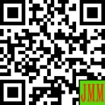 | Article History:  Received: DD-MM-20XX  Revised : DD-MM-20XX  Accepted: DD-MM-20XX  Online : DD-MM-20XX | This is an open access article under the  CC–BY-SA license

- INTRODUCTION
As a result of the Covid-19 pandemic, which began spreading in Indonesia in 2020, schools were forced to continue functioning with less-than-optimal implementation of learning, leading in a decline in educational quality. educators as a result of being infected with the covid-19 epidemic. Schools in Indonesia are one of the sectors where traditional face-to-face learning and teaching methods cannot be used. However, after the activities were suspended, several schools attempted to continue the teaching-learning process through online models (Sherly et al., 2021). But since October 2021, conditions in various parts of Indonesia have begun to recover, and important sectors such as the education sector have begun to be repaired, so an acceleration is needed in order to catch up since the pandemic began. On the ground in Pematangsintar City today, educational institutions have implemented PPKM level 2, as recommended by the Minister of Education, which includes limited face-to-face meetings. As a result, Pematangsiantar City's education needs to be improved in the wake of the Covid-19 pandemic.
The Covid-19 epidemic has had a major effect on human life, especially schooling. The positive and negative effects can be observed. There's a general perception that the covid-19 pandemic is harmful to humans and education in general, which is correct. But the researchers of this article see the COVID-19 virus as an opportunity for teachers to advance, move forward, innovate, and learn more. Teachers should view the covid-19 virus as an opportunity for growth rather than a threat. Hence, the Covid-19 pandemic has had a profound effect on human life in a wide range of areas, including the economy, society, and culture (Sherly et al., 2021). The Ministry of Education and Culture in Indonesia is implementing distance learning laws in order to preserve students' rights to acquire educational services and to protect inhabitants of education units from the detrimental impacts of Covid-19 during the Covid-19 Pandemic. education and ensuring that the psychological needs of educators, students, and their guardians are satisfied.
Online learning is very similar to conventional learning in that it involves students and teachers working together in a classroom to transfer information, develop spiritually, and build character. Online learning is also known as e-learning. The only thing that differs is the system that is being used. Conventional learning is done face-to-face, whereas online learning is done face-to-face via an internet network. (Silalahi et al., 2021) defined that during the pandemic, electronic learning (e-learning) has been regarded as the most effective method of continuing education and learning. In order to overcome time and distance constraints in conventional learning, e-learning has been able to use an online-based learning process (van Thao et al., 2021). IT-based learning models such as e-learning and blended learning, as well as other forms of virtual learning, have been utilized to support the learning process in the IT sector by vocational high schools and universities (Sherly et al., 2021). For online learning to work, it requires both teachers and students to be prepared, according to (Imania & Bariah, 2019), who define online learning as a method of converting traditional learning into digital form via an internet connection. When it comes to online education, the quality of the instructor makes all the difference. According to (Wahyono et al., 2020), changes in teaching and learning models, especially changes in online learning models, cannot be separated from the role of a teacher. When it comes to the Covid-19 pandemic, teachers must keep an eye out for a variety of factors, including changes in society.
Teachers with integrity are increasingly in demand as science and technology continue to advance at a rapid pace and become more sophisticated. A nation that isn't prepared for natural disasters and the rapid advancement of science and technology is almost certain to succumb to globalization. As a result, educational standards must be raised. As educational institutions, schools must teach students how to think creatively, critically, communicative, and collaboratively, or what are known as the "4Cs" of the 21st century.
In the human world, communication is the exchange of language. Consequently, human beings are involved in all forms of communication, including intrapersonal, group, and mass contexts. Studies have shown that language has long been recognized as a primary means of communication between individuals, including counseling and coaching activities; teaching and learning processes; workplace meetings; etc. When we say that we're communicating, we mean that we're learning to express ourselves verbally in a way that has both emotional and social meaning (Van, 2011).
With two or more people working together, "collaborative" means "working toward the same goal while respecting each person's individual contribution." Paz Dennen in (Roberts, 2004) defines "collaborative learning" as "knowledge construction through social interaction". Thus, "Educators must trust students to perform in ways that the teacher has not necessarily decided in advance," (Roberts, 2004), and "collaborative learning implies that (educators) must reconsider what they must do to prepare to teach and what they are doing while teaching."
The process of solving problems, making decisions, persuading, analyzing assumptions, and conducting scientific research all require the use of critical thinking. It is the ability to organize one's thoughts in an efficient manner. Having the ability to objectively assess one's own thoughts and those of others is critical thinking (Johnson, 2009).
In critical thinking, a person engages in an active process of self-reflection, asking questions, and gathering relevant information rather than simply accepting what others tell them (Fisher, 2009). (Johnson, 2009) argues that critical thinking's goal is to gain a deeper understanding of the subject matter. On the other hand, (Faiz, 2012) argues that critical thinking's primary goal is to ensure that our thinking is accurate and valid to the greatest extent. Students will be able to find solutions to their problems if they can think critically
For Lawrence, creativity is an idea or human thought that is novel; efficient; and understandable. (Septikasari & Frasandy, 2018) stated that creativity is the ability to produce new forms in the arts or in the arts, or to solve problems with new methods. He claims that creativity is an activity that manifests (embodiment) one's ability to produce something or solve a problem on one's own terms (Suratno, 2005). There are numerous sorts of innovation, but they all share one characteristic: they are novel to the extent that they are recognized as such by an individual or group. Innovation is viewed as a necessary component of achieving a certain goal or resolving a specific problem
As a result of this situation, various parties have taken a variety of approaches in order to catch up with the current gaps. Similar to the Pematangsiantar City KN-LWF institution, which seeks to organize seminars for teachers under the auspices of KN-LWF so that the quality of teachers who have started to slack due to being complacent during the pandemic, must be immediately improved so that they can carry out their duties properly, so that the quality of education can improve after the pandemic or "Post Covid-19 Pandemic" will be the theme of a seminar that will be held, and teachers are expected to use it to rethink how they teach during limited face-to-face learning (PTM) until normal conditions return.

- METHOD
According to Law No. 20 of 2003, the National Education System; Law No. 14 of the Republic of Indonesia concerning Teachers and Lecturers; and the KN-LWF education program, this educational seminar is based on three fundamental principles. The following are the aims of this seminar:
- The KN-LWF Pematangsiantar city is responsible for the professional development of teachers.
- Improving teacher competence in order to broaden their perspectives on how education will be implemented following the Covid-19 pandemic. 3.
- After the Covid-19 pandemic, it was necessary to find and develop learning models.
- Preparing teachers to be able to plan, implement, and evaluate learning in the aftermath of the Covid-19 pandemic."

A descriptive qualitative study was the approach taken in this case. It was explained by (Herman et al., 2021) that the goal of qualitative research is to gain a comprehensive understanding of phenomena encountered by research participants in a specific social and natural environment via explanations in the form of words and language. various natural approaches (Munthe et al., 2021); (Triana et al., 2021). The seminar activities in the context of community service are carried out using the lecture method using PowerPoint presentations, question and answer sessions and also discussions on several problems that occur in the school. Participants who took part in this seminar were the principals and school teachers of KN-LWF members in Pematangsiantar city and its surroundings, totaling 63 people. Seminar activities will be held on November 23, 2021 at GKPS Jalan Jenderal Sudirman Pematangsiantar.

- RESULTS AND DISCUSSION
Following lectures and socialization of the material presented by the resource persons, and a question and answer session about problems encountered in everyday life, particularly in classroom teaching, researchers discovered several findings that could be used as references and motivations. learning how to be a 21st-century educator,
- Teachers must encourage students to communicate more frequently in order to improve their communication skills. The child's brain will be stimulated to mimic the use of good sentences as a result of this activity. Additionally, students in the twenty-first century are taught how to communicate effectively with their classmates during the learning process, in order to gain a deeper understanding of the content and assist their peers in learning as well.
- Educators must use a variety of strategies to help students learn, including the use of new technologies like computers and mobile devices (ICT).
- As a result, the learning activities that are created must be capable of encouraging students to collaborate with one another (collaborative and cooperative)
- It is imperative that teachers inspire students' interest in a wide range of subjects and the real-world applications of their concepts.
- Learning developed by teachers must be capable of instilling a sense of critical thinking in students (HOTS).

Challenges in Implementing the 4Cs
After having the presentation with the participants, there were some challenges depicted in implementing the 4Cs for both teachers and students. There was a teacher from one school of GKPS that raised questions regarding to impelementation of 4Cs. One challenge is about the teachers’ life survival. One of the headmaster explained that how could the teachers learnt or gained the 4Cs while they were still struggling with their salaries that they didn’t get in the end of the month. Teachers were lost of spirits and also not interested to update and train themselves. This is normal since inner problem such as like salary (should be their rights) is not given to them. The other challenges here was teachers were out of ideas to teach the students. For example, when one of the participants, an English teacher, asked the keynote speaker, Dr. Herman, S.Pd., M.Pd., about how to teach students in a class where some students still did not understand and know the basic English such as ordinal numbers. The problems were more intensive where the teaching and learning process were conducted in online system (like using zoom meeting or google meet) and teachers felt that the process in teaching became more complicated. This is in line with statement from previous researchers, (Purwanto et al., 2020), about the problems faced by teachers. Educators' main challenges are claimed to be network issues, a lack of training, and a lack of awareness. Those who did not accept online learning cited a lack of awareness as the most important reason, followed by a lack of interest and questions about its utility. Due to connectivity challenges, online learning was shown to have substantial negatives such as a lack of presence, a lack of personal touch, and a lack of contact. Hence, students, teachers, and parents face a number of challenges when it comes to online teaching and learning activities, including a lack of technological mastery, additional internet quota fees, additional work for parents accompanying children to school, communication and socialization between students, teachers, and parents, and reduced and unlimited working hours for teachers due to the need to communicate and coordinate with parents, other teachers, and school principals.
Although there are lots of problems occured, one positive things that all people can not deny is the existence of technology such as gadget, android, zoom meeting and so on that can really help and encourage human’s activity including the teachers and students at school.

Steps to overcome the challenges

Though lots of problems or challenges exist to the teaching and learning process, teachers and students must try to overcome them. In Indonesia, teacher competence is the most important factor in determining the effectiveness of the learning process. The teacher will make every effort to ensure that the learning activities are successful. The teacher serves as both an organizer of the learning environment and a facilitator of learning. To do this, the teacher must fulfill the role of model, planner, forecaster, leader, and guide or guide to learning centers. (Anugrah, 2020) defined that teachers, schools, students, and even parents/guardians of kids should all be commended in the context of online learning since they are able to adapt fast. However, over time, all parties must review online learning to ensure that its objectives are met to the best of their abilities. Students' learning loads must be reasonable and quantifiable.
Furthermore, teachers must also show appreciation for students' accomplishments in order for learning objectives to be met. One of the learning objectives, including online learning, is the achievement of student competencies known as the 4Cs, which are: (1) critical thinking (critical thinking), which directs students to be able to solve problems (problem solving); (2) creativity thinking (creative thinking), which can be interpreted as the teacher assisting students with high creativity to think and see a problem from various sides or perspectives; (3) collaboration (cooperating or collaborating), and (4) students are able to have a good communication in conveying ideas effectively (Anugrah, 2020).

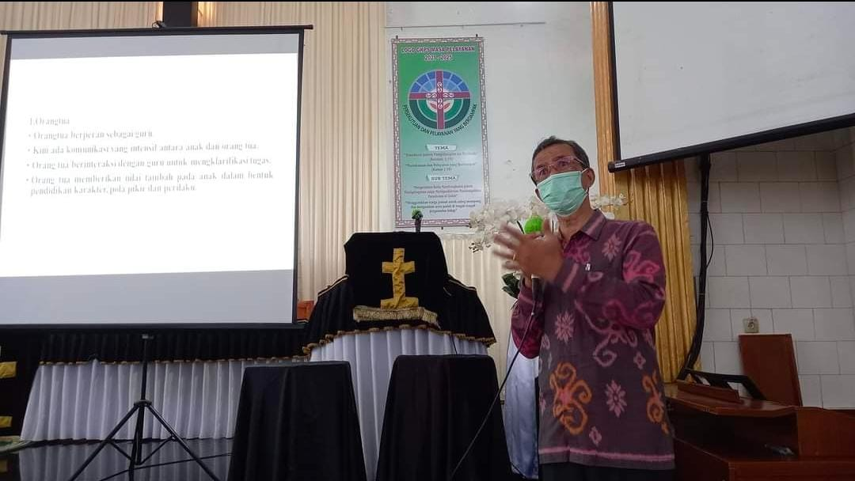

Figure 1. Opening speech from Drs. Ridwin Purba, M.Div., M.Pd. as the Education Coordinator of KN.LWF in Indonesia

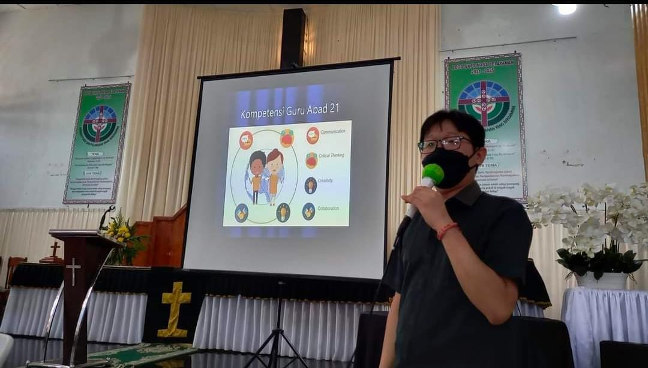

Figure 2. Dr. Herman, S.Pd., M.Pd., as the presenter in presenting Teacher’s Skill in 21st Century

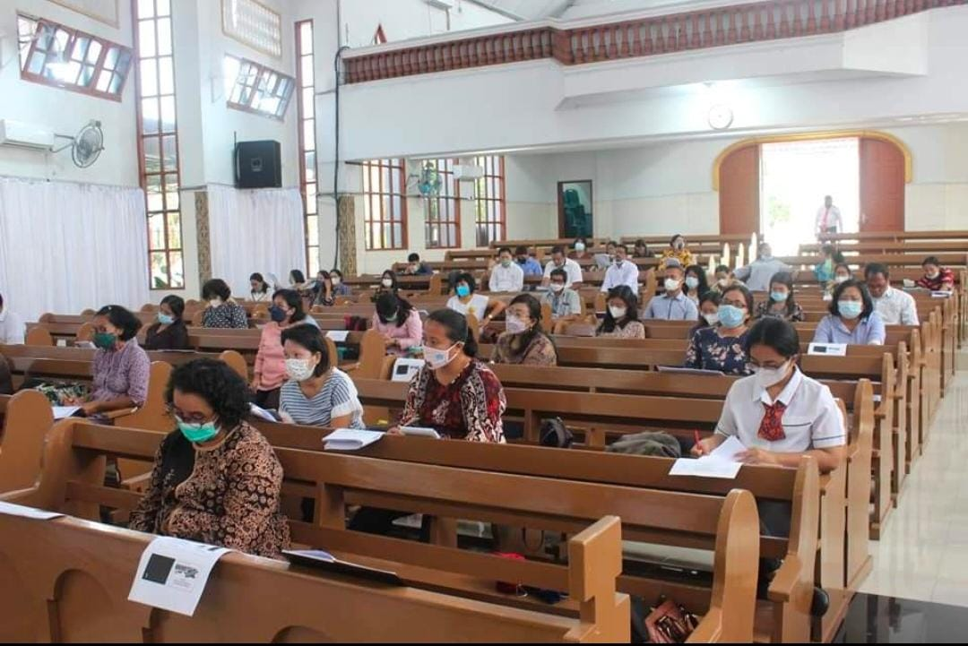

Figure 3. Participants (Principals and Teachers) in the seminar of Education

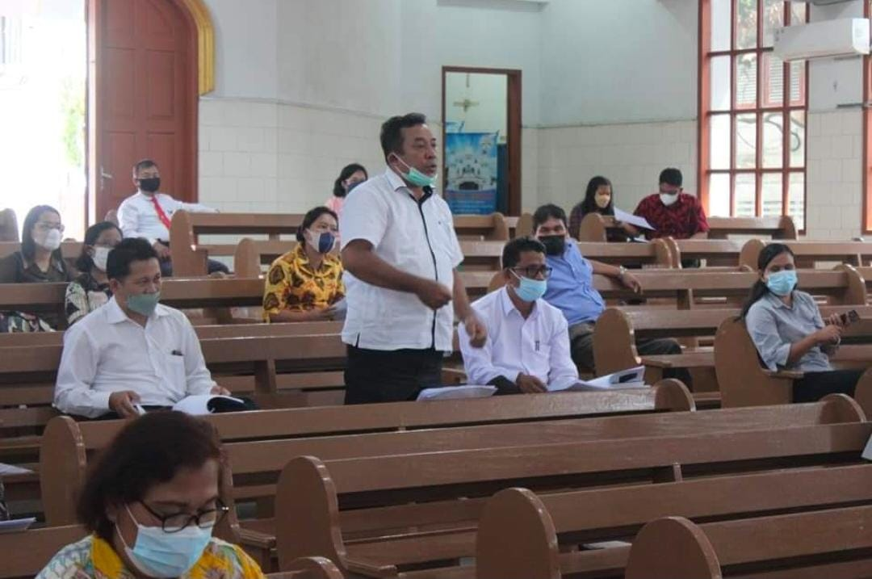

Figure 4. Question and Answer (Q&A) session to the presenter

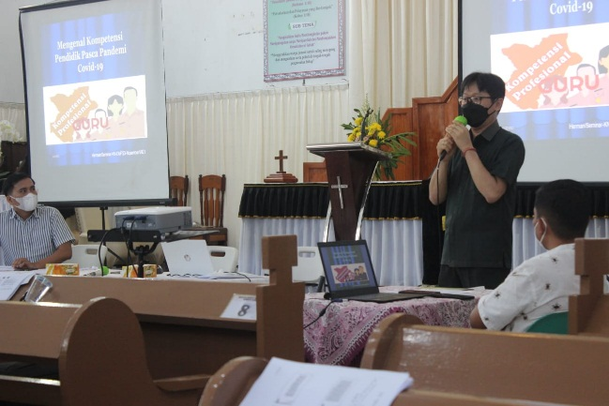

Figure 5. Question and Answer (Q&A) by Dr. Herman, S.Pd., M.Pd. to one of participants.

- CONCLUSION
So far, Indonesia's well-structured education system has been unaffected by the COVID-19 pandemic. Since the spread of the COVID-19 virus has led to the development of various policies, Indonesian educational institutions have been inspired to change the education system from traditional to distance learning. Distance learning policies are implemented by teachers, who have a critical role to play. Teachers should be challenged by some of the difficulties that arise in the distance learning process in order to maintain their professionalism in the classroom. This concept will have a profound impact on the nation's next generation, enabling them to face and overcome 21st-century life's challenges. The teacher, of course, must begin the process of shifting from a teacher-centered to a student-centered learning model. No matter how good the current curriculum or education system is, without qualified educators, it will all be for naught. Educators and education personnel must have the required qualifications, standardized competencies, and ability to support and organize educational activities professionally. As a final point, teachers need to work on their 21st-century teaching skills through Long Life Education.

THANK YOU NOTE
The researchers would like to send their highest gratitude to National Committee – Lutheran World Federation in Indonesia – A Communion of Churches (KN.LWF) in city of Pematangsiantar which has supported the seminar of education for teachers and principals in empowering their

REFERENCES

Anugrah, D. (2020). Dinamika Pembelajaran Daring Di Tengah Pandemi Covid-19. Berita Magelang. http://beritamagelang.id/kolom/dinamika-pembelajaran-daring-di-tengah-pandemi-covid-19
Faiz, F. (2012). Thinking Skills Pengantar Menuju Berpikir Kritis. Yogyakarta: Suka Press.
Fisher, A. (2009). Berpikir Kritis Sebuah Pengantar. Jakarta: Erlangga. https://doi.org/10.1142/7114
Herman, H., Silalahi, D. E., Sihombing, P. S. R., Sinurat, B., Sinaga, Y. K., Panjaitan, M. B., Purba, C. N., Hutauruk, B. S., Hutahaean, D. T., Marpaung, T. I., Pangaribuan, M., Purba, L., Munte, B., & Manahara Siahaan, T. (2021). Strengthening Character Education Through School Culture At Smk Swasta Teladan Tanah Jawa. Abdi Dosen : Jurnal Pengabdian Pada Masyarakat, 5(2), 178. https://doi.org/10.32832/abdidos.v5i2.868
Imania, K. A., & Bariah, S. K. (2019). Rancangan Pengembangan Instrumen Penilaian Pembelajaran Berbasis Daring. Jurnal Petik, 5(1), 31–47. https://doi.org/10.31980/jpetik.v5i1.445
Johnson, E. B. (2009). Contextual Teaching and Learning. (Edisi Terjemahan Ibnu Setiawan). Bandung: MLC.
Munthe, B., Herman, Arifin, A., Nugroho, B. S., & Fitriani, E. (2021). Online Student Attendance System Using Android. Journal of Physics: Conference Series, 1933(1). https://doi.org/10.1088/1742-6596/1933/1/012048
Purwanto, A., Pramono, R., Asbari, M., Santoso, P. B., Wijayanti, L. M., Choi, C. H., & Putri, R. S. (2020). Studi Eksploratif Dampak Pandemi COVID-19 Terhadap Proses Pembelajaran Online di Sekolah Dasar. EduPsyCouns: Journal of Education, Psychology and Counseling, 2(1), 1–12. https://ummaspul.e-journal.id/Edupsycouns/article/view/397
Roberts, T. S. (2004). Collaborative Learning: Theory and Practice. London: Idea Group Inc. https://doi.org/10.21432/t2pk6b
Septikasari, R., & Frasandy, R. N. (2018). Keterampilan 4C Abad 21 dalam Pembelajaran Pendidikan Dasar. Jurnal Tarbiyah Al-Awlad, 3(2), 112–122. https://doi.org/10.1016/j.jacc.2020.04.015
Sherly, Herman, Halim, F., Julyanthry, Dharma, E., Purba, R., & Manawari Girsang, R. (2021). Socialization for the Implementation of E-Learning Teaching Models for Teachers and Education Staffs at SMA Sultan Agung Pematangsiantar. Abdi Dosen : Jurnal Pengabdian Pada Masyarakat, 5(2), 275. https://doi.org/10.32832/abdidos.v5i2.879
Silalahi, R., Silalahi, Dumaris, E., & Herman. (2021). Students Perception of Using Google Classroom as English Teaching Media During Corona Virus 2019 at SMA Negeri 4 Pematangsiantar. JEELL (Journal of English Education, Language and Literature), 7(2), 12–30. https://doi.org/10.32682/jeell.v7i2.1730
Suratno. (2005). Pengembangan Kreativitas Anak Usia Dini. Jakarta: Depdiknas.
Triana, M., Herman, H., Sinurat, B., & Silalahi, D. E. (2021). An Analysis of Students Perception on the Use of Google Classroom in English Language Learning. Cetta: Jurnal Ilmu Pendidikan, 4(3), 607–618. https://doi.org/10.37329/cetta.v4i3.1474
Van, T. J. M. (2011). Pendidikan Anakku Terlambat Bicara. Jakarta: Perdana.
van Thao, N., Herman, Napitupulu, E. R., Hien, N. T., & Pardede, H. (2021). Code-switching in learning via zoom application: A study in an EFL context. Asian ESP Journal, 17(3), 91–111.
Wahyono, P., Husamah, H., & Budi, A. S. (2020). Guru profesional di masa pandemi COVID-19: Review implementasi, tantangan, dan solusi pembelajaran daring. Jurnal Pendidikan Profesi Guru, 1(1), 51–65. http://ejournal.umm.ac.id/index.php/jppg/article/view/12462

