**Inquiry Co-Operation Model: An Effort to Enhance Students’ Mathematical Literacy Proficiency**

**Putri Nur Malasari1, Tatang Herman2, Al Jupri3**

1Mathematics Education Department, Institut Agama Islam Negeri Kudus, Kudus

2,3Mathematics Education Department, Universitas Pendidikan Indonesia, Bandung

putrinurmalasari@iainkudus.ac.id

|  |  |  |  |
| --- | --- | --- | --- |
|  |  | **ABSTRAK** | |
| **Article History:**  Received:…-…-…  Revised: …-…-…  Accepted:…-…-… |  | **Abstract**: The urgency and proficiency of students’ mathematical literacy in Bandung that have not been optimal are the basis of this study. The aim of this study is to explain the enhancement of students' mathematical literacy proficiency due to the implementation of the inquiry co-operation model (experimental class) and conventional learning (control class) in terms of basic mathematical proficiency. This study is a quasi-experimental study with a non-equivalent control group design, and the research subjects were seventy students of class VIII of Bandung that were selected through a purposive sampling technique. The research data was obtained through mathematical literacy tests of material in a polyhedron. The results of the data analysis showed that: (1) the enhancement in mathematical literacy proficiency of the experimental students class was better than the control students class in terms of the basic mathematical proficiency (high and medium); (2) there is no significant difference in the increase of mathematical literacy proficiency in experimental students class in terms of the basic mathematical proficiency. It can be concluded that inquiry co-operation model espouses the enhancement of students' mathematical literacy proficiency. | |
| **Keyword*:***  Keyword1; mathematical literacy  Keyword2; inquiry co-operation model  Keyword3; basic mathematical proficiency |
| C:\Users\WINDOWS 7\Documents\Indeksi\New-Cros.jpg  <https://doi.org/10.31764/jtam.vXiY.ZZZ> | | | C:\Users\WINDOWS 7\Documents\Indeksi\88x31.png  *This is an open access article under the* ***CC–BY-SA*** *license* |

——————————◆——————————

1. **INTRODUCTION**

One of the international standard assessments used as benchmarks to determine the quality of mathematical proficiency in Indonesia is the Program for International Student Assessment (PISA). The PISA study was conducted by OECD countries (Organization of Economic Corporation Development) and the UNESCO (United Nations Educational Scientific and Cultural Organization) Institute for Statistics (OECD, 2015). The mathematical proficiency measured by PISA is mathematical literacy. Mathematical literacy is the proficiency to formulate, apply, and interpret mathematics in various contexts. There are six levels of mathematical literacy proficiency in the PISA framework(OECD, 2016b). Level one is the proficiency to complete routine procedures, level two is the proficiency to apply basic algorithms, level three is the proficiency to implement problem-solving strategies, level four is the proficiency to combine different representations, level five reflects the results of work, and level six is the proficiency to develop strategies and new approaches in dealing with problems(OECD, 2015).

The importance of having mathematical literacy skills is also implied in the goals of mathematics education which are stated by the National Council of Teachers of Mathematics (NCTM, 2000). The importance of having mathematical literacy skills is in contrast with the results of the PISA study taken by Indonesian students. Based on the results of the PISA study in 2006, 2009, 2012, 2015, 2018 it can be concluded that the mathematical literacy proficiency of Indonesian students needs to be improved (OECD, 1 C.E., 2003, 2007, 2016b, 2019). It turned out that the results of the PISA study were in line with the results of a preliminary study conducted by the author at one of the junior high schools in Bandung. The results of the preliminary study revealed that junior high school students in Bandung were still experiencing various difficulties in working on mathematical literacy problems. The questions used in the preliminary study are a matter of mathematical literacy created by PISA in 2012. Following in Figure 1 performed representations of student answers when answering mathematical literacy questions.

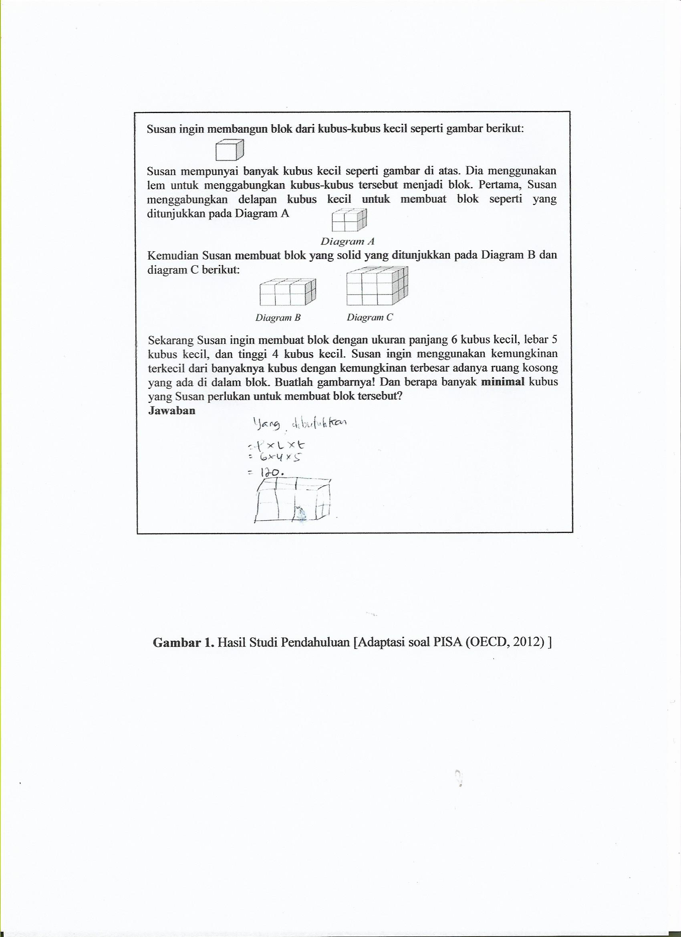

**Figure1.** Representation of Student Answers [PISA Problem(OECD, 2016a)]

Refer to Figure 1, it appears that students answer these questions by calculating the beam volume. This means students have understood that the cubes will form the building blocks. However, students still experience obstacles in making block image representation. These results indicate that students are still experiencing difficulties with the content of the mathematical literacy process, which is to formulate mathematical problems with a description of the process of sketching to build a flat side space. In addition, students also have obstacles in reflecting the meaning of the questions given. In other words, students do not understand the purpose of the problem, so the students' answers do not match expectations.

Same as the results of the preliminary study, the study of Wulandari (2015) found that junior high school students in Bandung were still experiencing various problems in solving mathematical literacy problems. The constraints faced by students were not being able to identify data on the problem, reflect the meaning of the statement given, make conclusions from two unrelated facts, and interpret three related dimensional objects.

One solution that can be done to improve mathematical literacy is through learning mathematics in schools. Good mathematics learning has some criteria. Those are the relationship between the taught material and real-life, the enjoyable and interesting learning atmosphere, the encouragement of student participation, and the improvement of students’ thinking habits(Yang, 2012, p. 83). One learning method that meets these criteria is the Inquiry Co-operation Model (ICM). ICM learning is a combination of guided inquiry learning and free inquiry. ICM learning is a learning model that emphasizes student activity in the process of inquiry, the discovery of a mathematical concept and solving problems related to daily life (AlrØ & Skovsmose, 2002). Several studies such as Effendi (2012), Purwatiningsih (2014), and Hasibuan & Irwan (2014) found that guided inquiry learning was better than conventional learning in enhancing a variety of mathematical proficiency.

This study not only focuses on learning that is carried out but also pays attention to aspects of students' Basic Mathematical Proficiency (BMP) because it is related to the effectiveness of learning implementation. BMP students have a role to learn new mathematical material that will be studied as Bruner’s connectivity theorem, that in mathematics between one concept with another concept there is a close relationship, not only in terms of content but also in terms of formulas that are studied (Takaya, 2008). The purpose of paying attention to the BMP aspect is to find out whether the improvement in students' mathematical literacy proficiency is evenly distributed in all BMP categories (high, medium, and low) or only certain BMP categories. If the improvement of mathematical literacy proficiency is evenly distributed in all BMP categories (high, medium, and low), then this study can be generalized that the application of ICM learning in mathematics learning is appropriate for all levels of proficiency.

1. **LITERATURE REVIEW**
2. **Inquiry Co-operation Model**

The Inquiry Co-operation Model (ICM) learning was initially introduced under the name of cooperative inquiry by John Heron. Initially, ICM was designed as a model of communication between teachers and students. Then, it was developed into a learning model to teach mathematics by AlrØ and Skovsmose(2002). According to AlrØ and Skovsmose(2002), ICM is an example of modified free inquiry learning. Modified free inquiry learning is a combination of guided inquiry and free inquiry (Basaǵa et al., 1994). ICM implementation consists of eight components as shown in Figure 2 below.

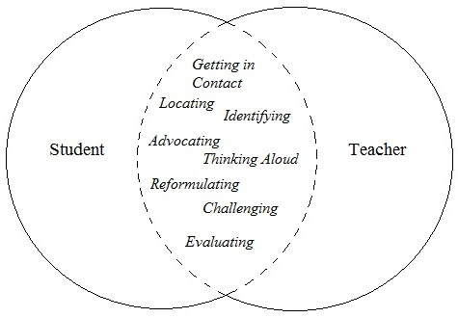

**Figure 2.** Inquiry Co-operation Model Components [AlrØ&Skovsmose(2002, p. 63)]

Referring to Figure 1, it appears that eight ICM components facilitate the relationship between students and teachers. So that students are active in expressing their perspectives, formulating concepts, and solving mathematical problems. A more detailed description of the eight ICM components is as follows.

* + - * 1. Getting in Contact

Students are given mathematical problems. Then, students use the knowledge they have in collaboration with other students carrying out the process of inquiry and problem-solving. The component of getting in contact is in line with Piaget's theory that students develop knowledge through schemes contained in cognitive structures(Santrock, 2014, p. 168). The schemes will develop and be renewed through the process of assimilation (the process of inserting new knowledge into the schemes contained in the cognitive structure that students already have) and accommodation (the process of adjusting the schemes that students have to process new knowledge). Thus, learning not only accepts new knowledge, but also there is a process of rearranging old knowledge to accommodate new knowledge(Barrouillet, 2015; Carey et al., 2015; Oesterdiekhoff, 2016).

* + - * 1. Locating

Students bring up hypothetical ideas or questions that lead to the possibility of solving mathematical problems.

* + - * 1. Identifying

Students identify things that are known and asked in mathematical problems. Identifying an information is used to determine problem-solving strategies.

* + - * 1. Advocating

Prompts can be implemented by teachers or students(Hsu et al., 2016). Teachers provide guidance when students require it. Also, students can advocate for other students or themselves.

* + - * 1. Thinking Aloud

The process of expressing thoughts, ideas, and feelings during the investigation process.

* + - * 1. Reformulating

Reformulating has the meaning of repeating what has been done through different words. In this stage, students are guided to conclude with their own words and solve mathematical problems.

* + - * 1. Challenging

In this process, there are challenges given to students by providing mathematical problems with a higher level of difficulty. The challenge is aimed at students to not quickly settle for every achievement and always try hard to solve other more complex problems. The teacher's role is to support students who have difficulty in solving problems. This component is in line with Vygotsky's theories namely the Zone of Proximal Development (ZPD) and scaffolding. ZPD is a range of tasks that are too difficult for students to master independently but can be learned through guidance from teachers or other students who understand better (Shooshtari et al., 2014; Stiles & Caro, 2016). Scaffolding is adjusted direction in guiding students who have difficulty(Cooper & Robinson, 2014; Howell & Saye, 2017).

* + - * 1. Evaluating

Evaluation is carried out by students’ way to answer several mathematical questions. Based on students' answers, the teacher can measure the students' mastery of the material, and determine the next learning step.

Based on the explanation of the eight components of ICM learning above, it appears that ICM learning stimulates students to construct mathematical concepts so that they can solve mathematical problems. This process is in line with Bruner's theory that learning is not only reflects the transmission and acceptance of knowledge, but also there is a process of building knowledge(Stoilescu, 2016).

1. **Mathematical Literacy**

Mathematical literacy is the knowledge to use mathematics tosolve life problems. The proficiency to think in mathematics is to reason logically, think problem-solving, and communicate mathematically(Ojose, 2011). Mathematical literacy is not only the proficiency to count, but also includes extensive knowledge as revealed by De Lang (2006, p. 15) that mathematical literacy includes spatial literacy, numeracy, and quantitative (see Figure 3).

Mathematical Literacy

Quantitative Literacy

Change & Relationship

Uncertainty

Numeracy

Spatial Literacy

Space & Shape

Quantity

**Figure 3.** Mathematical Literacy Structure [Modification De Lange (2006:15)]

Referring to De Lange (2003) as shown in Figure 3, spatial literacy is the proficiency to relate to spatial. While numeracy literacy, referring to De Lange (2003) as shown in Figure 3, is the proficiency to manage numbers and data. Quantitative literacy is more complex than numeracy literacy. Someone who has quantitative literacy can apply quantitative statements in familiar or unfamiliar contexts to manage numbers and data. The complex proficiency is quantitative literacy. Someone who has quantitative literacy can apply quantitative statements in familiar or unfamiliar contexts.

There are seven competencies needed in mathematical literacy proficiency according to PISA (*PISA 2015 Mathematics Framework*, 2017, p. 68), namely communication, mathematizing, representation, reasoning, and argument, devising strategies for solving problems, using symbolic, and using mathematical tools. Communication is the proficiency to communicate problems. Mathematizing is the proficiency to make mathematical models of real-world problems. Representation is the proficiency to restate mathematical objects. Reasoning and Argument involve the proficiency to reason and give reasons. Devising Strategies for Solving Problems is the proficiency to use strategies to solve problems. Using Symbolic is the proficiency to speak symbol, formal language, and technical language. And Using Mathematical Tools is the proficiency to use mathematical expressions.

In addition to the competencies needed in mathematical literacy, there are three proficiency process which are to formulate, apply, and interpret mathematics in problems’ solving. Explanation of the three process components, according to the OECD(2016b),firstly is formulating the situation mathematically. One of the formulating activities is to understand the mathematical structure of the problem. Second is to apply concepts, facts, procedures, and mathematical reasoning. The activity is designing and implementing strategies to solve mathematical problems. Third is to interpret, use and evaluate mathematical results. Among its activities is being able to fix suggestions and identify the limitations of the model used to solve mathematical problems. The three components’ process are used as indicators of mathematical literacy proficiency tests in this study.

1. **METHODS**

This study aims to examine the effect of ICM learning on mathematical literacy proficiency. In its application, the sample is not randomly selected and the variables in this study cannot be controlled entirely, so this study is quasi-experimental. The research design used was a non-equivalent control group design modified from Ruseffendi (2010, p. 53) as below:

Experimental Class : O X O

Control Class : O O

Annotation:

O : measurement of pre response and post response to the dependent variable

X : treatment of inquiry co-operation model learning

: experimental class and control class are not randomly selected

The subjects in this study were students of class VIII at one of the junior high schools in Bandung. Students of class VIII E as an experimental class (ICM study) and students of class VIII F as a control class (conventional learning). The instrument used was a mathematical literacy proficiency test on the material in polyhedron with indicators (1) formulating mathematical problems; (2) applying concepts, facts, procedures, and mathematical reasoning; (3) interpreting, using and evaluating mathematical results (OECD). Mathematical literacy proficiency in this study is reviewed from the BMP students. BMP is grouped into three groups, (1) high BMP, (2) medium BMP, and (3) low BMP, with the following criteria(Lestari & Yudhanegara, 2017, p. 233).

**Table 1.** Grouping Students Based on BMP

|  |  |
| --- | --- |
| **Criteria** | **Category** |
| $\overline{x}$ + $s$ | High group students |
| $\overline{x}$- $s$ $\overline{x}$ + $s$ | Medium group students |
| $\overline{x}$ + $s$ | Low group students |

The magnitude of the enhancement in students' mathematical literacy proficiency on experimental class and control class is calculated using the normalized gain (normalized gain) developed by Meltzer(2002)as follows:

 (1)

The results of the *n-gain* calculation are then interpreted using the classification from Hake (1999) which can be seen in the following table.

**Tabel 2.** *n-gain* (*g*) Category

|  |  |
| --- | --- |
| ***n-gain* (*g*)** | **Kategori** |
| *g* < 0,3 | Low |
| 0,3 ≤ *g* < 0,7 | Medium |
| *g* ≥ 0,70 | High |

1. **RESULT AND DISCUSSION**
   * + 1. **Result**

The pre-test, post-test, and n-gain scores of mathematical literacy proficiency of students who obtained ICM learning and who obtained normal learning were processed in descriptive and inferential statistics. Descriptive statistical calculations include determining the maximum score, minimum score, average score, and standard deviation of the score. A description of the mathematical literacy proficiency of students who obtained learning of ICM and conventional is presented in Table 3

**Table 3.** Students’ Mathematical Literacy Proficiency Description

|  |  |  |  |  |  |  |  |
| --- | --- | --- | --- | --- | --- | --- | --- |
| **BMP Category** |  | **ICM** | | | **CL** | | |
| **Pre-Test** | **Post-Test** | ***n-gain*** | **Pre-Test** | **Post-Test** | ***n-gain*** |
| High | $$\overline{x}$$ $$(\%)$$ | 7  20 | 22  62,86 | 0,54  53,64 | 7,29  20,82 | 16,71  47,76 | 0,34  33,88 |
|  | $$s$$ | 1,92 | 3,59 | 0,12 | 1,70 | 2,14 | 0,08 |
| Medium | $$\overline{x}$$ $$(\%)$$ | 5,65  16,57 | 19,50  55,71 | 0,47  47,11 | 6,44  18,41 | 16,61  47,46 | 0,35  35 |
|  | $$s$$ | 1,56 | 4,21 | 0,14 | 1,69 | 1,68 | 0,06 |
| Low | $$\overline{x}$$ $$(\%)$$ | 5,43  15,51 | 19,29  55,10 | 0,46  46,81 | 4,8  13,71 | 15,8  45,14 | 0,36  36 |
|  | $$s$$ | 0,53 | 4,79 | 0,16 | 1,55 | 1,39 | 0,05 |
| Ideal score = 35 and ideal *n-gain* = 1 | | | | | | | |

Referring to Table 3, the basic mathematical literacy proficiency of high and medium BMP students who get conventional learning is higher than students who receive ICM learning. However, for the low BMP category, the initial literacy proficiency of students who get ICM learning is higher than students who get conventional learning. While the final achievement of the mathematical literacy proficiency of the experimental class students based on the high, medium and low BMP categories wererespectively62.86%, 55.71%, and 55.1% of the ideal score. However, the percentage of post-test achievement of control class students in the high, medium, and low BMP categories wasrespectively47.76%, 47.46%, and 45.14% of the ideal score. Post-test scores of experimental class students when viewed from BMP are more diverse than control class students. Pre-test and post-test scores were processed to obtain n-gain values. The n-gain value serves to measure the increase of students' mathematical literacy proficiency. When viewed from the BMP category, the average percentage of n-gain categories of the high, medium, and low BMP who obtained ICM learning was higher than students who obtained normal learning.

The n-gain data test of mathematical literacy proficiency based on the BMP category is used to test the hypothesis that students who get ICM learning is better than students who obtain conventional learning in increasing mathematical literacy proficiency when viewed from the initial mathematical proficiency (high, medium, low).Previously, the prerequisite tests, normality and homogeneity tests, were carried out first. The normality test used is the Shapiro Wilk test at the significance level α = 0.05. Shapiro Wilk's test results showed that the n-gain of each BMP category in both classes was normally distributed. While for the homogeneity test, a Levene test with significance level α = 0.05 was used. Levene test results revealed that the high and low n-gain BMP had homogeneous variance. These results indicate an increase in the mathematical literacy proficiency of high and low BMP students to spread evenly. Conversely, n-gain BMP is having an inhomogeneous variance.

After concluding that the n-gain mathematical literacy proficiency of high BMP is normal and homogeneous distribution, then the average difference test with a t-test is performed. While the n-gain mathematical literacy proficiency of medium and low BMP is normally distributed but not homogeneous, then it is continued with a t-test with a significance level α = 0.05 as shown in Table 4.

**Table 4.** n-gain Difference Test Result Base on BMP

|  |  |  |  |  |  |  |
| --- | --- | --- | --- | --- | --- | --- |
| **BMP** | ***T*** | ***t'*** | $$df$$ | $$Sig.$$***(1-tailed)*** | **Decision** | **Annotation** |
| High | 3,634 | - | 13 | 0,0015 | *H0* Rejected | Better |
| Medium | - | 3,184 | 36 | 0,002 | *H0* Rejected | Better |
| Low | - | 1,712 | 13 | 0,066 | *H0* Rejected | Not Better |

Referring to Table 4, it can be concluded that students who obtain ICM learning is significantly better than students who obtain normal learning in the high and medium BMP category students who have an average n-gain mathematical literacy proficiency. On the other hand, low BMP students who get ICM learning are no better than low BMP students who get conventional learning.

Hypothesis testing is then carried out to determine differences in the increase of mathematical literacy proficiency of students in each BMP category who obtained ICM learning. Previously, a homogeneity test was carried out through the Levene test with the significance level α = 0.05. Levene test results show that overall n-gain has a homogeneous variance. So that the test continued with One Way ANOVA test at the level of significance α = 0.05 as shown in Table 5.

**Table 5.** The Result of One Way ANOVA

|  |  |  |  |
| --- | --- | --- | --- |
|  | $$Sig.\left(2-tailed\right)$$ | **Decision** | **Annotation** |
| 0,687 | 0.510 | *H0* Accepted | There is no difference |

Table 5 shows that there is no significant difference in increasing the mathematical literacy proficiency of students who obtain ICM learning when viewed from the BMP category (high, medium, and low). Table 4 and Table 5 present the results of mathematical literacy proficiency tests in inferential statistics. For descriptive statistics, see Figure 4.

**Figure 4.** Percentage of Mathematical Literacy Proficiency Achievement

Figure 4 shows that the percentage of students achieving mathematical literacy proficiency for each item who gets ICM learning was higher than students who get conventional learning. The highest percentage of students answering the questions correctly at level 1 questions was 93.33% for the experimental class and 83.80% for the control class. Meanwhile, the smallest percentage of students answering questions correctly at level 6 questions was 19.71% for the experimental class and 15.14% for the control class.

The results of the achievement at level 6 questions was in line with the PISA study which states that the proficiency of Indonesian students in answering questions at level 6 is still low (OECD, 2016c). The entire content of the process on mathematical literacy skills is contained in level 6 questions so that it made a complexity at level 6. The content of the process is to formulate problems mathematically; apply concepts, facts, procedures, and mathematical reasoning; and interpret, use, and evaluate mathematical results.

1. **Discussion**

The n-gain test results show that increasing the mathematical literacy proficiency of high and medium BMP students who obtain ICM learning in the moderate category is significantly better than high and medium BMP students who obtain normal learning in the medium category. On the other hand, the increase on mathematical literacy skills of low BMP students who received medium category ICM learning was not significantly better than those of low category BMP students who obtained normal learning. The factor that caused this finding to occur was the existence of advocating stages in ICM learning. The advocating stage raises the scaffolding process between high BMP students, medium BMP students, and low BMP students.

As expressed by Vygotsky that with the scaffolding process between students, it will cause students to reach the upper limit of ZPD (Zone of Proximal Development) (Fani & Ghaemi, 2011; Muhonen et al., 2016; Zhang & Whitebread, 2017). The scaffolding process helps students of the medium and low BMP categories because all students can exchange ideas during the process of solving problems, and gain learning experiences from students of the high BMP category. However, low BMP category students did not maximize the scaffolding process in this study. This is consistent with Galton's statement (Ruseffendi, 1991) that there are students with high, medium, and low proficiency where they have different individual proficiency in a group of students. Some problems usually arise in students with low proficiency in learning mathematics. They are more likely to be slow than moderate or high proficiency students. Although, they are given the opportunity to share and ask questions in discussion activities, but their opportunity is not often utilized as well as possible.

A more in-depth review of the differences in the improvement of mathematical literacy proficiency of BMP students (high, medium, and low) who obtained ICM learning revealed that there was no significant difference in the increase on mathematical literacy skills of students who obtained ICM learning when viewed from BMP (high, medium, and low). The results of this statistical test indicate that the increased literacy proficiency of high, medium and low proficiency students is statistically similar. These results are in line with the findings of Pujiastuti, et al (2014). This finding arises as a result of ICM learning in the process of linking prior mathematical proficiency when learning new material, especially at the stages of locating, identifying, advocating, reformulating, and challenging. Thus, all students become accustomed to recalling previous mathematics material which is useful for learning new material.

In addition to statistical analysis as explained. Next is an analysis of increasing students' mathematical literacy proficiency through the results of the pre-test and post-test. Mathematical literacy problems level 1 to level 3 were constructed by (Malasari et al., 2017). While the mathematical literacy problems level 4 to level 6 were constructed by researchers. The following is a mathematical literacy problem at level 3 (see Figure 5).



**Figure 5**. Mathematical literacy problem at level 3

Presented the results of the pre-test and post-test at level 3 of mathematical literacy problem (see Figure 6 and Figure 7).

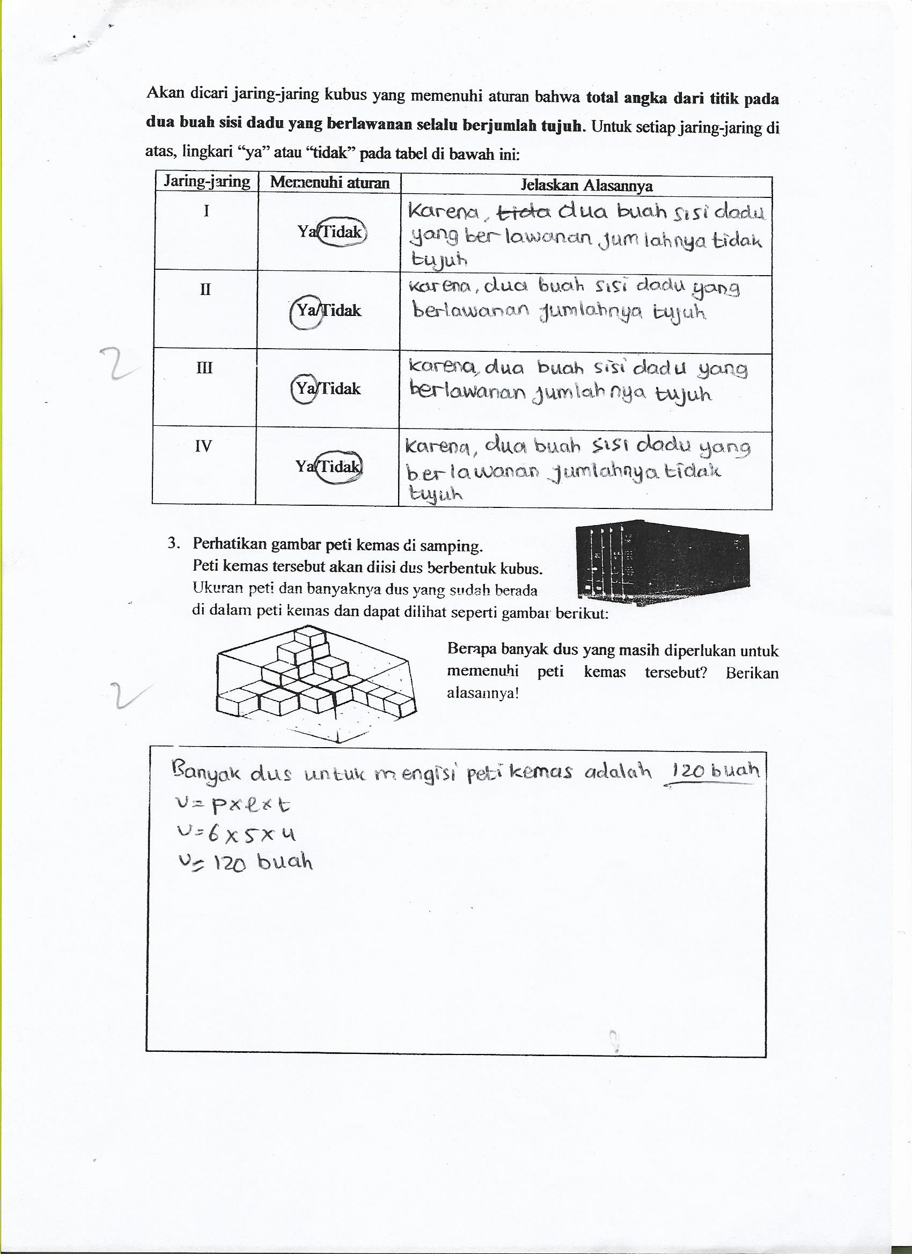

**Figure 6.** The Result of Pre-test

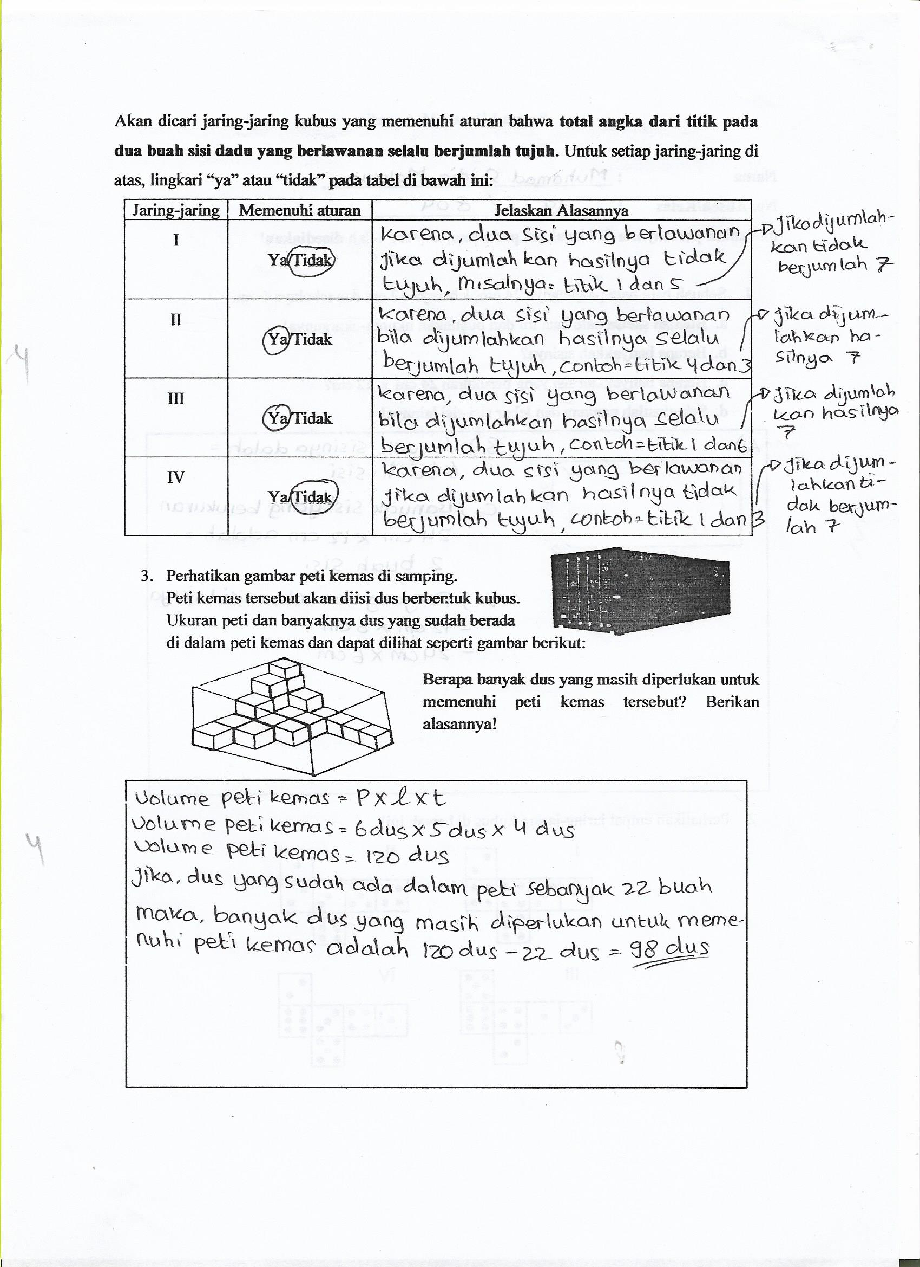

**Figure 7.** The Result of Post-test

Referring to Figure 6, in the results of the pre-test, students write120 pieces as the number of boxes to fill into the container based on. However, in the post-test Figure 7, an increase was seen in determining the number of boxes already in the box and determining the final result of the number of boxes needed to fill the container. An example of an increase at the time of the post-test was, students wrote if there were as many boxes already in the box 22 pieces, the number of boxes still needed to fill the container is 120 boxes - 22 boxes = 98 boxes. Based on the dimensions of the cognitive process of bloom revision taxonomy, level 3 questions are the dimensions of applying (C.3.). This is because level 3 questions require students' ability to implement volume formulas and surface area of flat side space(Krathwohl, 2002, p. 215). The ability to apply turns out to be in harmony with higher levels of thinking according to Anderson and Krathwol(Aksela, 2005, p. 38).

1. **CONCLUSION AND SUGGESTIONS**

Based on the results of the quantitative analysis and the discussion in the previous description, it can be concluded into two conclusions, namely as follows:

First, increasing the mathematical literacy proficiency of students who get ICM learning is significantly better than students who get conventional learning when viewed from the high and medium BMP categories. This finding apparently did not occur in students with a low BMP category. Students who get ICM learning are not significantly better than students who get normal learning in the category when reviewed by BMP in the low category. The cause of this finding occurs because high and medium BMP students can maximize the stages of advocating on ICM learning so that the process of exchanging ideas, asking questions, and supporting each other in solving mathematical literacy problems can run optimally. Conversely, low BMP students apparently cannot maximize the advocating stage.

Second, there is no significant difference in the increase on mathematical literacy skills of students who get ICM learning when viewed from the high, medium, and low BMP categories. The second finding arises because the stages of locating, identifying, advocating, reformulating, and challenging in ICM learning supports the process of attributing students’ mathematical proficiency when learning new material. Although the statistical test results showed no difference, the average n-gain value actually showed an increase on mathematical literacy proficiency of students in the high BMP category which is higher than students in the moderate and low BMP categories.

The next findings are that the percentage of student achievement in solving level 6 of mathematical literacy questions is still low, it would be better to maximize the process of implementing the challenging stages of ICM learning through giving mathematical literacy problems which are more challenging and solved in groups. In addition, it is better to maximize students' proficiency to solve mathematical literacy problems from questions level 1 to level 5 firstly because level 6 are the highest level in mathematical literacy proficiency.

**ACKNOWLEDGEMENT**

I would like to thank seventy students of grade eight at one of state junior high school in Bandung, for their active participant.

**REFERENCES**

Aksela, M. (2005). *Learning and Teaching Resources Branch. Focus on Inquiry: A Teacher’s Guide to Implementing Inquiry-Based Learning. Alberta Learning*.

AlrØ, H., & Skovsmose, O. (2002). *Dialogue and Learning in Mathematics Education*. Kluwer Academic Publisher.

Barrouillet, P. (2015). Theories of cognitive development: From Piaget to today. *Developmental Review*, *38*, 1–12. https://doi.org/10.1016/j.dr.2015.07.004

Basaǵa, H., Geban, Ómer, & Tekkaya, C. (1994). The Effect of the Inquiry Teaching Method on Biochemistry and Science Process Skill Achievements. *Journal Biochemical Education*, *1*(22), 29–32.

Carey, S., Zaitchik, D., & Bascandziev, I. (2015). Theories of development: In dialog with Jean Piaget. *Developmental Review*, *38*, 36–54. https://doi.org/10.1016/j.dr.2015.07.003

Cooper, J. L., & Robinson, P. (2014). Using Classroom Assessment and Cognitive Scaffolding to Enhance the Power of Small-Group Learning. *Journal on Excellence in College Teaching*, *25*, 149–161.

De Lange, J. (2003). Quantitative Literacy: Why Numeracy Matters for Schools and Colleges. *National Council on Education and the Disciplines*, 75–89.

De Lange, J. (2006). Mathematical Literacy for Living from OECD-PISA perspective. *Tsukuba Journal of International Study in Mathematics*, *25*, 13–35.

Effendi, L. A. (2012). Pembelajaran Matematika dengan Metode Penemuan Terbimbing untuk Meningkatkan Kemampuan Representasi dan Pemecahan Masalah Matematis Siswa SMP. *JurnalPenelitian Pendidikan*, *2*(13).

Fani, T., & Ghaemi, F. (2011). Implications of Vygotsky’s Zone of Proximal Development (ZPD) in Teacher Education: ZPTD and Self-Scaffolding. *Journal Procedia-Social and Behavioral Sciences*, *29*, 1549–1554.

Hake, R. R. (1999). Analyzing change/gain scores. *Unpublished.[Online] URL: Http://Www. Physics. Indiana. Edu/\~ Sdi/AnalyzingChange-Gain. Pdf*, *16*(7), 1073–1080. http://www.ncbi.nlm.nih.gov/pubmed/22025883%5Cnhttp://scholar.google.com/scholar?hl=en&btnG=Search&q=intitle:ANALYZING+CHANGE/GAIN+SCORES#0%5Cnhttp://scholar.google.com/scholar?hl=en&btnG=Search&q=intitle:Analyzing+change/gain+scores#0

Hasibuan, H., & Irwan, M. (2014). Penerapan Metode Penemuan Terbimbing pada Pembelajaran Matematika Kelas XI IPA SMAN 1 Lubuk Alung. *Jurnal Pendidikan Matematika*, *1*(3), 38–44.

Howell, J. B., & Saye, J. W. (2017). Integrating theory and practice: Factors shaping elementary teachers׳ interpretation of an inquiry model for teaching social studies. *The Journal of Social Studies Research*. https://doi.org/10.1016/j.jssr.2017.04.003

Hsu, Y. S., Wang, C., & YZhang, W. X. (2016). Supporting Technology-Enhanced Inquiry through Metacognitive and Cognitive Prompts: Sequential Analysis of Metacognitive Actions in Response to Mixed Prompts. *Journal Computers in Human Behavior*.

Krathwohl, D. R. (2002). A Revision of Bloom ’ s Taxonomy : An overview. *Theory Info Practice*, *41*(4), 212–218. https://doi.org/10.1207/s15430421tip4104

Lestari, & Yudhanegara. (2017). *Penelitian Pendidikan Matematika*. Reflika Aditama.

Malasari, P. N., Herman, T., & Jupri, A. (2017). The Construction of Mathematical Literacy Problems for Geometry. *Journal of Physics: Conference Series*, *895*(1). https://doi.org/10.1088/1742-6596/895/1/012071

Meltzer, D. . (2002). *The relationship between mathematics preparation and conceptual learning gains in physics: a possible ìhidden variableî in diagnostic pretest scores*.

Muhonen, H., Rasku-Puttonen, H., Pakarinen, E., Poikkeus, A. M., & Lerkkanen, M. K. (2016). Scaffolding through Dialogic Teaching in Early School Classrooms. *Journal Teaching and Teacher Education*, *55*, 143–154.

OECD. (1 C.E.). PISA 2009 Results, Volume I, What students know and can do: Student performance in reading, mathematics and science. In *OECD Publishing*. OECD Publishing. http://ezproxy.lib.ucalgary.ca:2048/login?url=http://search.ebscohost.com/login.aspx?direct=true&db=eric&AN=ED518013&site=ehost-live

OECD. (2003). The PISA 2003 Assessment Framework: Mathematics, Reading, Science and Problem Soloving Knowledge and Skills. In *Oecd*. OECD Publishing. https://doi.org/10.1787/9789264101739-en

OECD. (2007). *PISA 2006: Science Competencies for Tomorrow’s World*. OECD Publishing.

OECD. (2015). *PISA 2015 Draft Mathematics Framework*.

OECD. (2016a). *Assassement and Analytical framework: Mathematics, Reading, Science, Problem Solving and Financial Literacy.* OECD Publishing.

OECD. (2016b). *PISA 2015 Result and Focus*.

OECD. (2016c). *PISA 2015 Result In Focus (Paris OECD)*. OECD Publishing.

OECD. (2019). PISA 2018 insights and interpretations. In *OECD Publishing*. OECD Publishing. https://www.oecd.org/pisa/PISA 2018 Insights and Interpretations FINAL PDF.pdf

Oesterdiekhoff, G. W. (2016). Is a forgotten subject central to the future development of sciences? Jean Piaget on the interrelationship between ontogeny and history. *Personality and Individual Differences*, *98*, 118–126. https://doi.org/10.1016/j.paid.2016.03.098

Ojose, B. (2011). Mathematics Literacy: Are We Able to Put the Mathematics We Learn into Everyday Use? Journal of Mathematics Education. *Journal of Mathematics Education*, *41*, 89–100.

*PISA 2015 Mathematics Framework*. (2017). OECD Publishing. https://doi.org/10.1787/9789264281820-5-en

Pujiastuti, H., Kusumah, Y. S., Sumarmo, U., & Dahlan, J. A. (2014). Inquiry Co-operation Model for Enhancing Junior High School Students’ Mathematical Problems Solving Ability. *Journal of Contemporary Educational Research*, *1*(1), 51–60.

Purwatiningsi, S. (2014). Penerapan Metode Penemuan Terbimbing untuk Meningkatkan Hasil Belajar Siswa pada Materi Luas Permukaan dan Volume Balok. *Jurnal Elektronik Pendidikan Matematika Tadulako*, *1*(1).

Ruseffendi, H. E. . (1991). *Pengantar Kepada Membantu Guru Mengembangkan Kompetensinya dalam Pengajaran Matematika untuk Meningkatkan CBSA*. Tarsito.

Ruseffendi, H. E. . (2010). *Dasar-Dasar Penelitian Pendidikan dan Bidang Non-Eksakta Lainnya*. Tarsito.

Santrock, J. W. (2014). *Perkembangan Masa Hidup*. Erlangga.

Shooshtari, Z. G., Oshtari, Z. G., & Mir, F. (2014). ZPD, Tutor; Peer Scaffolding: Sociocultural Theory in Writing Strategies Application. *Journal Procedia - Social and Behavioral Sciences,* *98*, 1771–1776.

Stiles, W. B., & Caro, G. E. (2016). Exceeding the Therapeutic Zone of Proximal Development as a Clinical Error. *Journal Psychotherapy*, *3*(53), 268.

Stoilescu, D. (2016). Aspects of Theories, Frameworks and Paradigms in Mathematics Education Research. *European Journal of Science and Mathematics Education,* *2*(4), 140–154.

Takaya, K. (2008). Jerome Bruner’s Theory of Education: From Early Bruner to Later Bruner. *Journal Interchange*, *1*(39), 1–19.

Wulandari, I. C., Turmudi, & Hasanah, A. (2015). Studi Cross-Sectional Tingkat KemampuanLiterasiMatematisSiswaSekolahMenengahPertama di Bandung BerdasarkanPengujianSoal Pisa. *JurnalLingkarWidyaiswara*, *3*(2), 10–25.

Yang, X. (2012). What Constitutes Good Mathematics Teaching in Mainland China: Perspectives from Nine Junior Middle School Teachers. *Journal of Mathematics Education*, *1*(5), 77–96.

Zhang, H., & Whitebread, D. (2017). Linking Parental Scaffolding with Self-Regulated Learning in Chinese Kindergarten Children. *Journal Learning and Instruction*, *49*, 121–130.