Supplementary Files

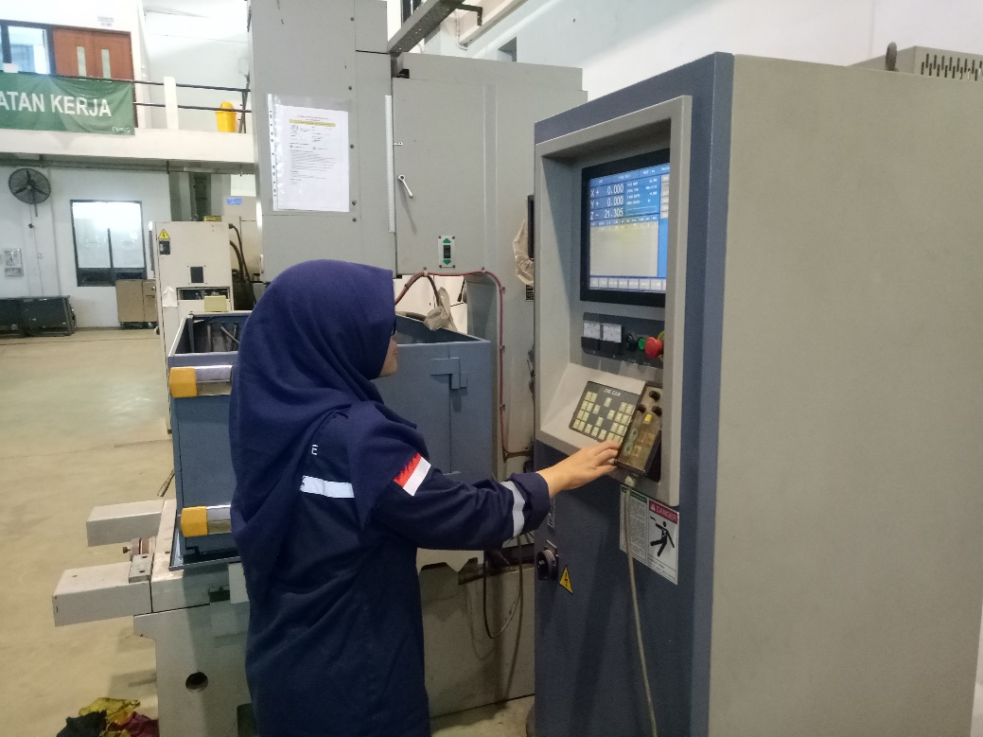
Figure 1. Experiment 1
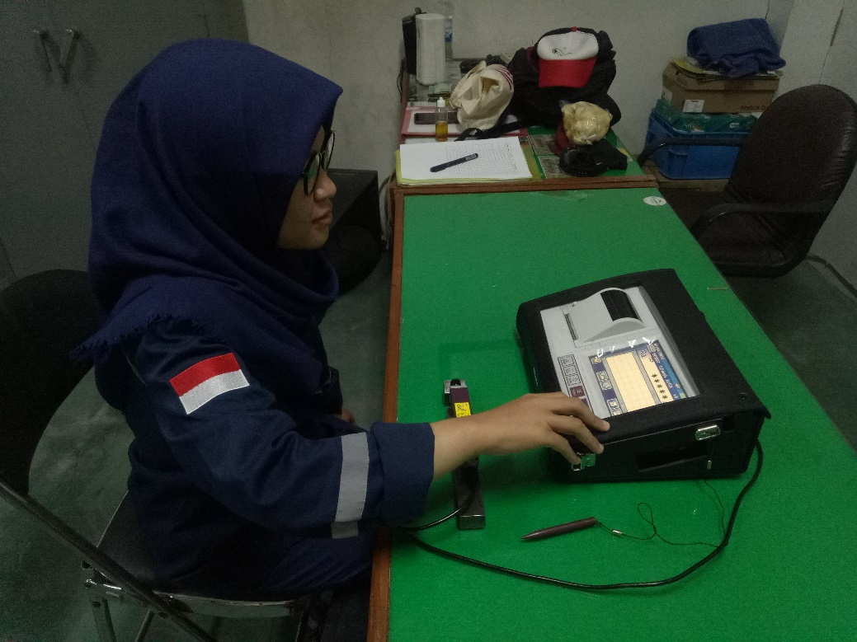
Figure 2. Roughness testing
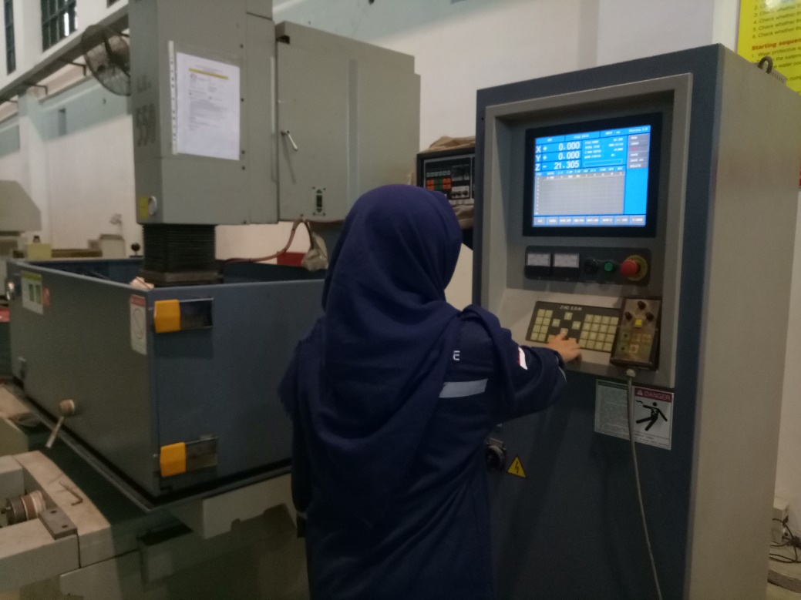
Figure 3. Experiment Validation

Surface roughness test results
Replication Experiments 1
Komb | Horizontal |  | Vertikal |  | Diagonal (45°) |  | Diagonal (-45°) |  | Mean
Komb | R1 | R2 | R1 | R2 | R1 | R2 | R1 | R2 | Mean
1 | 6.006 | 6.067 | 4.049 | 4.059 | 5.651 | 5.666 | 4.372 | 4.411 | 5.035
2 | 4.736 | 4.295 | 4.674 | 4.669 | 4.857 | 4.916 | 4.849 | 4.820 | 4.727
3 | 5.021 | 5.031 | 4.493 | 4.483 | 4.941 | 4.791 | 3.918 | 3.630 | 4.539
4 | 4.506 | 4.853 | 4.520 | 4.470 | 4.628 | 4.557 | 4.852 | 4.860 | 4.656
5 | 3.818 | 3.884 | 4.909 | 4.996 | 3.447 | 3.481 | 4.386 | 4.355 | 4.160
6 | 4.113 | 4.159 | 4.563 | 4.497 | 4.785 | 4.757 | 4.786 | 4.824 | 4.561
7 | 4.485 | 4.490 | 3.986 | 3.979 | 4.588 | 4.511 | 4.689 | 4.683 | 4.426
8 | 5.387 | 5.402 | 4.099 | 4.067 | 6.079 | 6.057 | 4.839 | 4.819 | 5.094
9 | 3.302 | 3.317 | 3.602 | 3.650 | 4.863 | 4.883 | 3.176 | 3.297 | 3.761
10 | 3.972 | 3.979 | 3.145 | 3.167 | 4.072 | 4.064 | 3.774 | 3.737 | 3.739
11 | 4.277 | 4.281 | 4.296 | 4.258 | 4.327 | 4.330 | 3.710 | 3.717 | 4.150
12 | 2.177 | 2.172 | 2.572 | 2.561 | 2.157 | 2.174 | 1.808 | 1.779 | 2.175
13 | 4.012 | 4.037 | 4.336 | 4.358 | 3.798 | 3.789 | 3.772 | 3.783 | 3.986
14 | 3.922 | 3.951 | 3.757 | 3.761 | 3.606 | 3.552 | 4.110 | 4.108 | 3.846
15 | 1.570 | 1.576 | 1.793 | 1.789 | 2.544 | 2.538 | 1.433 | 1.429 | 1.834
16 | 2.928 | 2.935 | 3.584 | 3.580 | 4.916 | 5.183 | 3.672 | 3.651 | 3.806
17 | 4.169 | 4.189 | 3.985 | 3.968 | 4.203 | 4.235 | 3.688 | 3.678 | 4.014
18 | 2.552 | 2.535 | 2.435 | 2.434 | 2.691 | 2.687 | 2.995 | 2.992 | 2.665

Replication Experiments 2
Komb | Horizontal |  | Vertikal |  | Diagonal (45°) |  | Diagonal (-45°) |  | Mean
Komb | R1 | R2 | R1 | R2 | R1 | R2 | R1 | R2 | Mean
1 | 4.639 | 4.633 | 4.242 | 4.359 | 5.548 | 5.528 | 4.187 | 4.167 | 4.663
2 | 4.050 | 4.124 | 5.464 | 5.467 | 5.074 | 5.091 | 5.020 | 5.016 | 4.913
3 | 4.119 | 4.134 | 3.470 | 3.429 | 3.986 | 4.077 | 4.431 | 4.202 | 3.981
4 | 5.102 | 4.923 | 4.732 | 4.733 | 4.583 | 4.785 | 4.351 | 4.408 | 4.702
5 | 3.940 | 3.892 | 5.524 | 5.528 | 4.751 | 4.822 | 4.309 | 4.335 | 4.638
6 | 3.512 | 3.277 | 5.033 | 5.017 | 3.844 | 3.786 | 4.318 | 4.246 | 4.129
7 | 5.922 | 5.876 | 4.765 | 4.771 | 4.645 | 4.633 | 3.369 | 3.508 | 4.686
8 | 5.371 | 5.301 | 3.772 | 3.774 | 4.590 | 4.506 | 4.134 | 4.083 | 4.441
9 | 3.875 | 3.883 | 4.668 | 4.552 | 3.712 | 3.705 | 3.436 | 3.442 | 3.909
10 | 4.853 | 4.963 | 3.909 | 3.924 | 4.479 | 4.291 | 3.661 | 3.691 | 4.221
11 | 1.841 | 1.846 | 2.932 | 2.937 | 1.745 | 1.751 | 2.827 | 2.828 | 2.338
12 | 1.886 | 1.888 | 3.660 | 3.581 | 2.916 | 2.895 | 1.587 | 1.559 | 2.497
13 | 4.942 | 4.789 | 3.664 | 3.657 | 3.127 | 3.091 | 3.738 | 3.718 | 3.841
14 | 3.771 | 3.767 | 4.532 | 4.436 | 3.503 | 3.487 | 4.463 | 4.464 | 4.053
15 | 1.909 | 1.912 | 1.890 | 1.905 | 2.008 | 2.013 | 2.110 | 2.151 | 1.987
16 | 5.860 | 5.844 | 3.970 | 3.962 | 3.744 | 3.733 | 4.399 | 4.400 | 4.489
17 | 3.559 | 3.363 | 3.350 | 3.448 | 2.428 | 2.435 | 3.643 | 3.667 | 3.237
18 | 2.865 | 2.817 | 3.732 | 3.669 | 2.764 | 2.774 | 2.363 | 2.370 | 2.919

Ratio S/N Roughness testing

