Multivariate Control Chart based on Neutrosophic Hotelling T2 Statistics and Its Application
Wibawati¹, Ahsan, M², Khusna, H³, Marita, QN⁴ , Wilda, U⁴
^{1,2,3,4,5.}Departement of Statistics, Institut Teknologi Sepuluh Nopember, Indonesia
wibawati@statistika.its.ac.id, muh.ahsan@its.ac.id, hidayatul@its.ac.id, mrtndyh23@gmail.com, wilda.udiatami@gmail.com

 |  | ABSTRACT
Article History:  Received : D-M-20XX  Revised : D-M-20XX  Accepted : D-M-20XX  Online : D-M-20XX |  | The Hotelling${ T}^{2}$control chart commonly used to monitor mean proses simultaneously of more than one interrelated quality characteristics observations. The data of quality characteristics in Hotelling ${ T}^{2}$ control chart can be in a subgroup of the data can be individual observation. Under classical statistics, this chart is applied when the observations of quality characteristics are precise, exact, or crips data. Actually, under uncertain conditions, the observations are not necessarily precise, exact, or indeterminacy. Classical Hotelling${ T}^{2}$control chart is not appropriate to monitor the process for this condition. To handle this situation, we proposed new Hotelling ${ T}^{2}$ monitoring scheme based on a fuzzy neutrosophic concept. The proposed Hotelling ${ T}^{2}$ statistics, its call Hotelling ${ T}^{2}$ $\left(T_{N}^{2}\right)$ control chart. This chart involves the indeterminacy of observations, its call neutrosophic data and will be expressed in the indeterminacy interval. In this paper, the neutrosophic Hotelling $T^{2}$will be applied to individual observations of glass production and will be compared by using classical Hotelling $T^{2}$ control chart. From the comparison, it concluded that the neutrosophic Hotelling $T^{2}$ control chart is more suitable for the indeterminacy of observations
Keyword:
quality;
control chart;
multivariate;
T2 Hotelling;
neutrosophic

https://doi.org/10.31764/jtam.vXiY.ZZZ |  |  | This is an open access article under the CC–BY-SA license

—————————— ——————————

- INTRODUCTION
A control chart is one of most the famous tools to monitor the process. Generally, there are two categories of control charts based on the types of quality characteristics: variable control chart and attribute control chart. Both of these charts, based on the number of monitored quality characteristics consist of a univariate control chart and multivariate control chart. Univariate control chart used to monitor the single quality characteristics. $\overline{X}-R,$ is one of the most popular univariate control charts. Hotelling ${ T}^{2}$ a control chart is one of the tools that widely used to monitor the multivariate process. The multivariate control chart is used to monitor the process simultaneously of two or more interrelated quality characteristics (Montgomery, 2020). The classical Hotelling ${ T}^{2}$ control chart suitable to monitor when all data observations are crips and precise.
In manufacture, we often meet the data observations, not price, or vague. In this case classical Hotelling ${ T}^{2}$ control chart not suitable to use. To handle the condition control chart-based fuzzy logic proposed by Zadeh (1965). Several researchers have developed fuzzy attribute control chart; fuzzy p control chart and the extension (Pandian & Puthiyanayagam, 2013) (Sogandi et al., 2014) (Shabani & Rezayian, n.d.), fuzzy c and u control chart (Darestani et al., 2014) (Fadaei & Pooya, 2018) (Ercan-Teksen & Anagün, 2020) (Ercan-Teksen & Anagün, 2018). Meanwhile, the fuzzy variable control charts; X-Individual fuzzy control chart (Gildeh & Shafiee, 2015) (Moraditadi & Avakhdarestani, 2016a) (Alizadeh & Ghomi, 2011) (Moraditadi & Avakhdarestani, 2016b) and fuzzy EWMA and CUSUM and also the performance (Wang & Hryniewicz, 2013) (Göztok et al., 2021) (Erginel & Şentürk, 2016). And the development of fuzzy multivariate control charts: (Ghobadi et al., 2014) (Ghobadi et al., 2015) (Pastuizaca Fernández et al., 2015) (Mashuri, 2020).
The other approach to monitoring the unprecise data neutrosophic can be used. Neutrosophic is an extension of fuzzy logic (Smarandache, 2014). The logic of neutrosophic is considered indeterminacy in the measurement. However, based on literature reviews, the neutrosophic control chart is still limited. The neutrosophic control charts that have been developed are neutrosophic $\overline{X}$ (Aslam & Khan, 2019), neutrosophic $S$ chart (Khan, Gulistan, Chammam, et al., 2020) (Khan, Gulistan, Hashim, et al., 2020), neutrosophic Exponentially Weighted Moving Average (NEWMA) $X$ (Aslam et al., 2019). Among these charts is the univariate control chart. Meanwhile, we are often interested to monitor multivariate processes that involve the indeterminacy of observations. Recently, Aslam introduced Hotelling ${ T}^{2}$ statistics under neutrosophic statistics (Aslam & Arif, 2020). The new statistics are the generalization of classical statistics under uncertainty conditions. This procedure is applied to chemical data. Based on comparison with classical Hotelling ${ T}^{2}$ statistics, the proposed method is more effective. Therefore in this paper proposed new Hotelling ${ T}^{2}$ monitoring scheme based on fuzzy neutrosophic concept and it call neutrosophic Hotelling ${ T}^{2}$ $\left(T_{N}^{2}\right)$ control chart. The proposed chart will be applied at spesific glass production and will be compared with the classical Hotelling ${ T}^{2}$ control chart.

- METHODS
To derive the propose chart several methods are needed.
- Neutrosophic Hotelling $T_{N}^{2}$ Statistics
If $x_{jkN}ϵ\left[x_{jkL},x_{jkU}\right]$ be a random variable of neutrosophic that represents neutrosophic observation for kth variable and jth observations. This interval expresses the indeterminacy, $x_{jkL}$ show the smallest value and $x_{jkU}$ is the largest value. Based on this form $x_{jkL}$ is a part of determinate and pa oart of indeterminate is $x_{jkU}I_{N}$, where $I_{N}ϵ\left[I_{N]L},I_{U}\right]$ and it can be stated as If $x_{jkN}=x_{jkL}+x_{jkU}I_{N}.$ If $x_{N}ϵ\left[n_{L},n_{U}\right]$ are observations of neutrosophic from neutrosophic variable $p_{N}ϵ\left[p_{L},p_{U}\right]$ .
- $X_{N}ϵ\left[\left[\begin{matrix}x_{11L} & ⋯ & \begin{matrix}x_{1kL} & ⋯ & x_{1pL}\end{matrix} \\ x_{j1L} & ⋯ & \begin{matrix}x_{j1L} & ⋯ & x_{jpL}\end{matrix} \\ x_{n1L} & ⋯ & \begin{matrix}x_{nkL} & ⋯ & x_{npL}\end{matrix}\end{matrix}\right],\left[\begin{matrix}x_{11U} & ⋯ & \begin{matrix}x_{1kU} & ⋯ & x_{1pU}\end{matrix} \\ x_{j1U} & ⋯ & \begin{matrix}x_{j1U} & ⋯ & x_{jpU}\end{matrix} \\ x_{n1L} & ⋯ & \begin{matrix}x_{nkU} & ⋯ & x_{npU}\end{matrix}\end{matrix}\right]\right];X_{N}$ (1)
The form of neutrosophic $X_{N}ϵ\left[X_{L},X_{U}\right]$ can be shown as
- $X_{N}=X_{L}+X_{U}I_{N};I_{N}ϵ\left[I_{L},I_{U}\right]$ (2)
The neutrosophic sample mean is presented by
- ${\overline{x}}_{kN}ϵ\left[\left[\frac{1}{n_{L}}\sum_{j=1}^{n_{L}}{x_{jkL}}\right],\left[\frac{1}{n_{U}}\sum_{j=1}^{n_{U}}{x_{jkU}}\right]\right];{\overline{x}}_{kN}ϵ\left[{\overline{x}}_{kL},{\overline{x}}_{kU}\right],$ (3)
where ${\overline{x}}_{kN}$ can be presented as ${\overline{x}}_{kN}={\overline{x}}_{kL}+{\overline{x}}_{kU}I_{N};I_{N}ϵ\left[I_{L},I_{U}\right]$.
The form of the neutrosophic sample variance is
- $s_{kN}^{2}ϵ\left[\left[\frac{1}{n_{L}}\sum_{j=1}^{n_{L}}{{\left(x_{jkL}-{\overline{x}}_{kL}\right)}^{2}}\right],\left[\frac{1}{n_{U}}\sum_{j=1}^{n_{U}}{{\left(x_{jkU}-{\overline{x}}_{kU}\right)}^{2}}\right]\right];s_{kN}^{2}ϵ\left[s_{kL}^{2},s_{kU}^{2}\right]$ , (4)
where $s_{kN}^{2}=s_{kL}^{2}+s_{kU}^{2}I_{N};I_{N}ϵ\left[I_{L},I_{U}\right].$
The formula of neutrosophic Covariance is:
- $S_{ikN}ϵ\left[\left[\frac{1}{n_{L}}\sum_{j=1}^{n_{L}}{\left(x_{jiL}-{\overline{x}}_{kL}\left(\left(x_{jkL}-{\overline{x}}_{kL}\right)\right)\right)}\right],\left[\frac{1}{n_{U}}\sum_{j=1}^{n_{U}}{\left(x_{jiU}-{\overline{x}}_{kU}\left(\left(x_{jkU}-{\overline{x}}_{kU}\right)\right)\right)}\right]\right];$(5)
where :
$S_{ikN}ϵ\left[S_{ikL},S_{ikU}\right],$ and
$S_{ikN}=S_{ikL}+S_{ikU}I_{N};I_{N}ϵ\left[I_{L},I_{U}\right].$
The Statistics neutrosophic $T^{2}$ Hotelling is :
$T_{N}^{2}=\left[{\left({\overline{X}}_{L}-μ_{0L}\right)}^{'}{\left(\frac{1}{n_{L}}S_{L}\right)}^{-1}\right]\left({\overline{X}}_{L}-μ_{0L}\right),{\left({\overline{X}}_{U}-μ_{0U}\right)}^{'},{\left(\frac{1}{n_{U}}S_{U}\right)}^{-1}\left({\overline{X}}_{U}-μ_{0U}\right);T_{N}^{2}∈\left[T_{L}^{2},T_{U}^{2}\right],$ (6)
where
- $T_{N}^{2}=T_{L}^{2}+T_{U}^{2}I_{N};I_{N}ϵ\left[I_{L},I_{U}\right].$
- $T_{N}^{2}\sim \frac{\left(n_{N}-1\right)}{\left(n_{N}-р_{N}\right)}F_{р_{N},\left(n_{N}-р_{N}\right)};T_{N}^{2}ϵ\left[T_{L}^{2},T_{U}^{2}\right].$
These statistics can be applied for testing hypothesis.

- Classical Hotelling ${ T}^{2}$ Control Chart
The classical Hotelling ${ T}^{2}$ control chart widely used d to monitor mean proses simultaneously of more than one interrelated quality characteristics observations. This chart was proposed by Harold Hotelling, 1947 (Montgomery, 2020). The classical Hotelling ${ T}^{2}$ control chart can be used to monitor both of subgroup and individual obeservation. The statisics of Hotelling ${ T}^{2}$ chart for individual as follows.
${ T}^{2}={\left(x-\overline{x}\right)}^{'}S^{-1}\left(x-\overline{x}\right).$ (7)
Let $p$ is the number of quality characteristics, suppose we have $m$ sample, each sample consist $n=1$. The Control limits of statistic ${ T}^{2}$ the control chart is (Montgomery, 2020)
Upper control limit (UCL)
$UCL =\frac{{(m-1)}^{2}}{m}β_{α;β/2(m-p-10/2}$ (8)
and Lower control limit (LCL),
$LCL= 0$.
The process is in control if all the points fall between control limits.

- RESULT AND DISCUSSION
      - Neutrosophic Hotelling ${ T}^{2}(T_{N}^{2})$ Control Chart
In this part, we discuss the new Hotelling ${ T}^{2}$ monitoring scheme based on a fuzzy neutrosophic concept. Control charts and hypothesis testing have a close relationship. A point plotting within the control limits is the same as failing to reject the statistical control hypothesis, whereas a point plotting outside the control limits is the same as rejecting the statistical control hypothesis. The statistics in this new chart is obtained by combining classical Hotelling ${ T}^{2}$ control chart and neutrosophic Hotelling ${ T}^{2}$ statistic ($T_{N}^{2} )$ which was proposed by Aslam (Aslam & Arif, 2020). Let $p_{N}ϵ\left[p_{L},p_{U}\right]$ is the number of quality characteristics and the data matrix $X_{N}ϵ\left[X_{L},X_{U}\right]$ , suppose we have $m$ sample with individual observation. The statistics of neutrosophic Hotelling ${ T}^{2}(T_{N}^{2})$Control Chart is given by :
$T_{N}^{2}=\left[{\left({\overline{X}}_{L}-μ_{0L}\right)}^{'}{\left(S_{L}\right)}^{-1}\right]\left({\overline{X}}_{L}-μ_{0L}\right),{\left({\overline{X}}_{U}-μ_{0U}\right)}^{'},{\left(S_{U}\right)}^{-1}\left({\overline{X}}_{U}-μ_{0U}\right),$ (9)
$$T_{N}^{2}∈\left[T_{L}^{2},T_{U}^{2}\right],$$
where $μ_{0L}$ and $μ_{0U}$ are target.
Based on equation (9), the proposed chart consists of two charts, namely lower $T_{N}^{2}$control chart and upper $T_{N}^{2}$control chart. The control limits of the proposed chart are as follows:
- ${UCL}_{N}=\frac{p_{N}{(m-1)}^{2}}{m}β_{α;β/2(m-p_{N}-10/2}$ and ${LCL}_{N}= 0$. (10)
The process is in control if all the points fall between control limits (${UCL}_{N}$ and ${LCL}_{N}$).

- Numerical Example
The application of neutrosophic hotelling $T_{N}^{2}$Control Chart using data from Quality Control division for quality characteristics of glass production. There are two quality characteristics such as Cutter line $(X_{1N})$ and Edge Distorsion $(X_{2N})$. The target of the cutter is 115 mm and the Edge distortion is 40 mm. The form of the data can be seen in Table 1.
Based on these data we find the neutrosophic mean sample are ${\overline{x}}_{1N}ϵ\left[132.76,151.03 \right]$ and ${\overline{x}}_{2N}ϵ\left[30.61,37.27 \right]$, and the neutrosophic covariance sample ($s_{N}^{2})$ is
$$s_{N}^{2}=\left(\begin{matrix}\begin{matrix}150.56 & 43.23 \\ 43.23 & 127.22\end{matrix} & \begin{matrix}60.40 & 38.01 \\ 69.95 & 65.84\end{matrix} \\ \begin{matrix}60.40 & 69.95 \\ 38.01 & 65.84\end{matrix} & \begin{matrix}107.99 & 90.55 \\ 90.55 & 95.33\end{matrix}\end{matrix}\right)$$
By using equation (9) and equation (10) we calculate neutrosophic Hotelling ${ T}^{2}$ statistic (see Table 2) and the control limits are ${LCL}_{N}=2.23$, ${UCL}_{N}=24.63$. The result of the neutrosophic hotelling $T_{N}^{2}$Control Chart as shown in Figure 1.

Table 1. The neutrosophic data of the cutter and Edge distortion
Subgroup | Cutter line |  | Edge distortion |  | Subgroup | Cutter line |  | Edge distortion
 | $$X_{1NL}$$ | $$X_{1NU}$$ | $$X_{2NL}$$ | $$X_{2NU}$$ |  | $$X_{1NL}$$ | $$X_{1NU}$$ | $$X_{2NL}$$ | $$X_{2NU}$$
1 | 140 | 158 | 25 | 30 | 18 | 139 | 145 | 28 | 30
2 | 170 | 198 | 72 | 73 | 19 | 136 | 143 | 30 | 37
3 | 139 | 145 | 28 | 30 | 20 | 137 | 161 | 32 | 39
4 | 122 | 166 | 50 | 52 | 21 | 131 | 146 | 42 | 55
5 | 115 | 145 | 18 | 21 | 22 | 130 | 151 | 31 | 49
6 | 112 | 152 | 15 | 37 | 23 | 141 | 149 | 34 | 38
7 | 136 | 143 | 30 | 37 | 24 | 139 | 151 | 33 | 42
8 | 141 | 149 | 34 | 38 | 25 | 133 | 162 | 36 | 38
9 | 120 | 155 | 21 | 26 | 26 | 123 | 138 | 34 | 37
10 | 136 | 143 | 30 | 37 | 27 | 139 | 145 | 28 | 30
11 | 128 | 144 | 34 | 40 | 28 | 143 | 166 | 17 | 30
12 | 117 | 145 | 20 | 30 | 29 | 141 | 149 | 34 | 38
13 | 136 | 143 | 30 | 37 | 30 | 140 | 142 | 20 | 28
14 | 118 | 160 | 38 | 48 | 31 | 136 | 137 | 29 | 37
15 | 106 | 155 | 28 | 38 | 32 | 141 | 149 | 24 | 30
16 | 116 | 155 | 23 | 30 | 33 | 139 | 145 | 28 | 30
17 | 141 | 149 | 34 | 38

Table 2. The neutrosophic $T_{N}^{2}$statistic of the cutter and Edge distortion
Subgroup | $$T_{NL}^{2}$$ | $$T_{NU}^{2}$$ | Subgroup | $$T_{NL}^{2}$$ | $$T_{NU}^{2}$$
1 | 17.85 | 31.75 | 18 | 13.22 | 15.63
2 | 33.02 | 56.13 | 19 | 14.87 | 17.73
3 | 14.87 | 17.73 | 20 | 11.11 | 11.33
4 | 0.90 | 24.34 | 21 | 10.86 | 27.21
5 | 5.65 | 26.07 | 22 | 3.55 | 7.51
6 | 6.33 | 19.08 | 23 | 6.43 | 11.95
7 | 11.11 | 11.33 | 24 | 13.22 | 15.63
8 | 13.22 | 15.63 | 25 | 11.99 | 15.04
9 | 6.00 | 32.22 | 26 | 6.28 | 29.22
10 | 11.11 | 11.33 | 27 | 2.12 | 7.89
11 | 4.19 | 10.50 | 28 | 14.87 | 17.73
12 | 5.32 | 17.73 | 29 | 27.83 | 42.48
13 | 11.11 | 11.33 | 30 | 13.22 | 15.63
14 | 0.27 | 20.20 | 31 | 21.74 | 16.64
15 | 1.35 | 21.38 | 32 | 11.66 | 7.28
16 | 3.64 | 28.14 | 33 | 19.61 | 21.59
17 | 17.85 | 31.75

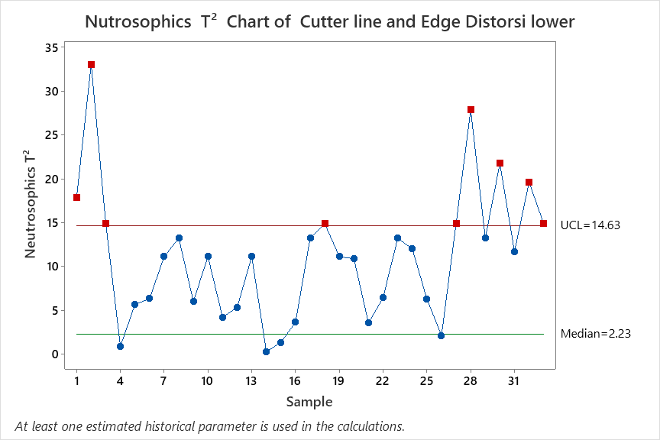 | 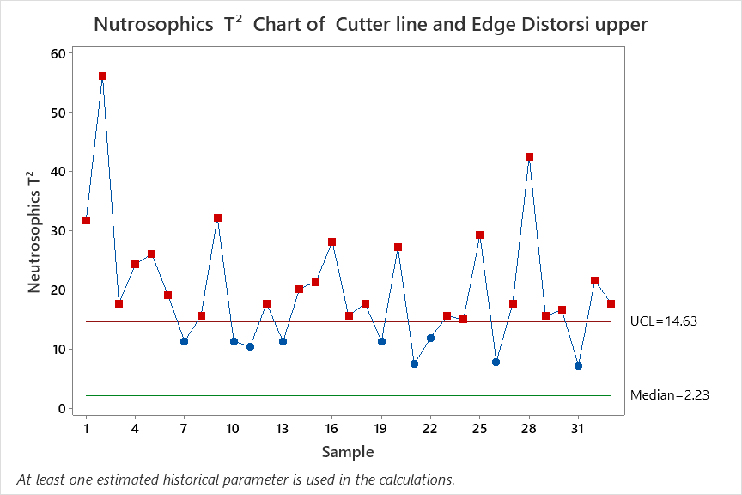
Figure 1. The neutrophil hotelling $T_{N}^{2}$ Control Chart
In Figure 1, the visualization of the neutrosophic hotelling $T_{N}^{2}$ control chart, indicate the process mean of glass production is out of control. 9 points fall outside of ${UCL}_{N}$ of lower control chart and in the upper control chart closed to 73% of data outside from ${UCL}_{N}$. In the next step, we compare the neutrosophic hotelling $T_{N}^{2}$ control chart with the classical Hotelling $T^{2}$ control chart, see Figure 2. This figure shows the process mean of glass production is also out of control, but by using the classical method, just one point falls outside ${UCL}_{N}$. Therefore based on this case the neutrosophic hotelling $T_{N}^{2}$ control chart is more sensitive than with the classical hotelling $T^{2}$ control chart

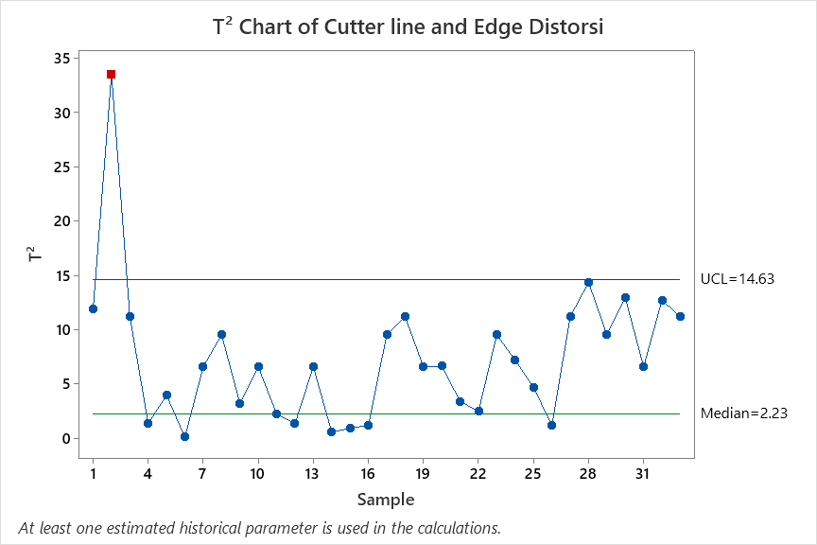
. Figure 2. The Classical Hotelling $T^{2}$ control Chart

- CONCLUSION AND SUGGESTIONS
The statistics of new Hotelling ${ T}^{2}$ monitoring scheme based on the fuzzy neutrosophic concept is obtained from a combination of neutrosophic hotelling $T_{N}^{2}$ statistic and classical Hotelling $T^{2}$ control chart. This chart is appropriate for indeterminacy data. The proposed chart consists of two charts, namely lower $T_{N}^{2}$control chart and upper $T_{N}^{2}$control chart. Based on the case study the proposed chart is more sensitive than the classical Hotelling $T^{2}$ control chart. The performance evaluation of $T_{N}^{2}$control chart can be considered for future research

ACKNOWLEDGEMENT
This paper was supported by Institut Teknologi Sepuluh Nopember, Indonesia, under Grand No. 1854/PKS/ITS/2021. The authors, gratefully acknowledge for the financial support

REFERENCES
Alizadeh, H. M., & Ghomi, S. (2011). Fuzzy development of Mean and Range control charts using statistical properties of different representative values. Journal of Intelligent & Fuzzy Systems, 22(5, 6), 253–265.
Aslam, M., AL-Marshadi, A. H., & Khan, N. (2019). A new X-bar control chart for using neutrosophic exponentially weighted moving average. Mathematics, 7(10), 957.
Aslam, M., & Arif, O. H. (2020). Multivariate analysis under indeterminacy: An application to chemical content data. Journal of Analytical Methods in Chemistry, 2020.
Aslam, M., & Khan, N. (2019). A new variable control chart using neutrosophic interval method-an application to automobile industry. Journal of Intelligent & Fuzzy Systems, 36(3), 2615–2623.
Darestani, S. A., Tadi, A. M., Taheri, S., & Raeiszadeh, M. (2014). Development of fuzzy U control chart for monitoring defects. International Journal of Quality & Reliability Management.
Ercan-Teksen, H., & Anagün, A. S. (2018). Interval type-2 fuzzy c-control charts using likelihood and reduction methods. Soft Computing, 22(15), 4921–4934.
Ercan-Teksen, H., & Anagün, A. S. (2020). Intuitionistic fuzzy c-control charts using defuzzification and likelihood methods. Journal of Intelligent & Fuzzy Systems, Preprint, 1–9.
Erginel, N., & Şentürk, S. (2016). Fuzzy EWMA and fuzzy CUSUM control charts. In Fuzzy Statistical Decision-Making (pp. 281–295). Springer.
Fadaei, S., & Pooya, A. (2018). Fuzzy U control chart based on fuzzy rules and evaluating its performance using fuzzy OC curve. The TQM Journal.
Ghobadi, S., Noghondarian, K., Noorossana, R., & Mirhosseini, S. S. (2014). Developing a multivariate approach to monitor fuzzy quality profiles. Quality & Quantity, 48(2), 817–836.
Ghobadi, S., Noghondarian, K., Noorossana, R., & Mirhosseini, S. S. (2015). Developing a fuzzy multivariate CUSUM control chart to monitor multinomial linguistic quality characteristics. The International Journal of Advanced Manufacturing Technology, 79(9), 1893–1903.
Gildeh, B. S., & Shafiee, N. (2015). X-MR control chart for autocorrelated fuzzy data using D p, q-distance. The International Journal of Advanced Manufacturing Technology, 81(5), 1047–1054.
Göztok, K. K., Uçurum, M., & Özdemir, A. (2021). Development of a Fuzzy Exponentially Weighted Moving Average Control Chart with an α-level Cut for Monitoring a Production Process. Arabian Journal for Science and Engineering, 46(2), 1911–1924.
Khan, Z., Gulistan, M., Chammam, W., Kadry, S., & Nam, Y. (2020). A new dispersion control chart for handling the neutrosophic data. IEEE Access, 8, 96006–96015.
Khan, Z., Gulistan, M., Hashim, R., Yaqoob, N., & Chammam, W. (2020). Design of S-control chart for neutrosophic data: An application to manufacturing industry. Journal of Intelligent & Fuzzy Systems, Preprint, 1–9.
Mashuri, M. (2020). A Fuzzy Bivariate Poisson Control Chart. Symmetry, 12(4), 573.
Montgomery, D. C. (2020). Introduction to statistical quality control. John Wiley & Sons.
Moraditadi, A., & Avakhdarestani, S. (2016a). Development of fuzzy individual x and moving range control chart. International Journal of Productivity and Quality Management, 17(1), 82–103.
Moraditadi, A., & Avakhdarestani, S. (2016b). Development of fuzzy individual x and moving range control chart. International Journal of Productivity and Quality Management, 17(1), 82–103.
Pandian, S. S. A., & Puthiyanayagam, P. (2013). TRIANGULAR FUZZY MULTINOMIAL CONTROL CHART WITH VARIABLE SAMPLE SIZE USING [alpha]-CUTS. International Journal of Engineering Science and Technology, 5(3), 699.
Pastuizaca Fernández, M. N., Carrión García, A., & Ruiz Barzola, O. (2015). Multivariate multinomial T 2 control chart using fuzzy approach. International Journal of Production Research, 53(7), 2225–2238.
Shabani, A., & Rezayian, A. (n.d.). Fuzzy Based Approach for Monitoring P-Control Chart by Means of Α-Level Fuzzy Midrange.
Smarandache, F. (2014). Introduction to Neutrosophic Statistics. ArXiv, abs/1406.2000.
Sogandi, F., Mousavi, S. M., & Ghanaatian, R. (2014). An extension of fuzzy P-control chart based on a-level fuzzy midrange. Advanced Computational Techniques in Electromagnetics, 2014(2014).
Wang, D., & Hryniewicz, O. (2013). The design of a CUSUM control chart for LR-fuzzy data. 175–180.

