The Development of Islamic Context Learning Materials to Facilitate the Conceptual Understanding of Mathematics

 |  | ABSTRACT
Article History:  Received : D-M-20XX  Revised : D-M-20XX  Accepted : D-M-20XX  Online : D-M-20XX |  | This research was conducted to develop and produce Islamic context-based mathematic learning material. The presentation of Islamic context for pre-service mathematics teachers was intended to facilitate conceptual understanding. This learning material contains material for rank and root, ratio and scale, and material for flat shapes and spatial shapes. Furthermore, the material is developed through design research with the type of development research. The research steps include three stages, namely the preliminary research stage, the development or prototyping stage, and the assessment stage. The data were collected by filling out a learning material scoring scale by Education and Language expert and an Islamic Study expert. The quality criteria for learning material have valid results if the experts score it with excellent and valid categories. Thus, they do not need significant revision. Based on the research results, the quality of Islamic context-based mathematics learning material is classified into valid criteria at a percentage of 84% according to Mathematics Education experts and a percentage of 83.3% according to Education and Language experts and classified as an excellent category at a percentage of 94% according to Islamic Study expert.
Keyword:
Learning material;
Islamic context;
Conceptual understanding;
validation
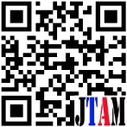

  https://doi.org/10.31764/jtam.vXiY.ZZZ |  |  | This is an open access article under the CC–BY-SA license

—————————— ——————————

- INTRODUCTION
Many studies revealed the importance of making learning more relevant to and interesting for students. This study is necessary since many students deem mathematics boring and containing complex concepts to understand. As revealed by the study conducted by Jablonka (2013) in 3 countries, German, Hong Kong, and the United States, students expressed their boredom by comparing mathematics with arts. According to some students, mathematics was boring since it was abstract, and it takes time to comprehend the mathematical language (Prediger, Erath, & Opitz, 2019). This boredom made students disinterested in mathematics, mainly for students with low achievement (Yeh et al., 2019). Indonesian students also assumed that learning mathematics could create fear in students (Mutohir et al., 2018), and such anxiety may affect pre-service teachers’ learning achievement (Novikasari, 2017). According to Zamansky and Zohar (2016), mathematics is deemed boring since it is irrelevant to daily life. Increasing students’ involvement in learning with scientific integration can increase students’ success.
Mathematics learning activity needs to be attractive to students and, on the other hand, increase learning success. According to Maass et al. (2019), mathematics learning quality can be increased by developing mathematics learning material integrated with other science, such as integration with the other subject. Quality learning material will guide students and teachers to achieve the learning objective desired by Ngware et al. (2015) and allow the student to learn (Fan, 2013). The study also shows a strong relationship between learning material and students’ success in mathematics (Törnroos, 2005). Learning materials in Indonesia need to be reviewed to examine their quality, as the study on mathematics textbooks at school by Yang and Sianturi (2017). The research compared textbooks in Indonesia and Singapore and showed that the Indonesian textbooks had a higher percentage of remembering and procedures without connection than Singaporean textbooks. Singaporean textbooks, meanwhile, were higher in the percentage of the procedure with connection and doing mathematics. The last two categories are of high cognitive ability levels.
Learning material is not only used at school but also in a higher education institution. Learning material always develops dynamically in line with knowledge development in mathematics education and government policy. There is, therefore, a possibility that the current year’s learning material is irrelevant to its use in the years to come. Critical teachers and lecturers are needed for the existing learning material, who can design materials to transform knowledge to enhance the quality of mathematics education. The improvement in mathematics education can be realized in school and teacher education.
Changes can be made at the higher education level by developing learning material mathematics for the student. Course activity can give valuable experience to students who will teach mathematical content since school students consider mathematics tedious and complex and college students (Rahman et al., 2020). The study by Tobias et al. (2010) shows that students in the first year of teacher education consider mathematics boring, and the mathematics at higher education institutions is not related to the mathematics at school. After taking a contextual-based course process, such students change in view and last changes later. According to Sinclair (2001), Hemmi and Ryve (2014), and Palinussa et al. (2021), contextual-based learning can support students’ interest in learning mathematics. Contextual-based learning by integrating Islam into mathematics learning can increase mathematical creativity (Abdillah et al., 2022).
The Mathematics Education study program, in consideration of the explanation above, needs to develop learning materials. In UIN Prof. K. H. Saifuddin Zuhri Purwokerto, especially the Mathematics Education study program, which is still new, was only opened in 2015. The study program’s learning materials are still limited and commonly use the learning materials used at other campuses, while one of the visions of Mathematics Education of UIN Prof. K. H. Saifuddin Zuhri Purwokerto is science and religion integration. Based on the researcher’s observation, all this time, there are not many learning materials at the higher education level that integrate mathematics with Islam. Islamic context-based learning material is expected to stimulate teacher education students to associate mathematical contents with Islamic context-based problems in daily life. Problems in daily life can contain, among others, the content of Al-Qur’an, Hadiths, worship practices, and events integrated with the existing concepts in mathematical contents. The integration is expected to enhance pre-service teacher students’ conceptual understanding. This conceptual understanding is essential, as revealed by the study conducted by Copur-Gencturk (2021), that teacher’s concept understanding will affect quality mathematics teaching. This research aimed at developing learning material mathematics which may facilitate pre-service mathematics teacher students’ conceptual understanding.

- METHODS
This research used a design research method with a development study type. This research consisted of three phases: preliminary research, development or prototyping, and assessment (Plomp, 2013). In the preliminary research phase, the researcher reviewed literature related to Islamic contents and mathematical contents in Mathematics Material Study for Junior High School subjects. Furthermore, the researchers connected the two contents to find a relationship between the Islamic context and mathematical content. In the second phase, the development or prototyping phase, learning material development would be validated and revised through an expert’s assessment. In the third phase, learning material intervention would be evaluated by pre-service teacher students through direct use of learning material in the Mathematics Education study program of UIN Prof. K.H. Saifuddin Zuhri. The last phase examined the learning material’s effectiveness in facilitating mathematical concept understanding.
This research used two data analysis techniques, quantitative and qualitative. The instrument shown to the experts and students was a questionnaire with questionnaires about learning material, visual design, and legibility of learning material. The data obtained from the questionnaire were analysed using a quantitative technique by calculating the percentage of questions given to the respondents. Meanwhile, the qualitative data used the scoring results, suggestions/recommendations, responses, criticism, and improvement.
The guideline in determining the validity to revise learning material in this research used scoring qualification criteria as follows:
Table 1 Scoring qualification
Percentage (%) | Validity Level | Description
90 – 100 | Highly valid | No Revision
80 – 89 | Valid | No Revision
65 – 79 | Adequately valid | Partially Revised
55 – 64 | Less valid | Revised
0 – 54 | Not valid | Totally Revised

The learning outcome through pretest and posttest examined the effectiveness of Islamic context-based mathematics learning material. N-Gain formula found learning outcome improvement.
The interpretation criteria were (Hake, 1999):
N-Gain is high if 0.7 ˂ g ≤ 1
N-Gain is moderate if 0.3 < g ≤ 0.7
N-Gain is low if 0 ˂ g ≤ 0.3.

- RESULT AND DISCUSSION
The preliminary research phase was carried out to examine the Islamic context related to the power and root, ratio and scale, and plane figure and solid figure materials for pre-service mathematics teacher students. This phase was a literature review on the Islamic and mathematical content. The research then found that Islamic context-based learning effectively improved mathematical concept understanding. As in the previous study by Ulpah and Novikasari (2020), the researcher followed this success by developing learning materials of other mathematical contents. Based on the literature study, preliminary research results, and upon discussion with the mathematic education lecturer, the researcher obtained the initial prototype of Islamic context-based mathematics learning.
The initial prototype contained Islamic context-based power and root, ratio and scale, and plane figure and solid figure materials. Below is an illustration of the Islamic context in mathematics learning.

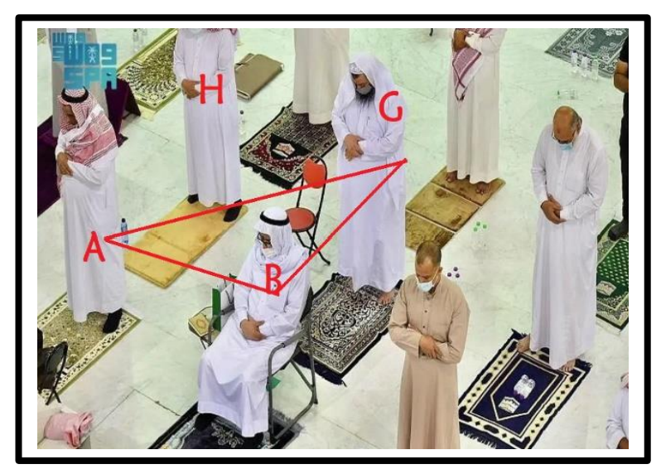
Figure 1 Islamic Context in Power Learning Material

The Islamic context presented in the learning material served as a way for students to construct their knowledge independently. This context was a concrete representation to reach abstract mathematical knowledge. Figure 1 presents the semi-concrete representation as follows.
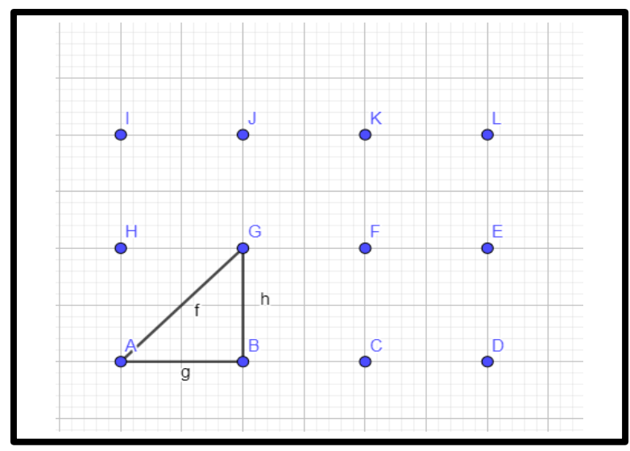
Figure 2 Representation of Islamic Context

Figure 2 above shows how learning material development considers the knowledge presentation process. The context is presented in abstract mathematical concepts.
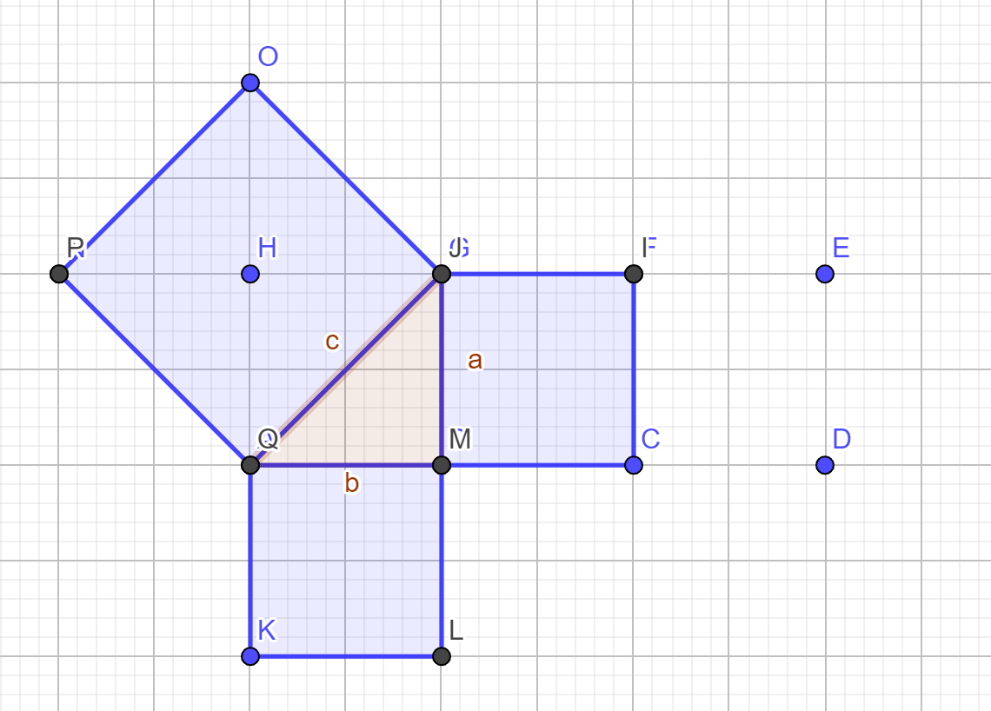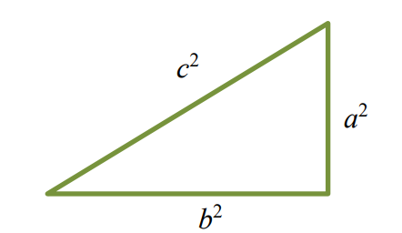

Figure 3 The Concept of Pythagoras

Learning Material is generally presented through the first flow of Islamic context presentation and changed into the semi-concrete form of representation and directed to an abstract form of mathematics. The last step above can direct students to the concept of mathematics as the learning objective. The way of teaching is confirmed by Webel et al. (2016) that mathematical presentation can conform to a representation system that is the existing contextual problems around students and can be solved.
The prototype phase was divided into two, prototype one and prototype 2. Prototype 1 was focused on expert scoring to validate learning material. Besides scoring using a questionnaire, the experts also criticized and suggested prototype one improvement. In prototype 2, the limited test was carried out on six pre-service teacher students.
The second phase outlined the research instrument as the scoring criteria for prototype 1. The research instrument developed the completed instrument outline. The research instrument used was the validation sheet and observation sheet. The feasibility examination based on an assessment by linguists and Islamic Study experts used a validation sheet. The Linguist scored it based on the Education and linguistic aspects, while the Islamic Study expert scored it based on Islamic aspects. To examine students’ responses to Islamic context-based mathematics learning materials using the observation sheet.
The material presented was mathematical material for SMP/MTs in power and root, ratio and scale, and plane figure and solid figure. The material was presented using simple, straightforward language for ease of understanding. The presentation of the text in teaching materials is equipped with colour images and the use of bold and italics to emphasize material keywords such as sub-chapter titles. The font and size in this learning material was Bookman Old Style 10 pt. Picture content was developed using the software GeoGebra 5.0 for accuracy. The colour was used consistently and ready to read since the background was white. The text and pictures were presented close to each other on one page. The picture was presented, serving to illustrate the material.
The validation phase was carried out to examine the feasibility of the developed prototype one based on an expert’s examination. The validated learning material product was revised as per experts’ suggestions and recommendations during the validation process. After learning material revision, a limited test was carried out. The final results of the research and development were in the form of Islamic context-based mathematics learning material for SMP/MTs products.
Before the test, the developed Islamic context-based mathematics learning material was also validated first by a Mathematics Education expert, Linguist, and Islamic Study expert. The validation by Mathematics Education Expert used mathematical concept understanding as to the development indicator. The maximum score of the statement item in the validation sheet was five, and the minimum score was 1.
Table 2 Results of Mathematics Education Expert’ Scoring
Scoring Aspect | Average | Percentage | Criteria
Mathematical Concept Accuracy | 4.25 | 85 % | Valid
Content Appropriateness in Islamic Context | 4 | 80 % | Valid
Algorithmic concept Precision | 4 | 80 % | Valid
Learning material validation by mathematics education experts above totally had an average of 4.2 at a percentage of 84%. The learning material was valid by mathematical content in facilitating mathematical understanding.
According to Tomlinson (2016), the learning material was developed using language that was easy for students to understand so that they would gain experience from the language used. Further, a lecturer with an education and language background learned material validation through media and linguistic aspects. The validation results are presented in Table 3.
Table 3 Results of Validation by Linguist
Scoring Aspect | Average | Percentage | Criteria
Clarity of the Used Language | 4.3 | 86.7 % | Valid
Picture Appropriateness to provide representation | 4.1 | 82.2 % | Valid
Variation Accuracy | 4.17 | 83.3% | Valid

The result of learning material validation by linguists shows that the average score was 4.16 at 83.3% with the “valid” category. Based on the validation results, we can conclude that the developed Islamic context-based mathematics learning material is of good quality. Thus, it is entirely appropriate for use.
A lecturer with an Islamic study background validated learning material regarding the Islamic context. The validation by Islamic study learning material experts aimed at obtaining information, criticism, and suggestions for the developed learning material to be of good quality from its completeness and suitability to the chosen Islamic context. The validation results can be observed in table 4.
Table 4 Results of Validation by Islamic Study Expert
Scoring Aspect | Average | Percentage | Criteria
Islamic Context Accuracy | 4.75 | 95 % | Valid
Islamic Context Appropriateness with Reality | 4.5 | 90 % | Valid
Islamic Context Appropriateness with Mathematical content | 4.67 | 93.3 % | Valid

The validation results by learning material experts show an average score of 4.7 and a percentage of 94% with the “very valid” category. Based on the results of validation by the three experts above, we can conclude that the developed Islamic context-based mathematics learning material has good quality, as shown by the result “valid.” Thus, it is appropriate for use.
The limited test was carried out with semester-8 students who had taken all courses in the Mathematics Education study program. The limited test was carried out with six students to assess the Islamic context-based mathematics learning material, and the results are as shown below.
Table 5 Results of Limited Test
No | Pre-Service Teacher Initials | Score Average
1 | MFA | 3.6
2 | KIK | 3.4
3 | DII | 3.3
4 | CWM | 4
5 | AUA | 3.5
6 | NFA | 3.1
 | Average | 3.5
 | Percentage | 86.75

The limited test results on the learning material show an average score of 3.28 and a percentage of 86.75% with the “valid” category. The six students in the limited test suggested adding Islamic material and examples of non-routine problems. Some improvements have been made related to the learning material presentation technique and the addition of material related to Islamic knowledge. The improvement confirms Darici’s opinion (2016) that it is necessary to consider pre-service teachers’ opinions and needs.
The assessment phase was carried out by applying learning material in mathematics learning class to examine students’ response to the learning material developed and examine students’ understanding improvement. Thirty-seven pre-service mathematics teacher students participated in the learning using an Islamic context. The information obtained is presented below.
Table 6 Results of Assessment Phase
Treatment | Nilai
Average Pretest | 24.19
Average Posttest | 68.65
Maximum Score | 100
N-Gain | 0.57

Islamic context as the source of learning in this research shows N-Gain average test result on mathematical concept understanding of 0.57, that is of “medium” category. Students’ response to the learning material shows 82%, which means that the quality of the learning material is in a good category. Learning using this learning material can help students develop their mathematical concept understanding. During learning, the pre-service teacher students showed interest in mathematics. Students’ increased interest in learning mathematics through learning material innovation may affect their success. As stated in the study carried out by Yeh et al. (2019), exciting learning material can increase students’ interest and success in learning mathematics.
In this research, the Islamic context improves mathematical concept understanding. According to Chan et al. (2019), authentic life contest presentations can develop pre-service teachers’ professionalism in the holistic study field. Pre-service teacher students understand mathematics in the contexts they are familiar with, facilitating them to comprehend mathematics related to the Islamic knowledge they believe.

- CONCLUSION AND SUGGESTIONS
The Islamic context-based learning material developed with power and root, ratio and scale, and plane figure and solid figure materials has passed various phases of development. The earning material has met the requirements and can be considered for use in learning mathematics. The expert validation and limited test show that the learning material is appropriate for use. In addition, after some revisions of the learning material, the experiment shows that the learning material can increase pre-service mathematics teacher students’ mathematical concept understanding with an N-gain of 0.57. Suggestions for future research can expand the scope of research material in school mathematics. Coverage of the material using the Islamic context.

ACKNOWLEDGEMENT
I would like to thank you funding for this research. This work was supported by the DIPA IAIN Purwokerto 2020.

References

Abdillah, Gelora Mastuti, A., Rijal, M., & Sehuwaky, N. (2022). Islamic Integrated Information Communication Technology Mathematics Learning Model for Students’ Creativity and Environmental Awareness. 6(1), 194–211. https://doi.org/10.31764/jtam.v6i1.5755
Chan, C. M. E., Ng, K. E. D., Lee, N. H., & Dindyal, J. (2019). Problems in Real-World Context and Mathematical Modelling. https://doi.org/10.1007/978-981-13-3573-0_9
Copur-Gencturk, Y. (2021). Teachers’ conceptual understanding of fraction operations: results from a national sample of elementary school teachers. Educational Studies in Mathematics, 107(3). https://doi.org/10.1007/s10649-021-10033-4
Darici, A. (2016). The Importance of Needs Analysis in Materials Development. In Issues in Materials Development. https://doi.org/10.1007/978-94-6300-432-9_3
Fan, L. (2013). Textbook research as scientific research: Towards a common ground on issues and methods of research on mathematics textbooks. ZDM - International Journal on Mathematics Education, 45(5). https://doi.org/10.1007/s11858-013-0530-6
Hake, R. R. (1999). Analyzing change/gain scores. Unpublished.[Online] URL: Http://Www. Physics. Indiana. Edu/\~ Sdi/AnalyzingChange-Gain. Pdf, 16(7).
Hemmi, K., & Ryve, A. (2014). Effective mathematics teaching in Finnish and Swedish teacher education discourses. Journal of Mathematics Teacher Education, 18(6). https://doi.org/10.1007/s10857-014-9293-4
Jablonka, E. (2013). Boredom in mathematics classrooms from Germany, Hong Kong and the United States. Proceedings of the Eighth Congress of European Research in Mathematics Education (CERME 8).
Maass, K., Doorman, M., Jonker, V., & Wijers, M. (2019). Promoting active citizenship in mathematics teaching. ZDM - Mathematics Education, 51(6). https://doi.org/10.1007/s11858-019-01048-6
Mutohir, T. C., Lowrie, T., & Patahuddin, S. M. (2018). The development of a student survey on attitudes towards mathematics teaching-learning processes. Journal on Mathematics Education, 9(1). https://doi.org/10.22342/jme.9.1.4193.1-14
Ngware, M. W., Ciera, J., Musyoka, P. K., & Oketch, M. (2015). Quality of teaching mathematics and learning achievement gains: evidence from primary schools in Kenya. Educational Studies in Mathematics, 89(1). https://doi.org/10.1007/s10649-015-9594-2
Novikasari, I. (2017). Hubungan antara Prestasi Belajar dan Tingkat Kecemasan Matematika pada Mahasiswa Calon Guru SD/MI. AKSIOMA Journal of Mathematics Education, 5(2). https://doi.org/10.24127/ajpm.v5i2.671
Palinussa, A. L., Molle, J. S., & Gaspersz, M. (2021). Realistic mathematics education: Mathematical reasoning and communication skills in rural contexts. International Journal of Evaluation and Research in Education, 10(2). https://doi.org/10.11591/ijere.v10i2.20640
Plomp, T. (2013). Educational Design Research: A Introduction. In Educational Design Research.
Rahman, M. N. A., Zamri, S. N. A. S., & Eu, L. K. (2020). The influence of opportunities to learn and efficacy belief factor towards mathematical knowledge for teaching. Asia Pacific Journal of Educators and Education, 35(1). https://doi.org/10.21315/apjee2020.35.1.7
Sinclair, N. (2001). The Aesthetic “Is” Relevant. In Source: For the Learning of Mathematics (Vol. 21, Issue 1).
Tobias, S., Serow, P., & Schmude, M. (2010). Critical Moments in Learning Mathematics: First Year Pre-service Primary Teachers’ Perspectives. In B. Sparrow, Kissane, & C. Hurst (Eds.), Shaping the future of mathematics education. (Proceedings of the 33rd annual conference of the Mathematics Education Research Group of Australasia). MERGA.
Tomlinson, B. (2016). The Importance of Materials Development for Language Learning. In Issues in Materials Development. https://doi.org/10.1007/978-94-6300-432-9_1
Törnroos, J. (2005). Mathematics textbooks, opportunity to learn and student achievement. Studies in Educational Evaluation, 31(4). https://doi.org/10.1016/j.stueduc.2005.11.005
Ulpah, M., & Novikasari, I. (2020). Developing Islamic Context-Based Learning Materials in Increasing Students’ Mathematical Understanding. Al-Jabar : Jurnal Pendidikan Matematika, 11(1). https://doi.org/10.24042/ajpm.v11i1.5432
Webel, C., Krupa, E., & McManus, J. (2016). Using Representations of Fraction Multiplication. Teaching Children Mathematics, 22(6), 366–373. https://doi.org/10.5951/teacchilmath.22.6.0366
Yang, D. C., & Sianturi, I. A. (2017). An Analysis of Singaporean versus Indonesian textbooks based on trigonometry content. Eurasia Journal of Mathematics, Science and Technology Education. https://doi.org/10.12973/eurasia.2017.00760a
Yeh, C. Y. C., Cheng, H. N. H., Chen, Z. H., Liao, C. C. Y., & Chan, T. W. (2019). Enhancing achievement and interest in mathematics learning through Math-Island. Research and Practice in Technology Enhanced Learning, 14(1). https://doi.org/10.1186/s41039-019-0100-9
Zamansky, A., & Zohar, Y. (2016). ‘Mathematical’ Does Not Mean ‘Boring’: Integrating Software Assignments to Enhance Learning of Logico-Mathematical Concepts (J. Krogstie, H. Mouratidis, & J. Su, Eds.; Vol. 249). Springer International Publishing. https://doi.org/10.1007/978-3-319-39564-7

