**Integer Multi-objective Adjustable Robust Counterpart Optimization Model Using Benders Decomposition: a Comprehensive Survey and Review**

**Athaya Zahrani Irmansyah1, Diah Chaerani2, Endang Rusyaman3**

1Master of Mathematics Program Study, Faculty of Mathematics and Natural Science,

Universitas Padjadjaran, Indonesia

2Department of Mathematics, Faculty of Mathematics and Natural Science,

Universitas Padjadjaran, Indonesia

[athaya17002@mail.unpad.ac.id](mailto:athaya17002@mail.unpad.ac.id)1, [d.chaerani@unpad.ac.id](mailto:d.chaerani@unpad.ac.id)2, [rusyaman@unpad.ac.id](mailto:rusyaman@unpad.ac.id)3

|  |  |  |  |
| --- | --- | --- | --- |
|  |  | **ABSTRACT** | |
| **Article History:**  Received : D-M-20XX  Revised : D-M-20XX  Accepted : D-M-20XX  Online : D-M-20XX |  | Multi-objective integer optimization model that contain uncertain parameter can be handled using the Adjustable Robust Counterpart (ARC) methodology with Polyhedral Uncertainty Set. The ARC method has two stages of completion, so completing the second stage can be assisted by the Benders Decomposition. This paper discusses the Systematic Literature Review (SLR) on this topic using the Preferred Reporting Items for Systematic Reviews and Meta-Analysis (PRISMA). PRISMA presents a database mining algorithm for previous articles and related topics sourced from Scopus, Science Direct, Dimensions, and Google Scholar. Four stages of the algorithm are used, namely Identification, Screening, Eligibility, and Included. In the Eligibility stage, a database of articles is obtained called Dataset 1, used for bibliometric mapping and evolutionary analysis. Moreover, in the Included stage, a final article database was obtained called Dataset 2, which was used to analyze research gaps and novelty. The analysis was carried out on two datasets, assisted by the output visualisation using RStudio software with the " bibliometrix" package, then we use the command 'biblioshiny()' to create a link to the “shiny web interface”. At the final stage of the article, it is concluded that there is no research on the ARC multi-objective integer optimization model with Polyhedral Uncertainty Sets using the Benders Decomposition Method, which focuses on discussing the general model and its mathematical analysis. This becomes the primary reference for further research on this topic. To complete this discussion, we conduct two research questions regarding the methods, application, research gaps, and recommendations of the topic. | |
| **Keyword*:***  Systematic Literature Review;  Adjustable Robust Counterpart;  Integer Optimization Model;  Polyhedral Uncertainty Set;  Benders Decomposition. |
| E:\UMUM\OJSQ\JTAM\JTAM-Barcode copy.jpg |
| C:\Users\WINDOWS 7\Documents\Indeksi\New-Cros.jpg  <https://doi.org/10.31764/jtam.vXiY.ZZZ> | | | C:\Users\WINDOWS 7\Documents\Indeksi\88x31.png  **This is an open access article under the CC–BY-SA license** |

—————————— ◆ ——————————

1. **INTRODUCTION**

The Optimization can be defined as the process of finding conditions that provide the maximum or minimum value of a function ( Irmansyah et al., 2021). Optimization problems can be converted into an optimization model. To build an optimization model, the steps that must be taken are to define decision variables, objective functions, and constraint function. Optimization models in real life often experience problems with data that cannot be known precisely (Diah Chaerani et al., 2022), this kind of data is termed uncertainty. One of the methodologies in dealing with the problem of data uncertainty in optimization is multi-stage Robust Optimization or commonly known as Adjustable Robust Counterpart (ARC). The ARC methodology was first introduced by Ben-Tal et al., 2004 by considering two sets of variables. The first set must be determined before resolving the uncertainty, and the other set can be calculated after the uncertainty is resolved. ARC is a two-stage Robust Optimization method that still needs to be developed (Yanıkoğlu et al., 2017).

Furthermore, there are three assumptions of uncertainty parameters that can be used in ARC, one of which is the Polyhedral Uncertainty Set used in this review article. This is because the set of data points of uncertainty mapped to the Polyhedral Uncertainty Set will produce a convex hull that guarantees a feasible solution. In addition, the Polyhedral Uncertainty Set is the best assumption of the uncertainty set among the other two sets because it does not include additional data outside the set and does not discard the original data used (Agustini et al., 2020; D. Chaerani et al., 2021).

In some problems such as internet shopping online (D. Chaerani et al., 2021) or Optimization Model for Agricultural Processed Products Supply Chain Problem (Irmansyah et al., 2021), the optimization problem involves integer variables and also has multiobjective function. These problems can be considered as two stages optimization problem and solved as ARC optimization problem.

The ARC Optimization problem can be approached by various methods such as Column-and-Constraint Generating Algorithm (Ji et al., 2019), Cutting Plane Method (Xiong & Jirutitijaroen, 2014), Branch and Bound Method (Romeijnders & Postek, 2021), and Benders Decomposition Method (Lee et al., 2013). Based on various methods to solve ARC optimization problems, a general model formulation of ARC multi-objective integer optimization can be obtained with Polyhedral Uncertainty Set using the Benders Decomposition Method approach. The Benders Decomposition Method is the basis of a mathematical model required to partition or divide the problem into linear or continuous parts that are easy to solve and nonlinear or easy integer parts are difficult to solve (Lee et al., 2013). This method is an optimization method for solving problems that have feasible subproblems. Previous studies examining very little has been done regarding the ARC multi-objective integer optimization model using the Benders Decomposition Method approach. These studies include Lee et al., 2013 who used the benders decomposition method approach for the Mixed-integer Linear Programming (MILP) optimization model, and Bertsimas et al., 2013 used the two-stage MILP optimization model.

This article discusses a Systematic Literature Review (SLR) that uses an integer multi-objective optimization model where optimization is viewed from more than one point of view (Hoyyi & Ispriyanti, 2015) or is said to have more than one objective function. The purpose of the SLR is to obtain an objective and comprehensive summary and the results of a critical analysis of previous research relevant to the topic being studied (Yi et al., 2019). The lack of research on the ARC multi-objective integer optimization model with Polyhedral Uncertainty Set using the Benders Decomposition Method approach supports the SLR on this topic. The research in this article applies the SLR using the Preferred Reporting Items for Systematic Reviews and Meta-Analysis (PRISMA) Method. The PRISMA Method presents algorithms and procedures for selecting articles ready for review, bibliometric map analysis based on specific linkages, theme evolution approach, and determination of research gaps and recommendations for further research.

Furthermore, our review complements the existing reviews on this topic (see Table 1). Table 1 summarizes the differences between our article and the existing review articles. Four relevant literature review articles are used as references compared to review articles submitted in this study. The categorization is based on content analysis that is integer variables, multi-objective function, Robust Optimization, and Benders Decomposition Method.

**Table 1**. Related Previous SLR Article

|  |  |  |  |  |  |  |
| --- | --- | --- | --- | --- | --- | --- |
| **No** | **Author** | **Paper** | **Content Analysis** | | | |
| **Integer variables** | **Multi-objective** | **Robust Optimization** | **Benders Decomposition** |
| 1 | Yanıkoğlu et al., 2019 | A survey of adjustable robust optimization | - | - |  | - |
| 2 | Goberna et al., 2022 | The radius of robust feasibility of uncertain mathematical programs: A Survey and recent developments |  | - |  | - |
| 3 | Mahrudinda et al., 2022 | Systematic literature review on adjustable robust counterpart for internet shopping optimization problem |  |  |  | - |
| Our paper | | |  |  |  |  |

Based on Table 1, all three articles have content analysis in the form of checking whether they discuss SLR regarding optimization models that use integer variables, have a multi-objective function, use a Robust Optimization approach to handle the uncertainty, and use the Benders Decomposition Method approach to solve the problem. We get the results that the SLR paper that discusses the multi-objective optimization model is Mahrudinda et al., 2022 which discusses the same thing but uses integer variables and ARC Optimization. Next, Yanıkoğlu et al., 2019 is an SLR paper that discusses Robust Optimization, followed by Goberna et al., 2022 which discusses the same thing using integer variables. Based on Table 1, it can be concluded that our SLR paper has a solid discussion, namely the SLR paper which discusses all the analysis contents.

To be precise, the PRISMA Method in this article refers mainly to Utomo et al., 2018. PRISMA Method provides an accurate standard methodology as a protocol for describing article selection criteria, search strategies, data extraction, and data analysis procedures (Abelha et al., 2020). Furthermore, the determination of Research Questions (RQs) was obtained based on the research objectives. Thus, in this article, we focus on the ARC multi-objective integer optimization model with Polyhedral Uncertainty Set using the Benders Decomposition Method approach and answer the following RQs:

1. What methods have been used by previous researchers in dealing with the ARC multi-objective integer optimization model with a Polyhedral Uncertainty Set?

2. How are the research gaps between the multi-objective integer optimization model, ARC, Polyhedral Uncertainty Sets, and the Benders Decomposition Method?

To conduct this article, we apply PRISMA Method in which there is a determination of bibliometric map analysis using RStudio software with the command “R-bibliometrix”, which will be explained in more detail later. This article is structured as follows: Section 2 presents a brief discussion of a materials and the steps of the method used, namely the PRISMA Method. Section 3 presents research results and discussion in bibliometric map results, visualization of relationships using RStudio software, thematic evolution, SLR analysis, answers from RQs, state-of-the-art explanations, and determination of research gaps, novelties, and recommendations for research that will be carried out. Finally, Section 4 presents the conclusions from the explanations in the previous sections.

1. **MATERIALS AND METHODS**

In this section, a brief discussion of materials which is the general formulation of integer programming based on Billionnet et al., 2014, Adjustable Robust Counterpart Optimization based on Gorissen et al., 2015, and Benders Decomposition Method based on Karbowski, 2021 are presented.

1. **Materials**
2. General Formulation of Integer Optimization Model

Classes of problems in optimization modeling can be characterized based on the type of variable and the type of function, including Linear Programming, Nonlinear Programming, Quadratic Programming, Linear Programming with integer variables, Nonlinear Programming with integer variables, Linear Programming with mixed integer variables, and so on. This research uses the initial general model formulation which is Integer Linear Programming (ILP). ILP is Linear Programming where all or part of the variables are limited in the form of integers/discrete. The case of ILP with a limited number of variables in the form of integers is called Mixed Integer Linear Programming (MILP).

The article that is the main reference for this subsection is Billionnet et al., 2014. The article describes the MILP deterministic problem where the variables in the model are partitioned into two sets with each stage of completion. First, the integer variables, called decision variables, that focus on the objectives to be obtained in the first stage, before knowing realization of the other variables. Second, the continuous variable, called the resource, focuses on the objectives to be obtained in the second stage. The MILP deterministic problem model can be written as follows: 

with , and  is a set of rational numbers. Furthermore, the article assumes that there are pairs of variables  that satisfy the constraint function in (1), so it can be said that the problem has a feasible solution.

The existence of the assumption of uncertainty in the decision variables  and  in the model introduced by Billionnet et al., 2014 supports the use of the ARC methodology. Furthermore, the existence of variable partitioning into two parts, namely integer variables as difficult variables $x$ and continuous variables $y$ as easy variables also supports the application of the Benders Decomposition Method approach which will be explained later.

1. Adjustable Robust Counterpart Optimization

Referring to Gorissen et al., 2015, there is a special method to handle integer variables in the ARC optimization problem. The method starts from the general Robust Counterpart (RC) problem as follows:



with ,  is a *here-and-now* variable,  is a *wait-and-see* variable, , and  is an uncertain coefficient matrix of the *here-and-now* variables. Note that the integer *wait-and-see* variable  has an uncertain coefficient matrix , so that this approach can deal with the problem of uncertainty in the *wait-and-see* integer variable coefficients. For simplicity, it is assumed that the uncertain coefficient matrix is ​​linear in  and without omitting the generalization,  is assumed to be a linearly uncertain objective function.

To model ARC with integer variables, we first divide the set of uncertainties  becomes as many as $m$ disjoint subsets, so that it is obtained:



and introduced an additional integer variable  which models the decision in . Next, reformulate the uncertain constraint and objective function on the problem (2) for each  and the set of uncertainty  as follows:



Note that the integer ARC formulation in (4) is more flexible than the non-adjustable in (2) in selecting integer variable values. This is because the ARC integer in (4) has a special decision  for each subset . Therefore, the integer ARC formulation in (4) produces Robust optimal results which are at least as good as the regular ARC formulation in (2).

1. Benders Decomposition Method

This section describes the mathematical description of the Benders Decomposition Method for the case of feasible subproblems. This feasible subproblem is determined based on the initial Mixed Integer Linear Programming (MILP) model which is partitioned into linear/continuous (easy) and nonlinear/integer (difficult) parts. The initial MILP model in the form of minimization  for example as follows (Karbowski, 2021):



with , and  In early models (5),  and  may be nonlinear/integer (the hard part), whereas  may be discrete/continuous (the easy part). Based on (5), it can be seen that for each definite value , problem (5) into linear programming with decision variables  which can be represented mathematically as  Furthermore, it is assumed that  has a finite optimal solution  for all  This assumption can be used even though in its application, this assumption can already be obtained by modifying it , so the assumption  fulfilled.

Furthermore, problem (5) can be rewritten in the form of a "nested minimization statement" or  which is equivalent to the following:



with  is the *Inner Optimization Problem* (IOP) from (6). Formulation (6) can be rewritten by substituting the dual formulation of IOP to get the next equivalent formulation, i.e.  as follows:



with  is the IOP from (7) and  is the dual variable. Formulation (7) has a set of constraint functions that are independent of the variable , that is  Furthermore, the IOP of (7) has a finite optimal solution due to the previously explicit assumption on  The optimal solution will always be at one extreme  Therefore, the next equivalent formulation is  can be determined as follows:



which is commonly referred to as the extreme point formulation. Formulation (8) can be rewritten as a single-minimization problem in the form of a full master problem that is:



Furthermore, formulation (9) makes it possible to define a relaxed master problem  which considers the subset  from obstacles  as follows:



with  defined as the empty set and is a zero number. Furthermore, the subproblem formulation of the Benders Decomposition Method is also obtained  which is used to solve the extreme point  given by a fixed value  ( conditional ). The formulation of  given as the following maximization problem:



with  The formulation of  has a finite optimal solution due to initial assumptions .

Based on the discussion of the three previous materials, an SLR article can be compiled using a combination of the three topics. The three materials make it easier for us to see the gaps between previous studies, then check whether there are studies that discuss two topics or three topics from these materials at once. Furthermore, the first step we took was determining keywords for each topic discussed in the next Method section.

1. **Methods**

Before discussing the method used to support the SLR process in this article, it is necessary to determine what materials are needed for the method. The first step is to determine keywords based on the research topic of this review article, namely the ARC multi-objective integer optimization model with Polyhedral Uncertainty Set using the Benders Decomposition Method approach. We arrange the division of keyword types, as shown in Table 2. Based on Table 2, keywords are divided into six focus sections. Keywords A, B, and C focus on the optimization model, Robust Optimization, and Benders Decomposition Method. In contrast, keywords D, E, F, and G combine keywords A, B, and C. In other words, keywords A, B, and C are the most common keywords, while keyword G is the most specific keyword because it is a combination of the three. This keyword classification aims to check whether there is a relationship between topics in previous research.

**Table 2**. Keywords Classification

|  |  |
| --- | --- |
| **Code** | **Keywords** |
| A | “optimization model” AND “integer” AND (“multi-objective” OR “multiobjective”) |
| B | (“robust counterpart” OR “robust optimization”) AND (“uncertainty” OR “polyhedral uncertainty set”) AND (“adjustable robust optimization” OR “adjustable robust counterpart”) |
| C | “benders decomposition method” |
| D | A AND B  “optimization model” AND “integer” AND (“multi-objective” OR “multiobjective”) **AND** (“robust counterpart” OR “robust optimization”) AND (“uncertainty” OR “polyhedral uncertainty set”) AND (“adjustable robust optimization” OR “adjustable robust counterpart”) |
| E | A AND C  “optimization model” AND “integer” AND (“multi-objective” OR “multiobjective”) **AND** “benders decomposition method” |
| F | B AND C  (“robust counterpart” OR “robust optimization”) AND (“uncertainty” OR “polyhedral uncertainty set”) AND (“adjustable robust optimization” OR “adjustable robust counterpart”) **AND** “benders decomposition method” |
| G | A AND B AND C  “optimization model” AND “integer” AND (“multi-objective” OR “multiobjective”) **AND** (“robust counterpart” OR “robust optimization”) AND (“uncertainty” OR “polyhedral uncertainty set”) AND (“adjustable robust optimization” OR “adjustable robust counterpart”) **AND** “benders decomposition method” |

Furthermore, after compiling keywords, the next step is to determine the article database source. In this article, the author used four database sources, namely Scopus, Science Direct, Dimensions, and Google Scholar. The database obtained from mining on these four sources serves as the material used in the PRISMA method. The six keywords obtained in Table 2 are inputted in the four databases, which will then get the total number identified in Table 3. Previously, in the application of database mining, data type filtering is also required. The searched database is filtered under several conditions: (1). The database is open access, that is, unlimited access via the internet, (2). Databases are publications published in the last six years, from 2017 to 2022 (3). The database is research in mathematics, mathematical science, or applied mathematics (this selection of research fields used only in Scopus, Science Direct, and Dimensions), (4). The database is in research articles or conference papers, (5). Source type database is open access journals and conference proceedings that have been published, (6). The database used English, (7). Using all types of publication stage, journal name, affiliation, funding sponsor, country/territory, and lastly (8). Database search within article title, abstract, and keywords. Based on the eight data type limitations, the results obtained are the number of articles in the four sources and their totals, as shown in Table 3. Based on Table 3, it can be seen that the more specific the inputted keywords, the fewer the number of databases obtained, even for keywords D to G, none of the articles identified.

**Table 3**. The Results of Database Mining of Six Type of Keywords in The Four Sources

|  |  |  |  |  |  |
| --- | --- | --- | --- | --- | --- |
| **Code** | **Scopus** | **Science Direct** | **Dimensions** | **Google Scholar**  **(with Publish or Perish application)** | **Total** |
| A | 25 | 21 | 19 | 5 | 70 |
| B | 11 | 5 | 16 | 8 | 40 |
| C | 12 | 17 | 9 | 35 | 73 |
| D | 0 | -* | 0 | 0 | 0 |
| E | 0 | 0 | 0 | 0 | 0 |
| F | 0 | -* | 0 | 0 | 0 |
| G | 0 | -* | 0 | 0 | 0 |
| Total | 48 | 43 | 44 | 48 |  |

Note: *Database mining can't be done because we have to use fewer boolean connectors (max 8 per field)

Furthermore, because there were no articles identified in keywords D to G, it was necessary to reconstruct the keywords so that at least the distribution of articles identified in each keyword was increased. The reconstruct in the form of a few generalizations and changes in the period to “all year research” on keywords are shown in Table 4, and the search results in the four databases can be seen in Table 5. Table 5 shows that the number of articles identified has increased. This means that database mining is sufficient for all six keywords.

The literature review in this paper was conducted using the Preferred Reporting Items for Systematic reviews and Meta-Analyses (PRISMA) Method20. PRISMA Method provides a standardized and accurate methodology for describing article selection criteria, search strategies, data extraction, and data analysis procedures (Abelha et al., 2020). Furthermore, both in terms of the methodology used and the results obtained, the PRISMA method has been proven to improve literature review quality (Panic et al., 2013). The PRISMA Method consists of four stages, as shown in Figure 1.

**Table 4**. Generalized Keywords

|  |  |
| --- | --- |
| **Code** | **Keywords** |
| A | “optimization model” AND “integer” |
| B | (“adjustable robust optimization” OR “adjustable robust counterpart”) |
| C | “benders decomposition method” |
| D | A AND B: “optimization model” AND “integer” **AND** (“adjustable robust optimization” OR “adjustable robust counterpart”) |
| E | A AND C: “optimization model” AND “integer” **AND** “benders decomposition method” |
| F | B AND C: (“adjustable robust optimization” OR “adjustable robust counterpart”) **AND** “benders decomposition method” |
| G | A AND B AND C: “optimization model” AND “integer” **AND** (“adjustable robust optimization” OR “adjustable robust counterpart”) **AND** “benders decomposition method” |

Based on Figure 1, the first thing to do is determine the keywords relevant to the planned research topic. Keyword classification is needed to provide the best specifications for the article results obtained. Keywords can be grouped from general to specific issues, then inputted into at least one desired database source so that the total number of articles identified is obtained. Furthermore, when inputting keywords into the database, article limitations are also applied as needed. This article uses eight search limitations as previously described.

**Table 5**. The Results of Database Mining from Generalized Keywords

|  |  |  |  |  |  |
| --- | --- | --- | --- | --- | --- |
| **CODE** | **Scopus** | **Science Direct** | **Dimensions** | **Google Scholar**  **(with Publish or Perish application)** | **Total** |
| A | 213 | 179 | 216 | 80 | 686 |
| B | 13 | 5 | 18 | 68 | 104 |
| C | 12 | 17 | 9 | 35 | 73 |
| D | 4 | 2 | 78 | 0 | 84 |
| E | 12 | 3 | 63 | 0 | 78 |
| F | 0 | 0 | 5 | 0 | 5 |
| G | 0 | 0 | 3 | 0 | 3 |
| Total | 254 | 200 | 392 | 183 |  |

The second stage is the screening stage. The first thing to do is screen duplication of identified articles at this stage. Duplicate may occur if using more than one article database source and will capture articles with the same title and author. Duplication checks can use the help of Jabref or Mendeley software until finally the total number of the latest articles is obtained. The next stage of the screening stage is to filter the articles that have been successfully selected to the duplicate screening stage based on the title and abstract.

Furthermore, the articles selected at the screening stage enter the eligibility stage by checking and reading the articles one by one thoroughly so that non-conforming articles are returned. Checking is done by examining the research methods, objectives, and outputs. The results of the article selection at the eligibility stage are articles that enter the final step, namely included, where the article is ready to be used as literature review material, bibliometric map mapping, and state-of-the-art preparation.

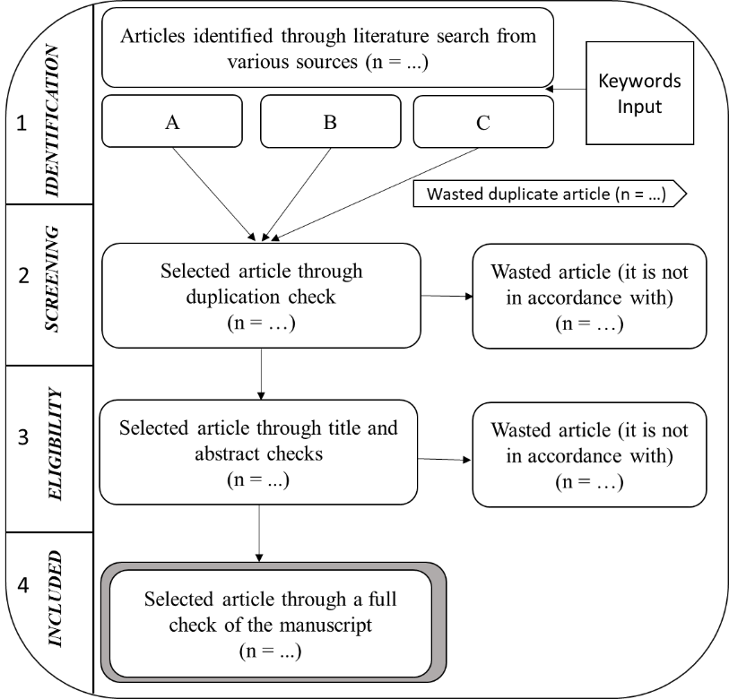

**Figure 1**. PRISMA Method Flowchart (Utomo et al., 2018)

1. **RESULT AND DISCUSSION**
   * + 1. **Final Result of the Database Mining Using PRISMA Method**

Describe After mining the article database and obtaining the results as shown in Table 5, the keywords with codes A to G have their totals. We store the total database of the articles in the file format “.bib". Next, we start the PRISMA Method algorithm as described in Figure 1. Table 6 provides the results of article selection using the PRISMA method. The first stage is the identification stage. We used Mendeley and Jabref software to compare which software could identify the total database papers (which we marked in bold). Some wasted articles on some code keywords A to G because the “.bib” file could not be identified. The next step is screening which is the second stage of the PRISMA Method.

In the second stage of the PRISMA Method, the duplicate screening process is the first thing done with the help of Mendeley software, thus providing a new total. Then go to title and abstract screening. In this section, we do a manual screening on the title and abstract of the article with several checking categorizations. First, the article discusses the integer optimization model in general and specifically for a particular problem. Second, the article uses the ARC methodology to solve the problem; otherwise, it is wasted. Furthermore, we stopped the second stage of the PRISMA Method until the duplicate screening stage on coded keywords A to D. We focused on keywords related to each other to see the research gap for further research, which will be discussed later.

**Table 6**. The Results of The Selection of Articles Using the PRISMA Method

|  |  |  |  |  |  |  |  |  |
| --- | --- | --- | --- | --- | --- | --- | --- | --- |
| **Identification (1)** | | | | **Screening (2)** | | **Eligibility (3)** | | **Included (4)** |
| **Code** | **Total** | **Identified by Mendeley** | **Identified by Jabref** | **Duplicate Check** | **Title and Abstract Screening** | **3 Stars\*** | **4 Stars\*\*** | **Full Text Screening/ 5 stars\*\*\*** |
| A | 680 | **525** | 509 | 521 | - | - | - | - |
| B | 104 | 81 | **95** | 83 | - | - | - | - |
| C | 73 | 69 | **70** | 64 | - | - | - | - |
| D | 84 | **83** | 78 | 83 | 83 | 144 | 16 | 0 |
| E | 78 | **76** | 72 | 76 | 76 | 3 |
| F | 5 | **5** | 5 | 5 | 5 | 3 |
| G | 3 | **3** | 3 | 3 | 3 | 1 |
| TOTAL | | | | | 167 | 144 | 16 | 6 |

Note: *not/less relevant, **Dataset 1 for bibliometric mapping, ***Dataset 2 for literature review).

The third stage of the PRISMA Method is eligibility. We categorize based on the number of stars, namely three stars and four stars. Three stars are articles with additional checks, namely articles that use an integer optimization model in MILP and eliminate articles that are not/less relevant. At the same time, four stars are articles that use the MILP optimization model with a Polyhedral Uncertainty Set in Robust Optimization, so that 144 articles are obtained for three stars and 16 articles that are more specific for four stars. The database of 16 articles at this stage is called Dataset 1, which is used for bibliometric mapping and determination of thematic evolution using the RStudio software.

The last stage of the PRISMA method is the included stage. At this stage, we finalize the selected articles called Dataset 2 (five stars), which will later be used to analyze the SLR in the form of state-of-the-art table results, the determination of research gaps, and recommendations for future research discussed. There were six final articles selected with additional checks, namely articles using the Benders Decomposition Method to handle easy and complex variables, in the next section.

1. **The Result of Bibliometric Maps Using RStudio Software Procedure**

The This section uses Dataset 1, which contains sixteen selected articles at the eligibility stage to determine the bibliometric map using RStudio software. Figure 2 represents the bibliometric mapping output diagram performed in this article. The diagram is divided into three general stages after total database mining for Dataset 1 is carried out, namely mining of bibliometric data, analysis of bibliometric data, and mapping of the state-of-the-art, identification, and analysis of gaps and trends. This diagram is implemented in the following discussion.

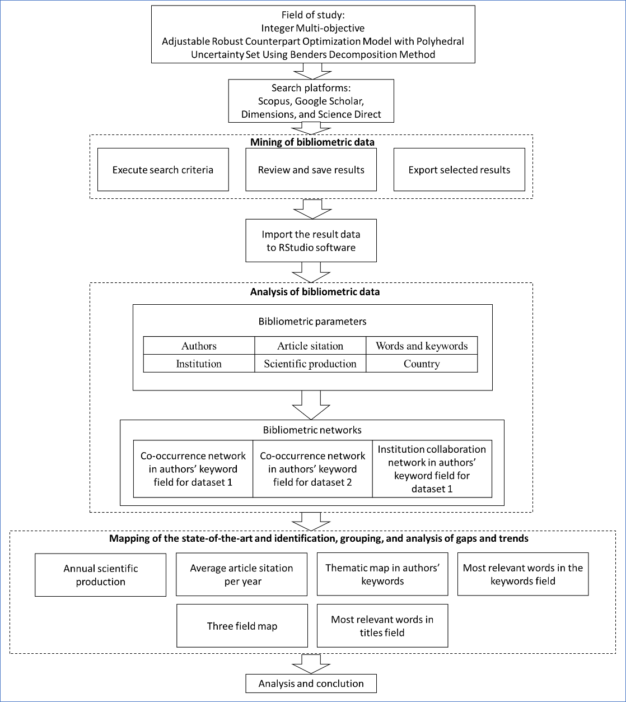

**Figure 2**. Bibliometric Mapping Output Diagram

The sixteen articles in Dataset 1 have a timespan between 1998 and 2022 with 5.5 years from publication, 7,875 average citations per document, 1,831 average citations per year per document, and 496 references. The information obtained from the 'main information' option in the RStudio software that is used to support the emergence of a bibliometric mapping which discusses the relationship between each keyword as shown in Figure 3, the relationship between authors as in Figure 4, and the interrelationships between institutions in various countries as in Figure 5. In the process in the RStudio software, we use the command 'biblioshiny()' to create a link to the “shiny web interface”. Louvain Cluster Algorithm is used with fifty minimum number of nodes. We set the minimum number of edges to 1, which means that the bibliometric map that will appear has at least one relationship between one node and another.

Figure 3 is a bibliometric map in the authors' keyword field. Sixty-one keywords appear, and eight clusters are based on color. The cluster provides information on keyword grouping based on the sixteen research topics in Dataset 1. Furthermore, the purple cluster has the most relevant impact because it raises the keywords “benders decomposition", the most pertinent words with six occurrences in the abstract field. Furthermore, the second most relevant words are the keywords “adjustable robust optimization” and “uncertainty” with three occurrences, and the keywords “microgrid”, “robust optimization”, and “unit commitment” with two occurrences. In other words, the larger the size of the words/phrase appear, the more these keywords are used in research.

Additionaly, Figure 4 bring up the bibliometric map in the authors' field. It aims to see the relationship between the authors. For example, has author A ever been associated with author B in a research article project. Sixty-three authors appeared (1 author of single-authored documents and 62 authors of multi-authored papers), which were then divided into four clusters based on color, namely purple, green, blue, and red. In this case, the most productive author on the topic under study was ZHANG, LIM, and LIU.

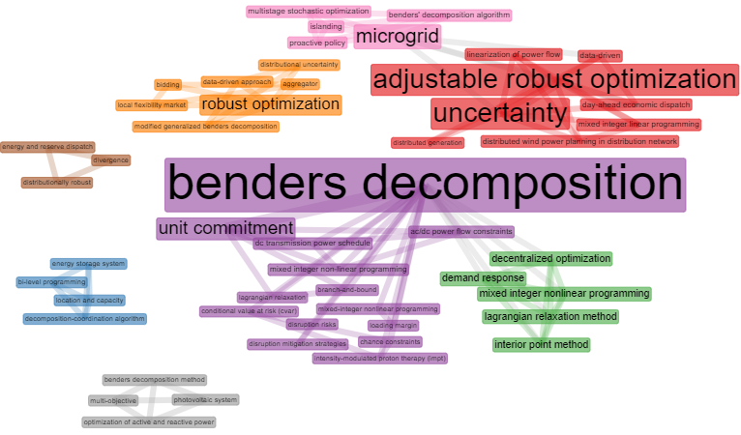

**Figure 3**. Bibliometric Map in The Authors’ Keyword Field for Dataset 1

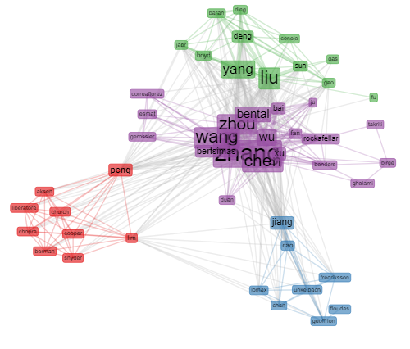

**Figure 4**. Bibliometric Map in The Authors’ Field for Dataset 1

A bibliometric map is also used to find linkages and see institution collaboration networks from Dataset 1. This aims to see which institutions have collaborated in completing a research article. Figure 5 gives 9 clusters. From these results, institutions in China marked with red and pink clusters rank first in the betweenness centrality analysis. In other words, institutions in China have the most extraordinary centrality (each node has the most number of passes or is connected to other institutions) compared to other institutions in research on this topic.

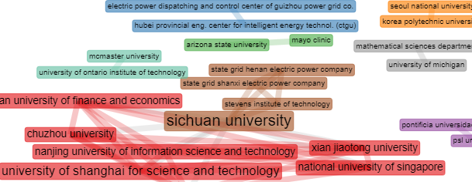

**Figure 5**. Institution Collaboration Network for Dataset 1

1. **Evolution Analysis**

Evolution analysis of the topics can be determined to present important information regarding the differences in subtopics by article authors based on clusters obtained in the 1998 to 2022 timeframe. In this section, Dataset 1, which contains 16 article databases, is analyzed based on their evolution. Annual scientific production for dataset one can be seen in Figure 6a. According to the annual scientific production output by the RStudio software, the result is that the most article production occurred in 2021 with four articles, followed by 2016, 2018, and 2020 which succeeded in publishing two articles each. This means that research related to the topic of this article is increasing from year to year. In addition, the average article citations per year are also analyzed and give the result that 2020 is the year with the most article citations, which is an average of 9.2 citations, followed by 2017 with an average of 4 citations as we can see in Figure 6b.

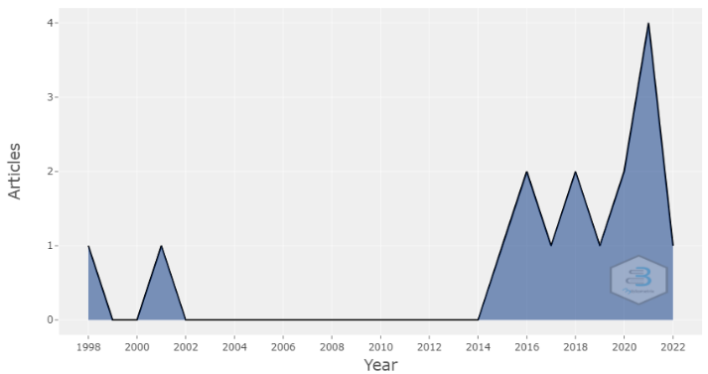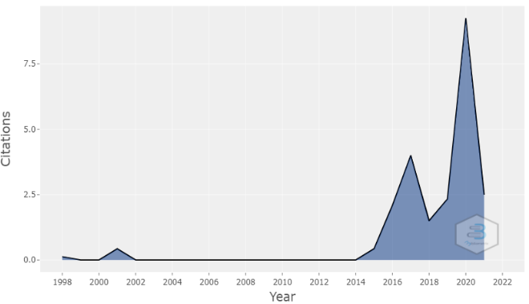

|  |  |
| --- | --- |
| (a) | (b) |

**Figure 6**. (a) Annual Scientific Production, (b) Average Article Citation Per Year

The thematic evolution map in authors keyword' field is presented in Table 7. The author's keyword field was chosen because it is one of the most relevant representations of research keywords. The thematic evolution map is beneficial for researchers to analyze the development of topics in four different quadrants; these are identified based on their identification on the degree of relevance (centrality) plotted on the X-axis and the degree of development (density) plotted on the Y-axis. Centrality defines the interaction level of the inter-clusters. Precisely, centrality measures the level of inter-cluster interaction, i.e., the extent to which a topic is connected to other issues. Furthermore, density measures the time when keywords in a particular cluster are linked, and thus a theme is developed.

In Figure 7, based on an explanation of the X and Y axes, it is known that the upper right quadrant contains topics with high centrality and density, which means these topics can influence research and are well developed. The lower right quadrant includes issues with centrality strong (able to control the other problems) but density weak (not well developed). The lower left quadrant contains topics with centrality and density vulnerable, meaning that these topics are less able to influence research and are not well developed. Finally, the upper left quadrant contains the opposite issue to the lower right quadrant.

Through this explanation, it can be seen that the emerging topics such as “microgrid” are in the upper right quadrant, which means they can influence research and are well developed. In brief, the topic of ARC with benders decomposition has not been frequently studied and is open to further research in connection. This is our contribution to our subsequent study.

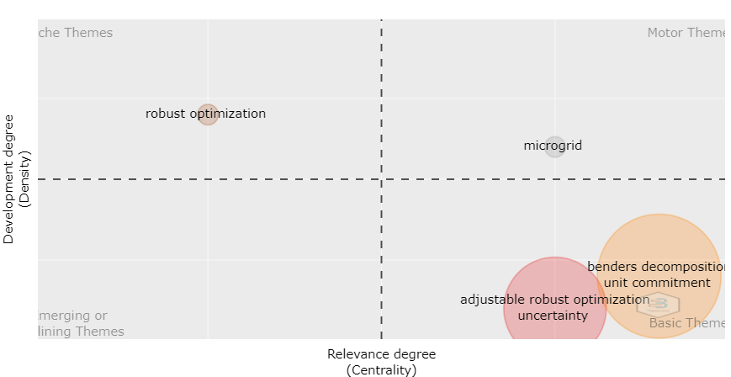

**Figure 7**. Thematic Map in Authors’ Keywords Field

A critical follow-up analysis is related to developing the most relevant words. The output of the most pertinent words generated by RStudio software has three types, namely unigram (maximum one word appears), bigram (maximum two words appear), and trigram (maximum three words appear). This study searches for the most relevant trigrams of words in the abstract and keywords. This Analysis of the relevance of words serves to see which keywords often and rarely appear, examine which keywords still have the opportunity to be developed in research, and which keywords have been carried out in many studies.

Figure 8a provides the ten most relevant words with various topics in keywords field. Keyword field ranked “benders decomposition” first with six occurrences, followed by “adjustable robust optimization” and “uncertainty” with three occurrences. Meanwhile, Figure 8b represents the most relevant words in the titles field where “adjustable robust”, “distribution network”, and “wind power” are in first place with three appearances. Benders decomposition ranks second with two occurrences. Based on the explanation from Figures 8a and 8b, it can be concluded that the ten relevant words produced do not yet represent the topic of this research simultaneously, namely the ARC multi-objective integer optimization model with a Polyhedral Uncertainty Set using the Benders Decomposition Method.

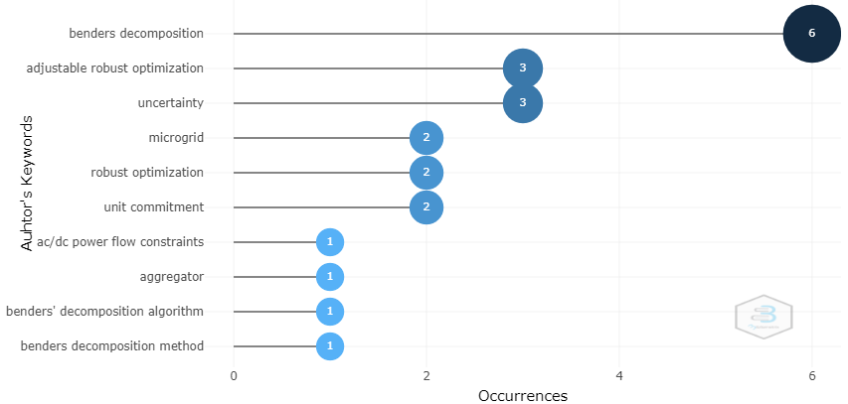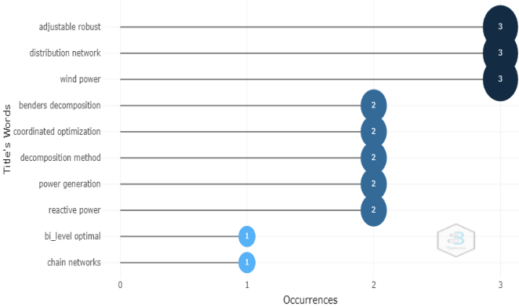

**Figure 8**. (a) Most Relevant Words in the Keywords Field, (b) Most Relevant Words in Titles Field

The next important thing in the discussion of the analysis of the evolution of the article is a three-field map which is one of the outputs. In the period 1998 to 2022, a three-field plot map can be visualized, as shown in Figure 9. The left column shows the countries involved in the article, the middle column shows the article author's name, and the right column shows the keywords used in the article written. This three-field plot can represent the relationship between the three characters in the entire article's database in one input.

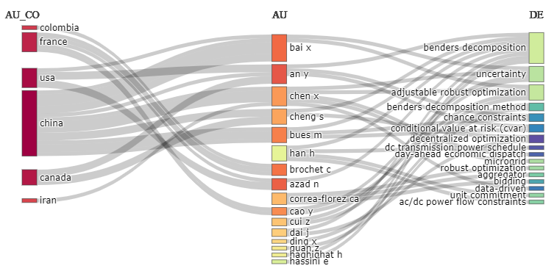

**Figure 9**. Three Field Map of Dataset 1

For example, for a study on the topic of the Benders Decomposition Method, the middle bar shows all authors do not yet present research on the topics “benders decomposition”, “adjustable robust optimization”, or “robust optimization” simultaneously, as well as in the country bar on the left. This means that research on the two topics has not been done much. In Figure 9, the keywords "multi-objective" and "polyhedral indeterminate sets" appear in the right-hand bar, thus supporting the assumption that the topic in this SLR article has not been studied much.

1. **The Result of Systematic Literature Review**

This section presents the study results from Dataset 2, namely a database containing six articles selected to the final stage as can be seen in Table 6. Articles in Dataset 2 were published within the 2013-2021 timeframe.

1. Methods and Application of Research Topics

This section intends to answer RQ1: What methods have been used by previous researchers in dealing with the ARC multi-objective integer optimization model with a Polyhedral Uncertainty Set? Based on the results of Dataset 2, it is known that the six articles do not have more than one objective function (single objective function), so none of them fulfills our desired research topic. Furthermore, the six articles used the Mixed-integer Linear Programming (MILP) Method. The problems handled by the MILP must contain data that contains uncertainty, where ARC and the Benders Decomposition Method take the uncertainty of the data in the six articles. The specifications for using the Benders Decomposition Method in each article are listed in Table 7.

**Table 7**. State-of-the-art ARC Integer Optimization Model Using the Benders Decomposition Method

|  |  |  |  |  |
| --- | --- | --- | --- | --- |
| **No** | **Authors** | **Objective function** | **Method** | **Application of the Bender's**  **Decomposition Method** |
|
| 1 | Lee et al., 2013 | Single | MILP and ARC Polyhedral | Two-stage polynomial finite MILP optimization model with simultaneous cut generation scheme to check the convergence of the Benders Decomposition Method |
| 2 | Kuznia et al., 2013 | Two-stage Robust Optimization Model with a column-and-constraint algorithm compared to the Benders Decomposition Method |
| 3 | Bertsimas et al., 2013 | Two-stage MILP optimization model |
| 4 | Zarrinpoor et al., 2017 |
| 5 | Hashemi Doulabi et al., 2021 | Two-stage MILP optimization model by comparing the optimal solution between the Benders decomposition method and the Dantzig-Wolfe decomposition method |
| 6 | Gamboa et al., 2021 | Two-stage MILP optimization model with rectangular uncertainty set approach |

The first six articles dominate mathematical models and methods in everyday life numerical experiment. Furthermore, the details of the research topic can be seen in Table 8 which explains the distribution of the types of variables based on the stage of work in each article. The division of variable types into non-adjustable (solved in the first stage) and adjustable (solved in the second stage) is a two-stage variable type that is always present and used in ARC problems.

**Table 8**. State-of-the-art Variables in ARC Integer Optimization Model

|  |  |  |  |  |
| --- | --- | --- | --- | --- |
| **No** | **Authors** | **Variable** | | |
| ***Non-Adjustable* (first step)** | ***Adjustable* (second step)** |
| 1 | Lee et al., 2013 | Determination of capacity design using integer programming | Determination of capacity design using integer programming | |
| 2 | Kuznia et al., 2013 | Determination of facilities using Mixed-integer Linear Programming (MILP) | Determination capacities using Mixed-integer Linear Programming (MILP) | |
| 3 | Bertsimas et al., 2013 | Determination of Unit Commitment (UC) using MIP | Determination of Unit Commitment (UC) using MIP | |
| 4 | Zarrinpoor et al., 2017 | Determination of health facility allocation policy using MIP | Determination of health facility allocation policy using MIP | |
| 5 | Hashemi Doulabi et al., 2021 | The original problem decision variable uses the Dantzig-Wolfe Decomposition Method | Decision variables reformulated original problem using the Benders Decomposition Method | |
| 6 | Gamboa et al., 2021 | Data-driven determination variables | Variables in the recourse function | |

1. Research Gaps and Recommendations on Research Topics

This section intends to answer RQ2: How are the research gaps between the multi-objective integer optimization model, ARC, Polyhedral Uncertainty Set, and the Benders Decomposition Method? Based on the discussion about obtaining Dataset 1 and 2 using the PRISMA Method, then conducting an evolutionary analysis, it can be seen that the research topic in the article we discussed provides several search gaps as follows.

First, there is no research on the ARC multi-objective integer optimization model with Polyhedral Uncertainty Set using the Benders Decomposition Method. Based on the bibliometric analysis in Figure 2, which contains articles in dataset one and in Table 7 and Table 8, which includes articles on, there has not been any emergence of optimization models with more than one objective function is, commonly called multi-objective. This is a gap in previous research which is an opportunity for something new that must be developed in future research. Second: there is no research on the ARC multi-objective integer optimization model with Polyhedral Uncertainty Set using the Benders Decomposition Method, which discusses general models and their mathematical analysis. Based on Tables 7 and 8, the six articles focus on numerical experiments of the MILP model used in real life problems. The main focus of the research topic of this review article is the output in the form of a general model, so it is a novelty to develop or publish a new optimization model with specifications in the form of an ARC multi-objective integer optimization model with a Polyhedral Uncertainty Set using the Benders Decomposition Method.

1. **CONCLUSION AND SUGGESTIONS**

In this review article, we present a Systematic Literature Review (SLR) with the topic of ARC multi-objective integer optimization model with Polyhedral Uncertainty Set using the Benders Decomposition Method. The Preferred Reporting Items for Systematic Reviews and Meta-Analysis (PRISMA) method is used as a protocol to describe article selection criteria, search strategies, data extraction, and data analysis procedures proven to improve the quality of literature review. We used six kinds of keyword combinations with 256 identified articles from four digital libraries, namely Scopus, Science Direct, Dimensions, and Google Scholar. After all the PRISMA Method protocols were carried out, sixteen articles were obtained as Dataset 1, used for bibliometric mapping and evolution analysis. In comparison, the last six articles as Dataset 1 were analyzed to support SLR.

The results of Dataset 1 analysis show that the sixteen articles have a timespan between 1998 and 2022 with average years from the publication of 5.5, average citations per document of 7,875, an average citation per year per document 1,831, and a total of 496 references. Furthermore, it can be concluded that the ten relevant words produced in the most pertinent words of keywords in the title field not yet represent the topic of this research, namely the ARC multi-objective integer optimization model with a Polyhedral Uncertainty Set using the Benders Decomposition Method approach. In brief, the topic of ARC with Benders Decomposition Method has not been frequently studied and is open to further research in connection. This is our contribution to the following study.

The results of Dataset 2 analysis provide a research gap. There is no research on the ARC multi-objective integer optimization model with Polyhedral Uncertainty Set using the Benders Decomposition Method, which discusses general models and their mathematical analysis. This becomes the main reference for further research on this topic. Furthermore, future research analysis was conducted on the ARC multi-objective integer optimization model with Polyhedral Uncertainty Set using the Benders Decomposition Method.

**ACKNOWLEDGEMENT**

This research is supported by Universitas Padjadjaran and the Indonesian Ministry of Education, Culture, Research, and Technology under project with Basic Research Scheme.

**REFERENCES**

Abelha, M., Fernandes, S., Mesquita, D., Seabra, F., & Ferreira-Oliveira, A. T. (2020). Graduate employability and competence development in higher education-A systematic literature review using PRISMA. *Sustainability (Switzerland)*, *12*(15). https://doi.org/10.3390/SU12155900.

Agustini, R. A., Chaerani, D., & Hertini, E. (2020). Adjustable robust counterpart optimization model for maximum flow problems with box uncertainty. *World Scientific News*. http://psjd.icm.edu.pl/psjd/element/bwmeta1.element.psjd-d3bda928-14de-4915-9abf-b14cfee42610.

Ben-Tal, A., Goryashko, A., Guslitzer, E., & Nemirovski, A. (2004). Adjustable robust solutions of uncertain linear programs. *Mathematical Programming*, *99*(2), 351–376. https://doi.org/10.1007/s10107-003-0454-y.

Bertsimas, D., Litvinov, E., Sun, X. A., Zhao, J., & Zheng, T. (2013). Adaptive robust optimization for the security constrained unit commitment problem. *IEEE Transactions on Power Systems*, *28*(1), 52–63. https://doi.org/10.1109/TPWRS.2012.2205021.

Billionnet, A., Costa, M. C., & Poirion, P. L. (2014). 2-stage robust MILP with continuous recourse variables. *Discrete Applied Mathematics*, *170*, 21–32. https://doi.org/10.1016/j.dam.2014.01.017.

Chaerani, D., Rusyaman, E., Mahrudinda, Marcia, A., & Fridayana, A. (2021). Adjustable robust counterpart optimization model for internet shopping online problem. *Journal of Physics: Conference Series*, *1722*(1). https://doi.org/10.1088/1742-6596/1722/1/012074.

Chaerani, Diah, Irmansyah, A. Z., Perdana, T., & Gusriani, N. (2022). Contribution of robust optimization on handling agricultural processed products supply chain problem during covid-19 pandemic. *Uncertain Supply Chain Management*, *10*(1), 239–254. https://doi.org/10.5267/j.uscm.2021.9.004.

Gamboa, C. A., Valladão, D. M., Street, A., & Homem-de-Mello, T. (2021). Decomposition methods for Wasserstein-based data-driven distributionally robust problems. *Operations Research Letters*, *49*(5), 696–702. https://doi.org/10.1016/j.orl.2021.07.007.

Goberna, M. A., Jeyakumar, V., Li, G., & Vicente-Pérez, J. (2022). The radius of robust feasibility of uncertain mathematical programs: A Survey and recent developments. *European Journal of Operational Research*, *296*(3), 749–763. https://doi.org/10.1016/j.ejor.2021.04.035.

Gorissen, B. L., Yanıkoğlu, İ., & den Hertog, D. (2015). A practical guide to robust optimization. *Omega*, *53*, 124–137.

Hashemi Doulabi, H., Jaillet, P., Pesant, G., & Rousseau, L.-M. (2021). Exploiting the Structure of Two-Stage Robust Optimization Models with Exponential Scenarios. *INFORMS Journal on Computing*, *33*(1), 143–162. https://doi.org/10.1287/ijoc.2019.0928.

Ji, H., Wang, C., Li, P., Ding, F., & Wu, J. (2019). Robust Operation of Soft Open Points in Active Distribution Networks With High Penetration of Photovoltaic Integration. *IEEE Transactions on Sustainable Energy*, *10*(1), 280–289. https://doi.org/10.1109/TSTE.2018.2833545.

Karbowski, A. (2021). Generalized benders decomposition method to solve big mixed-integer nonlinear optimization problems with convex objective and constraints functions. *Energies*, *14*(20). https://doi.org/10.3390/en14206503.

Kuznia, L., Zeng, B., Centeno, G., & Miao, Z. (2013). Stochastic optimization for power system configuration with renewable energy in remote areas. *Annals of Operations Research*, *210*(1), 411–432. https://doi.org/10.1007/s10479-012-1110-9.

Lee, C., Lee, K., & Park, S. (2013). Benders decomposition approach for the robust network design problem with flow bifurcations. *Networks*, *62*(1), 1–16. https://doi.org/10.1002/net.21486.

Mahrudinda, M., Chaerani, D., & ... (2022). Systematic literature review on adjustable robust counterpart for internet shopping optimization problem. *International Journal of …*. http://m.growingscience.com/beta/ijds/5251-systematic-literature-review-on-adjustable-robust-counterpart-for-internet-shopping-optimization-problem.html.

Hoyyi, A., Ispriyanti, D. (2015). OPTIMISASI MULTIOBJEKTIF UNTUK PEMBENTUKAN PORTOFOLIO 1 Staf Pengajar Jurusan Statistika FSM UNDIP. (n.d.). 31–39.

Panic, N., Leoncini, E., De Belvis, G., Ricciardi, W., & Boccia, S. (2013). Evaluation of the endorsement of the preferred reporting items for systematic reviews and meta-analysis (PRISMA) statement on the quality of published systematic review and meta-analyses. *PLoS ONE*, *8*(12). https://doi.org/10.1371/journal.pone.0083138.

Romeijnders, W., & Postek, K. (2021). Piecewise constant decision rules via branch-and-bound based scenario detection for integer adjustable robust optimization. *INFORMS Journal on Computing*. https://doi.org/10.1287/ijoc.2019.0934.

Utomo, D. S., Onggo, B. S., & Eldridge, S. (2018). Applications of agent-based modelling and simulation in the agri-food supply chains. *European Journal of Operational Research*, *269*(3), 794–805. https://doi.org/10.1016/j.ejor.2017.10.041.

Xiong, P., & Jirutitijaroen, P. (2014). Two-stage adjustable robust optimisation for unit commitment under uncertainty. *IET Generation, Transmission and Distribution*, *8*(3), 573–582. https://doi.org/10.1049/iet-gtd.2012.0660.

Yanıkoğlu, İ, Gorissen, B., & ... (2017). Adjustable robust optimization—a survey and tutorial. *Available Online at …*. https://www.researchgate.net/profile/Ihsan-Yanikoglu/publication/319876919_A_Survey_of_Adjustable_Robust_Optimization_-_Cite_as_Yanikoglu_et_al_2019_EJOR_2773_799-813/links/59bf823d0f7e9b48a29b60c4/A-Survey-of-Adjustable-Robust-Optimization-Cite-as-Yaniko.

Yanıkoğlu, İhsan, Gorissen, B. L., & den Hertog, D. (2019). A survey of adjustable robust optimization. *European Journal of Operational Research*, *277*(3), 799–813. https://doi.org/10.1016/j.ejor.2018.08.031.

Yi, J., Lu, C., & Li, G. (2019). A literature review on latest developments of Harmony Search and its applications to intelligent manufacturing. *Mathematical Biosciences and Engineering*, *16*(4), 2086–2117. https://doi.org/10.3934/mbe.2019102.

Zahrani Irmansyah, A., Chaerani, D., & Rusyaman, E. (2021). Optimization Model for Agricultural Processed Products Supply Chain Problem in Bandung During Covid-19 Period. *Jurnal Teknik Industri*, *23*(2). https://doi.org/10.9744/jti.24.2.

Zarrinpoor, N., Fallahnezhad, M. S., & Pishvaee, M. S. (2017). Design of a reliable hierarchical location-allocation model under disruptions for health service networks: A two-stage robust approach. *Computers and Industrial Engineering*, *109*(November 2018), 130–150. https://doi.org/10.1016/j.cie.2017.04.036.