APPENDIX 3.2.
INSTRUMENT’S VALIDITY TESTING

Correlations
 |  | total
q1 | Pearson Correlation | .768**
 | Sig. (2-tailed) | .000
 | N | 33
q2 | Pearson Correlation | .685**
 | Sig. (2-tailed) | .000
 | N | 33
q3 | Pearson Correlation | .538**
 | Sig. (2-tailed) | .001
 | N | 33
q4 | Pearson Correlation | .859**
 | Sig. (2-tailed) | .000
 | N | 33
q5 | Pearson Correlation | .581**
 | Sig. (2-tailed) | .000
 | N | 33
q6 | Pearson Correlation | .505**
 | Sig. (2-tailed) | .003
 | N | 33
q7 | Pearson Correlation | .454**
 | Sig. (2-tailed) | .008
 | N | 33
q8 | Pearson Correlation | .704**
 | Sig. (2-tailed) | .000
 | N | 33
q9 | Pearson Correlation | .839**
 | Sig. (2-tailed) | .000
 | N | 33
q10 | Pearson Correlation | .882**
 | Sig. (2-tailed) | .000
 | N | 33
q11 | Pearson Correlation | .566**
 | Sig. (2-tailed) | .001
 | N | 33
q12 | Pearson Correlation | .617**
 | Sig. (2-tailed) | .000
 | N | 33

q13 | Pearson Correlation | .534**
 | Sig. (2-tailed) | .001
 | N | 33
q14 | Pearson Correlation | .757**
 | Sig. (2-tailed) | .000
 | N | 33
q15 | Pearson Correlation | .797**
 | Sig. (2-tailed) | .000
 | N | 33
q16 | Pearson Correlation | .671**
 | Sig. (2-tailed) | .000
 | N | 33
q17 | Pearson Correlation | .546**
 | Sig. (2-tailed) | .001
 | N | 33
q18 | Pearson Correlation | .591**
 | Sig. (2-tailed) | .000
 | N | 33
q19 | Pearson Correlation | .526**
 | Sig. (2-tailed) | .002
 | N | 33
q20 | Pearson Correlation | .549**
 | Sig. (2-tailed) | .001
 | N | 33
q21 | Pearson Correlation | .582**
 | Sig. (2-tailed) | .000
 | N | 33
q22 | Pearson Correlation | .647**
 | Sig. (2-tailed) | .000
 | N | 33
q23 | Pearson Correlation | .571**
 | Sig. (2-tailed) | .001
 | N | 33
q24 | Pearson Correlation | .516**
 | Sig. (2-tailed) | .002
 | N | 33
q25 | Pearson Correlation | .824**
 | Sig. (2-tailed) | .000
 | N | 33
**. Correlation is significant at the 0.01 level (2-tailed).

APPENDIX 3.3.
INSTRUMENT’S RELIABILITY TESTING

Case Processing Summary
 |  | N | %
Cases | Valid | 33 | 100.0
 | Excludedª | 0 | .0
 | Total | 33 | 100.0
a. Listwise deletion based on all variables in the procedure.

Reliability Statistics
Cronbach's Alpha | N of Items
.939 | 25

Item-Total Statistics
 | Scale Mean if Item Deleted | Scale Variance if Item Deleted | Corrected Item-Total Correlation | Cronbach's Alpha if Item Deleted
q1 | 18.70 | 39.718 | .749 | .935
q2 | 18.73 | 39.705 | .657 | .936
q3 | 18.85 | 39.695 | .488 | .938
q4 | 18.73 | 38.955 | .845 | .934
q5 | 18.97 | 39.093 | .528 | .938
q6 | 18.85 | 39.883 | .452 | .938
q7 | 18.73 | 40.705 | .412 | .939
q8 | 18.88 | 38.610 | .666 | .935
q9 | 18.79 | 38.422 | .820 | .934
q10 | 18.76 | 38.502 | .868 | .933
q11 | 18.76 | 40.002 | .526 | .937
q12 | 18.94 | 38.934 | .568 | .937
q13 | 18.79 | 39.985 | .489 | .938
q14 | 18.88 | 38.297 | .725 | .935
q15 | 18.97 | 37.718 | .767 | .934
q16 | 18.73 | 39.767 | .642 | .936

q17 | 18.79 | 39.922 | .502 | .938
q18 | 18.82 | 39.528 | .547 | .937
q19 | 18.73 | 40.392 | .488 | .938
q20 | 18.85 | 39.633 | .499 | .938
q21 | 18.85 | 39.445 | .535 | .937
q22 | 18.94 | 38.746 | .601 | .936
q23 | 18.85 | 39.508 | .523 | .937
q24 | 18.85 | 39.820 | .464 | .938
q25 | 18.85 | 38.070 | .801 | .933

APPENDIX 3.4.
INSTRUMENT’S NORMALITY
Tests of Normality
 | Class | Kolmogorov-Smirnovª
 |  | Statistic | df | Sig.
Reading Comprehension | Experimental Group | .125 | 34 | .194
 | Control Group | .129 | 33 | .174
a. Lilliefors Significance Correction

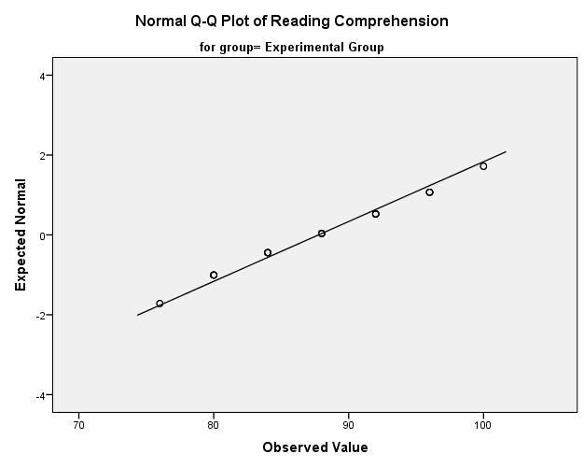

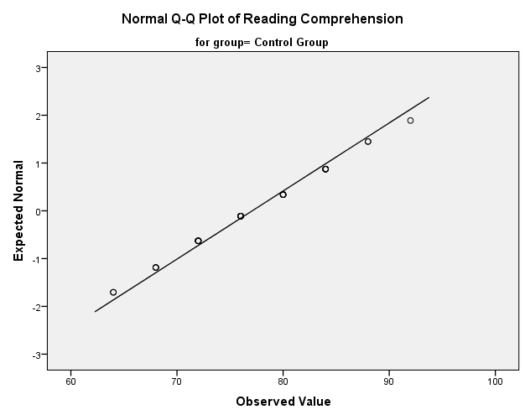

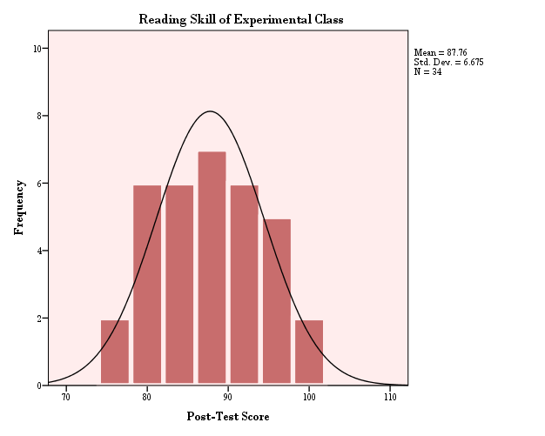

APPENDIX 3.5.
INSTRUMENT’S HOMOGENEITY

Test of Homogeneity of Variances
Reading Comprehension
Levene Statistic | df1 | df2 | Sig.
.138 | 1 | 65 | .711

ANOVA
Reading Comprehension
 | Sum of Squares | df | Mean Square | F | Sig.
Between Groups | 1907.901 | 1 | 1907.901 | 40.702 | .000
Within Groups | 3046.845 | 65 | 46.875
Total | 4954.746 | 66

APPENDIX 3.6
DESCRIPTIVE STATISTIC

- EXPERIMENTAL CLASS

Statistics
Experimental_Class
N | Valid | 34
 | Missing | 0
Mean |  | 87.76
Std. Error of Mean |  | 1.145
Median |  | 88.00
Mode |  | 88
Std. Deviation |  | 6.675
Variance |  | 44.549
Range |  | 24
Minimum |  | 76
Maximum |  | 100
Sum |  | 2984
Percentiles | 30 | 84.00
 | 60 | 88.00

Experimental_Class
 |  | Frequency | Percent | Valid Percent | Cumulative Percent
Valid | 76 | 2 | 5.9 | 5.9 | 5.9
 | 80 | 6 | 17.6 | 17.6 | 23.5
 | 84 | 6 | 17.6 | 17.6 | 41.2
 | 88 | 7 | 20.6 | 20.6 | 61.8
 | 92 | 6 | 17.6 | 17.6 | 79.4
 | 96 | 5 | 14.7 | 14.7 | 94.1
 | 100 | 2 | 5.9 | 5.9 | 100.0
 | Total | 34 | 100.0 | 100.0

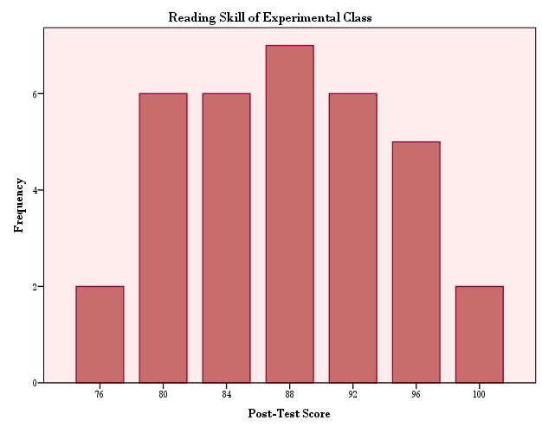

- CONTROL CLASS

Statistics
Control_Class
N | Valid | 33
 | Missing | 0
Mean |  | 77.09
Std. Error of Mean |  | 1.222
Median |  | 76.00
Mode |  | 72
Std. Deviation |  | 7.019
Variance |  | 49.273
Range |  | 28
Minimum |  | 64
Maximum |  | 92
Sum |  | 2544
Percentiles | 30 | 72.00
 | 60 | 80.00

Control_Class
 |  | Frequency | Percent | Valid Percent | Cumulative Percent
Valid | 64 | 2 | 6.1 | 6.1 | 6.1
 | 68 | 3 | 9.1 | 9.1 | 15.2
 | 72 | 7 | 21.2 | 21.2 | 36.4
 | 76 | 6 | 18.2 | 18.2 | 54.5
 | 80 | 6 | 18.2 | 18.2 | 72.7
 | 84 | 6 | 18.2 | 18.2 | 90.9
 | 88 | 2 | 6.1 | 6.1 | 97.0
 | 92 | 1 | 3.0 | 3.0 | 100.0
 | Total | 33 | 100.0 | 100.0

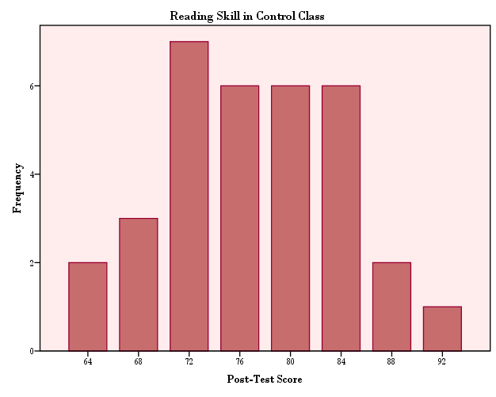

- FREQUENCIES

Statistics
 |  | Experimental | Control
N | Valid | 34 | 33
 | Missing | 0 | 1
Mean |  | 87.76 | 77.09
Std. Error of Mean |  | 1.145 | 1.222
Median |  | 88.00 | 76.00
Mode |  | 88 | 72
Std. Deviation |  | 6.675 | 7.019
Variance |  | 44.549 | 49.273
Range |  | 24 | 28
Minimum |  | 76 | 64
Maximum |  | 100 | 92
Sum |  | 2984 | 2544
Percentiles | 30 | 84.00 | 72.00
 | 60 | 88.00 | 80.00

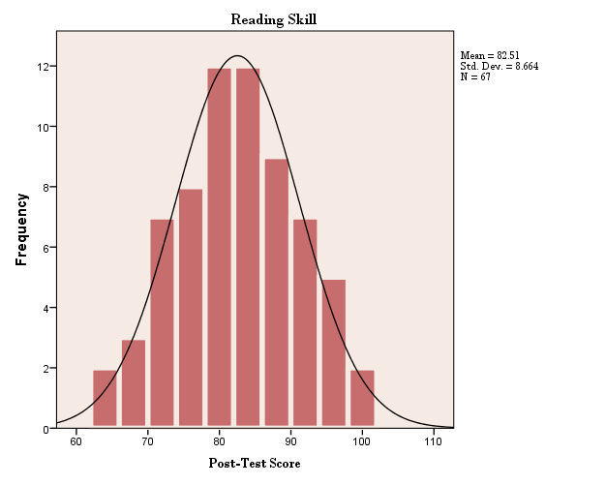

APPENDIX 3.6.
INDEPENDENT T-TEST

Group Statistics
 | Class | N | Mean | Std. Deviation | Std. Error Mean
Reading Comprehension | Experimental Group | 34 | 87.76 | 6.675 | 1.145
 | Control Group | 33 | 77.09 | 7.019 | 1.222

Independent Samples Test
 | Levene's Test for Equality of Variances |  | t-test for Equality of Means
 | F | Sig. | t | df | Sig. (2-tailed) | Mean Difference | Std. Error Difference | 95% Confidence Interval of the Difference
 |  |  |  |  |  |  |  | Lower | Upper
Equal variances assumed | .138 | .711 | 6.380 | 65 | .000 | 10.674 | 1.673 | 7.332 | 14.015
Equal variances not assumed |  |  | 6.375 | 64.580 | .000 | 10.674 | 1.674 | 7.330 | 14.018

