Strengthening Student Research Literacy: Research Methodology Training at MAN Insan Cendekia East Lombok
Muhammad Iqbal^{1*}, Agus Jayadi², Baiq Rohiyatun³, Muzakkir⁴, Ahmad Muslim⁵, Hidayat Joni Mursyid⁶, Imam Maksum Al Maliki⁷
^{1,2,3,4,5}Faculty of Education and Psychology, Universitas Pendidikan Mandalika, Indonesia
^{6,7} MAN Insan Cendekia East Lombok, West Nusa Tenggara, Indonesia
¹muhammadiqbal@undikma.ac.id
ABSTRACT
Abstract: This community service activity aimed to enhance the research literacy of students at MAN Insan Cendekia (IC) East Lombok through research methodology training. The inadequate understanding of scientific research methodology among students served as the rationale for this initiative, particularly in supporting the Youth Scientific Group (Kelompok Ilmiah Remaja/KIR) program and preparing students for research competitions such as Madrasah Young Researchers (MYRES). The implementation method employed an interactive lecture approach, discussion, and mentoring with pretest-posttest evaluation using cognitive test instruments based on Bloom's Taxonomy (C1-C4). The activity was conducted on October 11, 2025, involving approximately 110 students as participants. The posttest evaluation results from 72 respondents indicated that the mean score for research methodology literacy reached 64.11 with a standard deviation of 24.33. The categorization revealed that 22% of students fell within the Excellent category (≥85), 21% in the Good category (75-84), 6% in the Fair category (65-74), 18% in the Poor category (55-64), and 33% in the Very Poor category (<55). This activity contributed positively to strengthening the research literacy of madrasah students and is recommended for continuation through sustainable mentoring programs.
Keywords: research literacy, research methodology, training, madrasah students, community service
A. INTRODUCTION
Research literacy constitutes a fundamental competency that students must possess to navigate the challenges of the 21st century. The ability to comprehend, analyze, and conduct research systematically serves as essential capital for developing critical thinking skills and problem-solving capabilities (Anderson & Krathwohl, 2001). Within the context of madrasah education in Indonesia, the strengthening of research literacy has become increasingly relevant in alignment with the Ministry of Religious Affairs' policies promoting research-based madrasah development and the organization of scientific competitions such as Madrasah Young Researchers (MYRES) and the Madrasah Science Competition (Kompetisi Sains Madrasah/KSM).
MAN Insan Cendekia (IC) East Lombok represents one of the premier madrasahs in the Province of West Nusa Tenggara, possessing substantial potential for student research development. However, based on preliminary observations and communication with school authorities, it was identified that the majority of students had not yet acquired adequate understanding of scientific research methodology. This condition has become an impediment to optimizing Youth Scientific Group (KIR) activities and participation in various national and international research competitions.
Research literacy refers to an individual's capacity to understand, evaluate, and conduct research systematically (Ramayanti, 2023). In the educational context, research literacy encompasses understanding of the scientific research process, the ability to formulate research questions, select appropriate methodologies, collect and analyze data, and communicate findings effectively. The development of research literacy among madrasah students is crucial for cultivating a scientific culture and the critical thinking skills necessary to address global challenges.
Research literacy plays a pivotal role in habituating students to scientific and critical thinking. Scientific thinking constitutes a cognitive process involving the ability to systematically observe phenomena, pose relevant questions, formulate evidence-based hypotheses, design methods to test hypotheses, objectively analyze data, and draw conclusions supported by facts (Kivunja, 2018). Students accustomed to scientific thinking patterns will be better equipped to distinguish between facts and opinions, evaluate the credibility of information sources, and make evidence-based decisions.
Critical thinking, as an integral component of research literacy, involves the ability to analyze arguments, identify underlying assumptions in statements, evaluate evidence, and construct logical arguments (Paul & Elder, 2019). In an era inundated with various types of content, critical thinking skills have become increasingly vital. Students possessing strong research literacy will demonstrate greater skepticism toward unsubstantiated claims, exercise greater caution in accepting information from various sources, and be more capable of independently constructing knowledge through systematic investigation processes.
Recent research indicates that research literacy can be developed through structured and interactive training approaches (Karim, 2023). Research methodology training integrated with direct practice has proven effective in enhancing students' research understanding and skills (Ekawanti et al., 2022). Furthermore, strengthening research literacy aligns with the mandate of the Merdeka Curriculum, which emphasizes the development of 21st-century skills, including critical thinking and creativity.
Based on these conditions, the community service team from Universitas Pendidikan Mandalika organized a research methodology training program as an implementation of the Tri Dharma of Higher Education, specifically in the domain of community service. This activity was expected to provide tangible contributions to strengthening the research capacity of madrasah students and support the achievement of the madrasah's vision as an educational institution excelling in academic and research domains.
B. IMPLEMENTATION METHOD
Location and Time
The training activity was conducted at MAN IC East Lombok, located on Jl. Soekarno Hatta, Suangi, Sakra District, East Lombok Regency, West Nusa Tenggara Province. The activity was implemented in a single day, specifically on Saturday, October 11, 2025.
Participants
The training activity involved approximately 110 students from MAN IC East Lombok across various grade levels (X, XI, and XII). During implementation, 19 students successfully completed the pretest while 72 students completed the posttest due to technical constraints related to internet connectivity.
Activity Stages
The activity was implemented through three main stages. First, the preparation stage encompassed coordination with school authorities, development of training modules and materials, and preparation of supporting facilities including Google Form-based evaluation instruments. Second, the implementation stage consisted of three core activities: pretest administration, delivery of research methodology materials, and posttest administration. Third, the evaluation stage involved pretest and posttest data analysis to measure training effectiveness and formulate follow-up recommendations.
Delivery Method
The material delivery method employed an interactive lecture approach, discussion, and mentoring. The materials presented encompassed student research literacy strengthening, including fundamental research concepts, scientific method steps, problem formulation, literature review, and research methodology. The participatory and interactive training approach was selected due to its proven effectiveness in enhancing trainees' understanding and skills (Drewery & Lollar, 2024).
Evaluation Instruments
The evaluation instruments comprised three sections: (1) general and administrative information including consent and research experience; (2) demographic data and student profiles encompassing 14 items regarding identity, family background, academic profile, and interests; and (3) cognitive ability measurement consisting of 10 objective test items based on Bloom's Taxonomy. The item distribution included 4 C1-Remembering items (weight of 6 each), 2 C2-Understanding items (weight of 8 each), 2 C3-Applying items (weight of 12 each), and 2 C4-Analyzing items (weight of 18 each), with a score range of 5-100. Bloom's Taxonomy, as revised by Anderson and Krathwohl (2001), provides a systematic framework for classifying cognitive learning objectives, and in the context of research methodology training, the first four levels (C1-C4) constitute the essential foundation that students must master (Crowe et al., 2008).
C. RESULTS AND DISCUSSION
Description of Implementation Results
The research methodology training was conducted on Saturday, October 11, 2025, at MAN IC East Lombok with approximately 110 students in attendance. The activity commenced with an opening ceremony by school representatives, followed by online pretest completion via Google Form. During the pretest phase, internet connectivity issues resulted in only 19 students successfully completing the assessment.
Material delivery was conducted using interactive lecture methods supported by presentation media. The materials presented encompassed research introduction, the importance of research, scientific method steps, research idea development, problem formulation, literature review, and research methodology. Participant enthusiasm was evident from the numerous questions posed during discussion sessions. Following material delivery, students completed the posttest, which was successfully finished by 72 students.
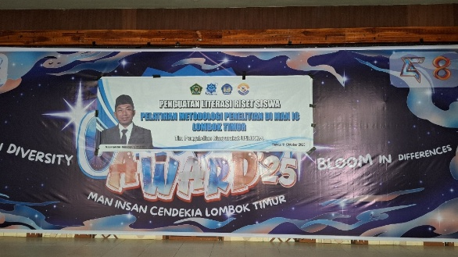  Image 1. Training Activity Banner | 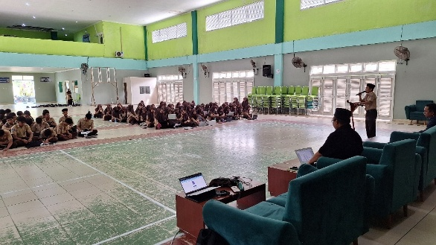  Image 2. Opening Address by Madrasah Leadership Representative
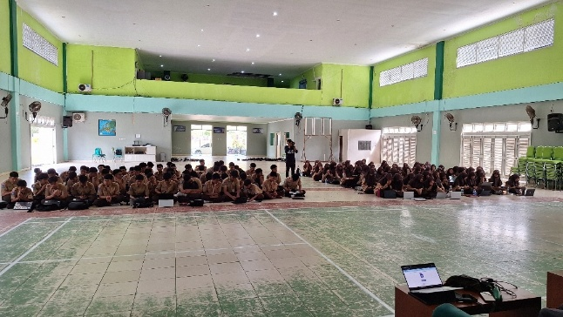  Image 3. Front View of Participants in Attendance | 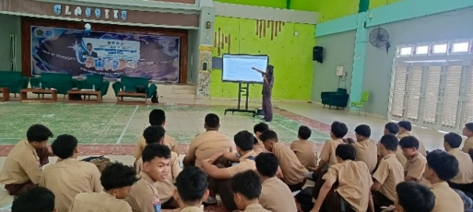  Image 4. Presentation of Material Photo 1
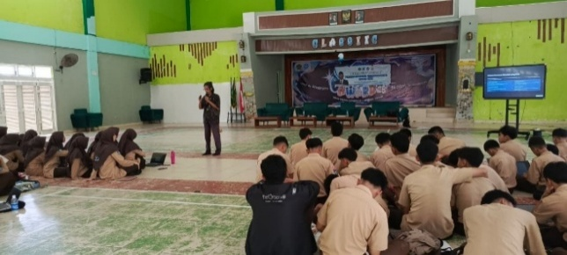  Image 5. Presentation of Material Photo 2 | 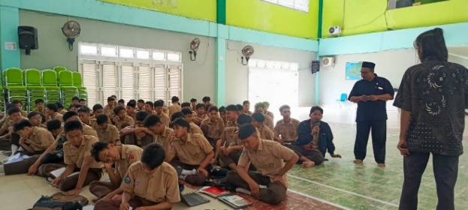  Image 6. Interactive Discussion Photo 1
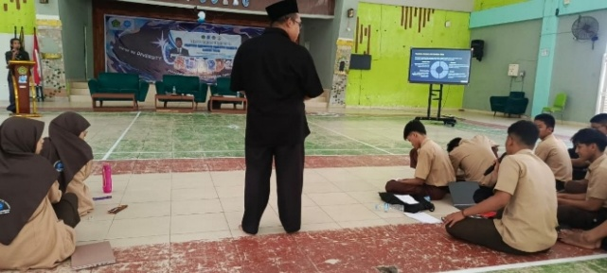  Image 7. Interactive Discussion Photo 2 | 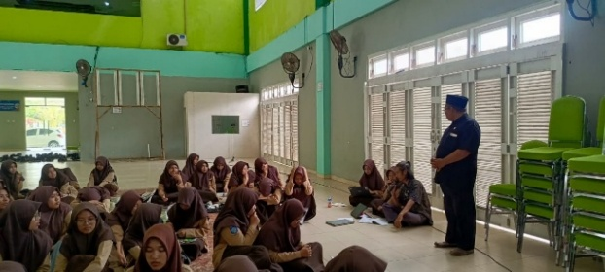  Image 8. Speaker Mingling with Participants
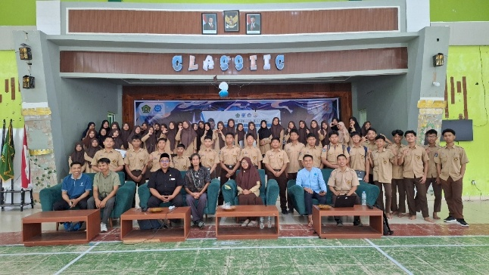  Image 9. Group Photo During Closing Session | 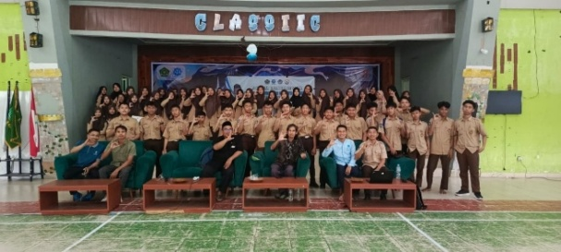  Image 10. Final Photo During Closing Session
All photos taken during the training can be seen in this link: Documentation of Research Literacy Trainig
Participant Demographic Profile
Based on posttest data completed by 72 students, the participant demographic profile can be described as follows. Regarding prior research experience, 59.7% of students (43 individuals) reported having conducted research or scientific writing during their enrollment at MAN IC East Lombok, while 40.3% (29 individuals) had no prior research experience. The gender composition of participants was relatively balanced, with females comprising 54.2% (39 individuals) and males comprising 45.8% (33 individuals).
By grade level, participants originated from three levels: Grade XII dominated with 52.8% (38 individuals), followed by Grade X at 38.9% (28 individuals), and Grade XI at 8.3% (6 individuals). The age range of participants was 15-18 years, with the following distribution: 17-year-olds at 31.9% (23 individuals), 16-year-olds at 26.4% (19 individuals), 15-year-olds at 23.6% (17 individuals), and 18-year-olds at 18.1% (13 individuals). Preferred subjects among participants were dominated by Biology (29.2%), followed by Mathematics and English at 12.5% each, Geography (8.3%), and Physics (6.9%).
Table 1. Cross Tabulation between Class, Research Experience, and Gender
Grade | Experience in Research |  | Gender |  | Total
Grade | Experience in Research |  | Male | Female | Total
X | No | Count | 13 | 13 | 26
X | No | % within | 46.4% | 46.4% | 92.9%
X | Yes | Count | 0 | 2 | 2
X | Yes | % within | 0.0% | 7.1% | 7.1%
X | Total | Count | 13 | 15 | 28
X | Total | % within | 46.4% | 53.6% | 100.0%
XI | No | Count | 1 | 2 | 3
XI | No | % within | 16.7% | 33.3% | 50.0%
XI | Yes | Count | 3 | 0 | 3
XI | Yes | % within | 50.0% | 0.0% | 50.0%
XI | Total | Count | 4 | 2 | 6
XI | Total | % within | 66.7% | 33.3% | 100.0%
XII | No | Count | 0 | 0 | 0
XII | No | % within | 0 | 0 | 0
XII | Yes | Count | 16 | 22 | 38
XII | Yes | % within | 42.1% | 57.9% | 100.0%
XII | Total | Count | 16 | 22 | 38
XII | Total | % within | 42.1% | 57.9% | 100.0%
Total | No | Count | 14 | 15 | 29
Total | No | % within | 19.4% | 20.8% | 40.3%
Total | Yes | Count | 19 | 24 | 43
Total | Yes | % within | 26.4% | 33.3% | 59.7%
Total | Total | Count | 33 | 39 | 72
Total | Total | % within | 45.8% | 54.2% | 100.0%

Test Results Analysis
Based on posttest data analysis from 72 respondents, descriptive statistics were obtained as presented in Table 1.
Table 2. Descriptive Statistics of Research Methodology Literacy Scores
Statistic | Value
N (Number of Respondents) | 72
Mean | 64.11
Median | 64.00
Mode | 76
Standard Deviation | 24.33
Skewness | -0.331
Kurtosis | -0.723
Range | 94
Minimum | 6
Maximum | 100
The data in Table 1 indicate that the mean research methodology literacy score was 64.11 with a standard deviation of 24.33. The median value (64.00), which closely approximates the mean, indicates a relatively symmetrical data distribution. The mode of 76 represents the most frequently occurring score. The skewness value (-0.331) indicates a slightly left-skewed distribution (negative skew), while the kurtosis value (-0.723) indicates a flatter distribution (platykurtic) compared to a normal distribution.
The categorization of research methodology literacy scores was conducted using five categories as presented in Table 2.
Table 3. Categorization of Research Methodology Literacy Scores
Category | Score Range | Frequency | Percentage
Excellent | ≥ 85 | 16 | 22%
Good | 75 – 84 | 15 | 21%
Fair | 65 – 74 | 4 | 6%
Poor | 55 – 64 | 13 | 18%
Very Poor | < 55 | 24 | 33%
Total | – | 72 | 100%
The categorization results in Table 2 indicate that 43% of students (31 individuals) fell within the Excellent and Good categories, suggesting adequate understanding of research methodology literacy. Approximately 6% of students (4 individuals) were in the Fair category. However, 51% of students (37 individuals) remained in the Poor and Very Poor categories, indicating the necessity for continued intervention to enhance their research literacy.
Discussion
The evaluation results demonstrate that the research methodology training produced positive impacts on student research literacy. Although the mean score (64.11) remained below the Good category (75-84), the score distribution revealed considerable variation in capabilities among participants. This finding aligns with Karim's (2023) assertion that research literacy can be developed through structured training approaches, though sustained time and mentoring are required to achieve optimal outcomes.
The finding that 59.7% of students possessed prior research experience indicates that MAN IC East Lombok has established a solid foundation for research culture development. However, posttest results suggest that such experience has not been complemented by adequate methodological understanding. This condition is consistent with Nardi's (2018) observation that practical experience must be supplemented with strong conceptual understanding to produce comprehensive research competence.
The substantial percentage of students in the Poor and Very Poor categories (51%) underscores the importance of sustainable mentoring programs. This finding supports Drewery and Lollar's (2024) argument that experiential learning, such as training, requires consistent follow-up to ensure effective knowledge transfer. Additionally, the limited implementation duration (one day) constitutes a factor that warrants consideration in designing similar training programs in the future.
Furthermore, the variation in scores across different grade levels suggests that research literacy development should be approached as a progressive, multi-year curriculum component rather than a single intervention. The dominance of Grade XII students among participants with higher scores may reflect their greater exposure to academic activities and maturity in understanding abstract concepts. This observation aligns with the developmental learning theory, which posits that cognitive abilities evolve with age and experience (Piaget, 1972).
The positive reception of the interactive lecture method, as evidenced by active participation during discussion sessions, supports the social constructivist approach to learning, wherein knowledge is constructed through social interaction and collaborative meaning-making (Vygotsky, 1978). Future programs should capitalize on this finding by incorporating more collaborative elements, such as group research projects and peer mentoring, to facilitate deeper learning and knowledge retention.
D. CONCLUSIONS AND RECOMMENDATIONS
Based on the implementation results of this community service activity, it can be concluded that the research methodology training was successfully implemented with approximately 110 students from MAN IC East Lombok as participants. The posttest evaluation indicated a mean research methodology literacy score of 64.11, with 43% of students falling within the Excellent and Good categories, while 51% remained in the Poor and Very Poor categories. The interactive lecture, discussion, and mentoring methods proved effective in delivering foundational research methodology understanding to students.
For program continuation, it is recommended that sustainable mentoring programs be implemented for students who participated in the training, particularly for the 51% who remained in the Poor and Very Poor categories. Additionally, advanced training focusing on specific topics such as data collection techniques, data analysis, and research report writing should be considered. For the madrasah, it is recommended to establish student research groups under regular supervision by KIR supervising teachers, enhance internet infrastructure capacity to support technology-based learning activities, and systematically integrate research literacy materials into KIR extracurricular activities.
ACKNOWLEDGMENTS
The authors express gratitude to the Institute for Research and Community Service (LPPM) of Universitas Pendidikan Mandalika for supporting and facilitating the implementation of this community service activity. Appreciation is also extended to the Principal of MAN Insan Cendekia East Lombok along with all administrators, teachers, and students who received and fully supported the implementation of this community service activity.
REFERENCES
Anderson, L. W., & Krathwohl, D. R. (2001). A taxonomy for learning, teaching, and assessing: A revision of Bloom's taxonomy of educational objectives. Longman.
Crowe, A., Dirks, C., & Wenderoth, M. P. (2008). Biology in Bloom: Implementing Bloom's taxonomy to enhance student learning in biology. CBE—Life Sciences Education, 7(4), 368–381. https://doi.org/10.1187/cbe.08-05-0024
Drewery, M. L., & Lollar, J. (2024). Undergraduates' perceptions of the value of service-learning. Frontiers in Education, 9, 1330456. https://doi.org/10.3389/feduc.2024.1330456
Ekawanti, A., Lestari, R. V., Cholidah, R., & Al Maliki, I. M. (2022). Research methodology training in science and technology for students of Madrasah Aliyah Insan Cendekia East Lombok. Jurnal Pengabdian Magister Pendidikan IPA, 5(2), 123–130.
Karim, A. R. (2023). Analysis of the importance of scientific writing skills for high school students. NUSRA: Jurnal Penelitian dan Ilmu Pendidikan, 4(4), 1226–1233. https://doi.org/10.55681/nusra.v4i4.1802
Kivunja, C. (2018). Distinguishing between theory, theoretical framework, and conceptual framework: A systematic review of lessons from the field. International Journal of Higher Education, 7(6), 44–53. https://doi.org/10.5430/ijhe.v7n6p44
Ministry of Religious Affairs of the Republic of Indonesia. (2024, July 4). 7,961 madrasah student research proposals registered for MYRES 2024. https://kemenag.go.id/nasional/7-961-proposal-riset-siswa-madrasah-didaftarkan-ikut-myres-2024-8vZMg
Nardi, P. M. (2018). Doing survey research: A guide to quantitative methods (4th ed.). Routledge.
Paul, R., & Elder, L. (2019). The miniature guide to critical thinking: Concepts and tools (8th ed.). Foundation for Critical Thinking.
Piaget, J. (1972). The psychology of the child. Basic Books.
Ramayanti, R. (2023). Development of module-based information literacy for Madrasah Aliyah Negeri students. Tik Ilmeu: Jurnal Ilmu Perpustakaan dan Informasi, 7(1), 45–60. http://dx.doi.org/10.29240/tik.v7i1.6752
Salam, M., Awang Iskandar, D. N., Ibrahim, D. H. A., & Farooq, M. S. (2023). Service learning in higher education: A systematic literature review. Asia Pacific Education Review, 20, 573–593.
Sugiyono. (2019). Quantitative, qualitative, and R&D research methods. Alfabeta.
Vygotsky, L. S. (1978). Mind in society: The development of higher psychological processes. Harvard University Press.
Yusuf, A. M. (2017). Quantitative, qualitative, and mixed research methods. Kencana.

The Google Form for data collection and the Google Sheet containing respondent answers can be accessed at the following 2 links: Data Collection Form and Respondent Answers Sheet.

